Problem 1 – Exploring Right Triangle Trigonometry
We will begin this activity by looking at the definitions of the sine, cosine, and tangent of a right triangle. Start the Learning Check application by pressing  and selecting LearnChk. Open the file Trig. You are given the definition for the sine, cosine, and tangent of a right triangle. Copy the definitions onto your worksheet.
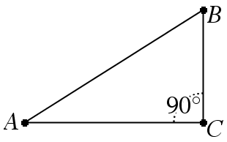
1. What is the definition of sin A for right ABC?

2. What is the definition of cos A for right ABC?

3. What is the definition of tan A for right ABC?

Answer the following questions about sine, cosine, and tangent for ABC.
4. What is sin A?

5. What is cos A?

6. What is tan A?

7. What is sin B?

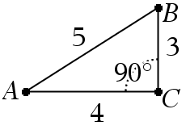
8. What is cos B?

9. What is tan B?

Problem 2 – Exploring the Sine Ratio of a Right Triangle
For this problem, we will investigate the sine ratio. Start the CabriTM Jr. application by pressing  and selecting CabriTMJr. Open the file TRIG by pressing □, selecting Open…, and selecting the file. You are given right triangle ABC.
10. Grab and drag point B. Record the data you collected in the table below. Leave the last column blank for now.
Position | BC | AB
1
2
3
4

11. What do you notice about the ratio of BC to AB?

12. Did ∠A change when you moved point B in ABC?

Because the ratio remains the same and ∠A remains fixed, we can use the ratio of BC to AB to find the measurement of ∠A. To do this, we will use the definition of sine and the inverse of sine. By definition,. To find the measurement of ∠A, we use the inverse of sine to get the formula . Exit Cabr TMJr. and go to the Home screen to find the inverse sine of . Record this into the last column of the table above.
13. What is the measurement of ∠A?

14. What is the measurement of ∠B?

Problem 3 – Exploring the Cosine Ratio of a Right Triangle
For this problem, we will investigate the sine ratio. Start the CabriTM Jr. application and open the file TRIG. You are given right triangle ABC.
15. Collect data for four positions of point B as in Problem 2.
Position | AC | AB
1
2
3
4

Because the ratio remains the same, and ∠A remains fixed, we can use the ratio of AC to AB to find the measurement of ∠A. To do this, we will use the definition of cosine and the inverse of cosine. By definition, . To find the measurement of ∠A, we use the inverse of cosine to get the formula . Exit CabriTM Jr. and go to the home screen to find the inverse cosine of . Record this into the last column of the table above.
- What is the measurement of ∠A?

17. What is the measurement of ∠B?

18. How would you solve an equation of the form to find the measure of ∠A?

Problem 4 – Applying the Sine, Cosine, and Tangent Ratios of a Right Triangle
Find and label the measure of each angle given two sides of the right triangle.
19.  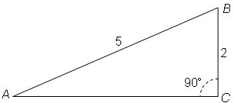 | 20.  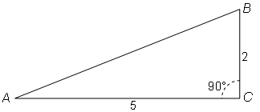
21.  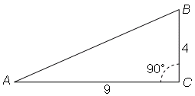 | 22.  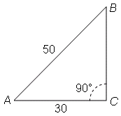
23.  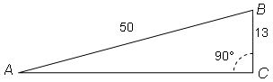 | 24.  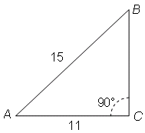
25.  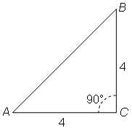 | 26.  