Math Objectives  - Students will determine the multiplicity of zeros of a polynomial function when given its graph or its equation in factored form.  - Students will write an equation for a polynomial function when given information about its zeros and the multiplicity of the zeros.  - Students will write an equation for a polynomial function when given its graph.  - Use appropriate tools strategically (CCSS Mathematical Practice).  - Look for and make use of structure (CCSS Mathematical Practice).  Vocabulary  - degree of a polynomial • multiple zeros  - multiplicity  About the Lesson  - This lesson involves students utilizing graphs and equations of polynomial functions to determine the zeros of the functions and whether the functions cross the x-axis or is tangent to the x-axis at the zeros.  - As a result, students will:  - Write possible equations for a polynomial function, given information about its zeros.  - Write the equations in factored form, given the graphs of polynomial functions.  TI-Nspire™ Navigator™  - Send the TI-Nspire document to students  - Use Class Capture or Quick Poll to examine the values of x for which the graph crosses the x-axis  - Use Quick Poll questions to adjust the pace of the lesson according to student understanding  Activity Materials  - Compatible TI Technologies: TI-Nspire™ CX Handhelds,  TI-Nspire™ Apps for iPad®,  TI-Nspire™ Software | 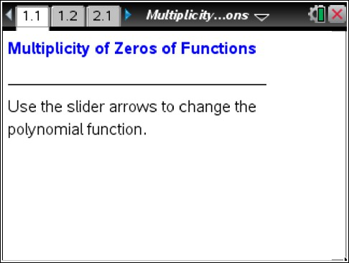  Tech Tips:  - This activity includes screen captures taken from the TI- Nspire CX handheld. It is also appropriate for use with the TI-Nspire family of products including TI-Nspire software and TI-Nspire App. Slight variations to these directions may be required if using other technologies besides the handheld.  - Watch for additional Tech  Tips throughout the activity for the specific technology you are using.  - Access free tutorials at  http://education.ti.com/calcul ators/pd/US/Online- Learning/Tutorials  Lesson Files:  Student Activity  - Multiplicity_of_Zeros_of_ Functions_Student.pdf  - Multiplicity_of_Zeros_of_ Functions_Student.doc  TI-Nspire document  - Multiplicity_of_Zeros_of_ Functions.tns

Discussion Points and Possible Answers

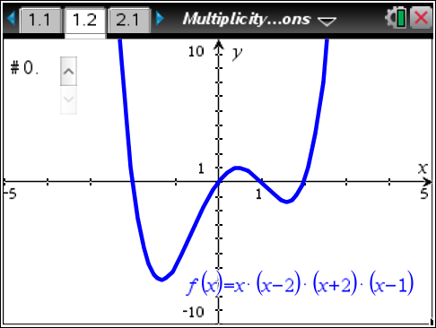
Move to page 1.2.
- The initial value of the slider is #0.
  - What are the zeros of the function?

Answer: x = -2, x = 0, x = 1, x = 2

  - For what value(s) of x does the graph of the function cross the x-axis?

Answer: x = -2, x = 0, x = 1, x = 2

  - For what value(s) of x is the graph of the function tangent to the x-axis?

Answer: none

  - What degree is the polynomial?

Answer: 4
TI-Nspire Navigator Opportunity: Live Presenter
See Note 1 at the end of this lesson.

- Use the slider to change the graph for functions #1–#5. For each function, answer the questions asked in Question 1. Use the table below to record your results.

Answer:

# | Function | Zeros | Cross | Tangent | Degree
1 | f(x) = (x + 1)²(x – 2)(x –1) | –1, 1, 2 | 1,2 | –1 | 4
2 | f(x) = (x + 1)(x – 2)²(x – 1) | –1, 1, 2 | –1, 1 | 2 | 4
3 | f(x) = (x + 2)²(x – 1)² | –2, 1 | None | –2, 1 | 4
4 | f(x) = (x + 1)³(x – 1)(x – 2) | –1, 1, 2 | –1, 1, 2 | None | 5
5 | f(x) = (x – 2)²(x – 1)(x + 1)² | –1, 1, 2 | 1 | –1, 2 | 5

3. How are the zeros of a polynomial function related to the factors of a polynomial function?

Answer: The zeros of the function are the solutions when the factors are set equal to zero and solved. When the coefficient of x is 1 in the factor, the zero and the constant term in the factor have opposite signs.
Teacher Tip: All the polynomial functions in this activity have a leading coefficient of 1.
4. How do the exponents in each term in the factored form of the polynomial function affect its graph?

Answer: When the exponent of the factor is odd, the graph crosses the x-axis at the corresponding zero. When the exponent of the factor is even, the graph is tangent to the x-axis at the corresponding zero.
TI-Nspire Navigator Opportunity: Quick Poll
See Note 2 at the end of this lesson.
5. When a polynomial has a repeated linear factor, it has a multiple zero. Write the factored form of a polynomial function that crosses the x-axis at x = –2 and x = 5 and is tangent to the x-axis at x = 3. Which of the zeros of the function must have a multiplicity greater than 1? Explain your reasoning.

Answer: f(x) = (x + 2)(x – 5)(x – 3)²; x = 3 must have an even multiplicity greater than 1 because the graph is tangent to the x-axis at x = 3.
Teacher Tip: The other two zeros could have an odd multiplicity greater than 1 because the degree of the polynomial is not given. However, x = 3
is the only zero that must have an even multiplicity greater than 1.

6. Write two additional polynomial functions that meet the same conditions as described in Question 6. Explain what is different from your function in Question 6, and how you determined your polynomial functions.

Sample Answers: Answers will vary. However, the exponents of the factors (x + 2) and (x – 5) must be odd because the graph crosses at these corresponding zeros. The exponent of the factor (x – 3) must be even because the graph is tangent to the x-axis at x = 3.
Examples: f(x) = (x + 2)(x – 5)(x – 3)⁴
f(x) = (x + 2)³(x – 5)(x – 3)²
f(x) = (x + 2)³(x – 5)⁵(x – 3)²
Teacher Tip: Students might change the a-value instead of the exponents of the factors. For example, f(x) = 2(x + 2)(x – 5)(x – 3)². Encourage the students to explore the meaning of varying exponents.
Move to page 2.1.  7. Select the slider until it reads #1.  - Write the factored form of the polynomial function graphed.  Answer: f(x) = (x + 1)(x – 1)²(x – 2) | 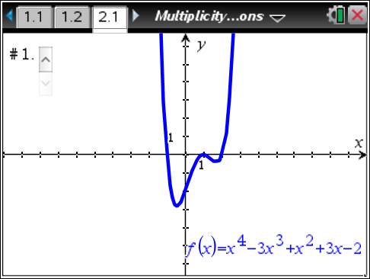
b. Describe how you determined the factors of the polynomial function.

Sample Answers: The graph crosses the x-axis at x = –1 and x = 2 and is tangent to the x-axis at x = 1. This means there is even multiplicity greater than 1 at x = 1. One factor must be (x – 1) raised to an even power. Since the degree of the polynomial is 4, the exponents of the factors must add to 4. If (x – 1) takes a power of 2 for multiplicity, (x + 1) and (x – 2) can only have a power of 1.
8. Select the slider until it reads #2.
  - Write the factored form of the polynomial function graphed.

Answer: f(x) = (x + 1)²(x – 1)²

  - Describe how you determined the degree of each of the factors of the polynomial function.

Answer: The graph never crosses the x-axis, but it is tangent to the x-axis at x = –1 and x = 1, meaning both are multiple zeros. The degree of the polynomial is 4, so each factor has an exponent of 2.

9. Select the slider until it reads #3.
  - Write the factored form of the polynomial function graphed.

Answer: f(x) = (x + 2)(x + 1)(x – 1)³
b. Describe how you determined the degree of each of the factors of the polynomial function.

Answer: The graph of the function crosses at x = –2, x = –1, and x = 1. Since the degree of the polynomial is 5, one of the roots has a multiplicity of 3. At x = 1, the function changes concavity, so the exponent is odd and greater than 1.
Teacher Tip: Students might not recognize which zero should have a multiplicity of 3. This would be a good place to discuss concavity if appropriate.
10. For what reasons would you use the factored form of a polynomial function? The standard form?

Answer: The factored form of a polynomial function shows the x-intercepts clearly, while it is easier to find the y-intercept using the standard form.

Wrap Up
Upon completion of the discussion, the teacher should ensure that students are able to understand:
- The multiplicity of zeros of a polynomial function when given its graph or its equation in factored form.
- How to write an equation for a polynomial function when given information about its zeros and the multiplicity of the zeros.
- How to write an equation for a polynomial function when given its graph.

TI-Nspire Navigator

Note 1
Question 2, Live Presenter
After students have answered all of the parts of Question 2, use Teacher Edition computer software or Live Presenter to show students the zeros of graph #1. Use the Point On tool and drag it to each of the three zeros. See how many students were able to identify all three. (Note: Do not use the Graph Trace tool because there are multiple functions graphed in this problem.)
Repeat this demonstration with graphs #2 – #5 if so desired.

Note 2
Question 4, Quick Poll
Use several Quick Polls to test students’ understanding of how exponents and degrees affect the behavior of a graph. For example:
- A polynomial has a factor (x – 8)². What happens at the zero?
  - Tangent to the x-axis
  - Crosses the x-axis Correct answer: A

