Open the TI-Nspire document Factoring_Trinomials_2.  In the activity Factoring Trinomial Part 1, you used tiles to factor trinomials such as x² + 5x + 6. This activity will explore trinomials of the form x² + bx + c, where b is a negative integer and c is positive. One example is the trinomial x² – 5x + 6. Its factors are (x – 2) and  (x – 3). | 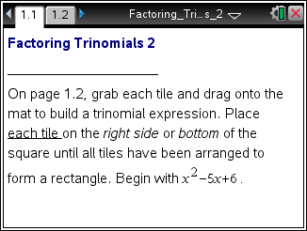

Move to page 1.2. | Press / ¢ and / ¡ to navigate through the lesson.
Follow along as your teacher shows how to move the tiles to factor the trinomial x² – 5x + 6. The white tiles represent negative numbers. The darker tiles represent positive numbers.

Arrange the tiles to construct the trinomial x² – 3x + 2.
1. a. Arrange the tiles to form a rectangle with area x² – 3x + 2.
b. What are the dimensions of the rectangle?

Click the Reset box in the lower left portion of the screen.

- For each of the following, move the correct tiles to the mat.
a. Factor the trinomial x² – 7x + 6 by arranging the tiles on page 1.3 to make a rectangle. Verify that your answer is correct by finding the product of the factors.

b. Three trinomials have the form x² + bx + c where –9 ≤ b ≤ –1 and 1 ≤ c ≤ 12. The large rectangle is a square. Find one of these trinomials. Show that the product of the sides of the square will produce this trinomial.

- Sali factored the trinomial x² – 6x + 6. His answer was (x – 4)(x – 2). Tell whether he was correct or incorrect and why.

- a. Find the factors of each of the following trinomials.

Trinomial | Factored Form
x² – 8x + 7
x² – 11x + 18
x² – 14x + 40
x² – 26x + 48

b. How can tell whether you have factored each trinomial correctly?

- Suppose x² – bx + c = (x – m)(x – n). How are m and n related to b? How are they related to c?

6. Compare the method used in this lesson with the one used to factor trinomials with all positive terms. Would the method from this lesson work on the trinomial x² + 2x – 8? Explain.

