Open the TI-Nspire document Sound_and_Waves.tns.  Sound is created by patterns of higher pressure, or compressions, and rarefactions, or lower pressure areas moving through the air. As these patterns form, they produce noise or notes. Specific notes, such as a C note form by a very specific pattern. In this activity you will explore ways to model these wave patterns and relate them to sound. | 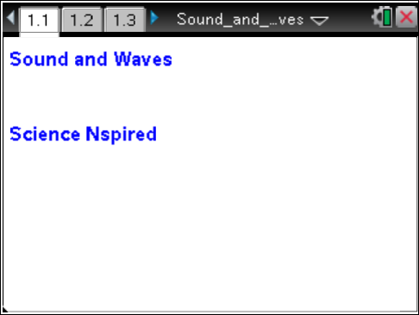

Move to page 1.2. |  |  |  | Press / ¢ and / ¡ to navigate through the lesson.
1. Explore the wave that is generated by changing the amp (amplitude) slider and observe the results. Change the freq (frequency) slider and observe the changes that occur. Note that for a sound wave, a peak in the graph represents a high pressure area, or compression, and a dip represents a lower pressure area, or rarefaction. For a water wave or wave in a rope, peaks and dips represent the actual motion of the rope or water surface in a given direction. |  |  |  | 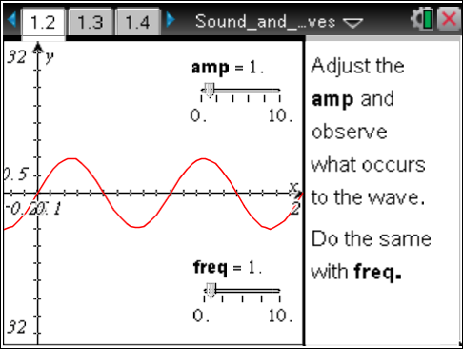
Move to pages 1.3–1.7. Answer the following questions here or in the .tns file.
Q1. What happens to the wave as amplitude (amp) changes?

Q2. What parts of the wave do not change when you adjust the amplitude?

Q3. If the amplitude is set to 5, how is the “5” seen on the graph?

Q4. What changes as frequency (freq) changes?

Q5. If the frequency is 2, in units used for the graph, how is this number represented on the graph?

Move to pages 1.8 and 1.9 and use this information to answer the following questions.
Amplitude is the height of the wave from the line of symmetry or the middle of the wave.
Frequency is the number of waves per time.
Sound travels in waves with different frequencies and amplitudes.
Move to pages 1.10 and 1.11. Answer the following questions here or in the .tns file.
Q6. What property of sound does wave amplitude affect?
A. speed  B. volume |  | C. pitch  D. beats
Q7. What property of sound does wave frequency affect?
A. speed  B. volume |  | C. pitch  D. beats
Move to page 1.12.  2. Modify the 1’s in the equation at the top of the screen to determine which is amplitude and which is frequency. |  |  |  | 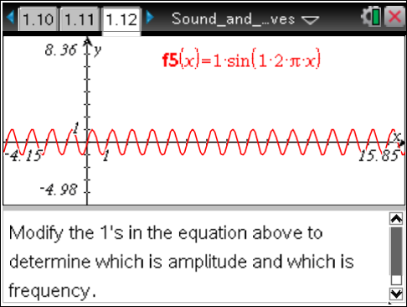
Move to pages 1.13 and 1.14. Answer the following questions here or in the .tns file.
Q8. In the equation y = a sin (b · 2π · x), what does a represent?
A. the amplitude |  | B. the frequency
Q9. In the equation y = a sin (b · 2π · x), what does b represent?
A. the amplitude |  | B. the frequency
Move to pages 2.1 and 2.2.  Wave Addition  In this next problem, you will explore the addition of two waves.  3. On page 2.2 modify one variable at a time starting with frequency of wave 1 and answer the questions on the following pages. |  |  |  | 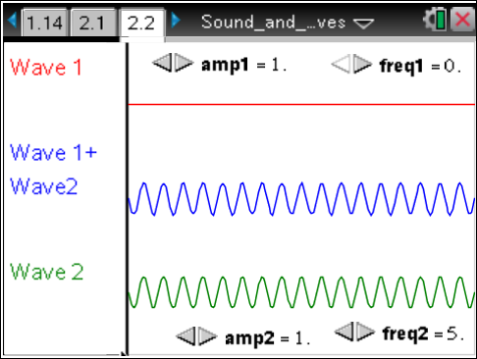
Move to pages 2.3 and 2.4. Answer the following questions here or in the .tns file.
Q10. What happens to the sum wave when the frequency of wave 1 is changed?

Q11. If wave 1 is a sound wave, a higher frequency will cause ___________________.
A. higher pitch | B. no change in pitch |  | C. lower pitch

Move to pages 3.1 and 3.2.  Wave Addition  In this next problem, you will explore the addition of two waves.  4. Adjust the phase for the top wave. The sum of wave 1 and wave 2 (bottom wave) appears as the middle wave. |  | 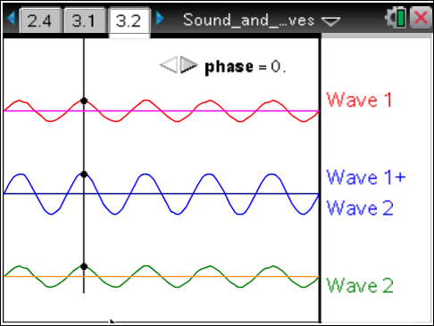
Move to pages 3.3–3.5. Answer the following questions here or in the .tns file.
Q12. What effect does a phase shift have on the summation wave?

Q13. The phase change will ___________________.
A. change the pitch  B. change the volume | C. change the speed  D. have no change to sound
Q14. What does it mean to be in phase?

