This is a project based STEM activity that will require you to understand and perform the processes of engineering design:
- Identify
- Research
- Design
- Create
- Evaluate
- Communicate

Vocabulary
- Resistivity
- Current
- Voltage
- Heating power
- Heating/cooling rate

Activity Materials Per Student Group
- Compatible TI Technologies: TI-Nspire™ Apps for iPad®
- Vernier™ Go Wireless® Temp sensor
- Drinking straw without paper jacket
- 2 meters of Magnet Wire 24 Gauge AWG Enameled Copper
- 6-Volt Super Heavy Duty Lantern Battery
- Knife Blade switch-single pole single throw (double throw if optional fan is used)
- Insulated alligator clip leads.
- 5volt brushless DC cooling fan 25mm x 25mm

The Engineering Problem
Your Company designs and manufactures consumer electronics. Your project manager has tasked you with designing a new line of battery powered consumer appliances that will keep a hot drink, such as coffee or tea, warm for a long period of time. Your task is to design a small electric heating element for the new line of products and to verify your design with test data.
- Identify: State your engineering goal here. What are you trying to build? What does it need to accomplish? How will you evaluate how well it works?

- Research: Use appropriate internet resources to learn about your engineering goal. Your research may include building processes, constraints, potential problems, sources of error, materials, time limits, and scientific principles that apply to your design.

Make sure you pay close attention to the Background Information and the instructions that are included on page 1.3.  Use this information as you experiment with the simulation on page 1.4 in the document. Pay attention to the warning messages that may pop up during the simulation.  Check your understanding by answering the questions that follow the simulation in the document. | 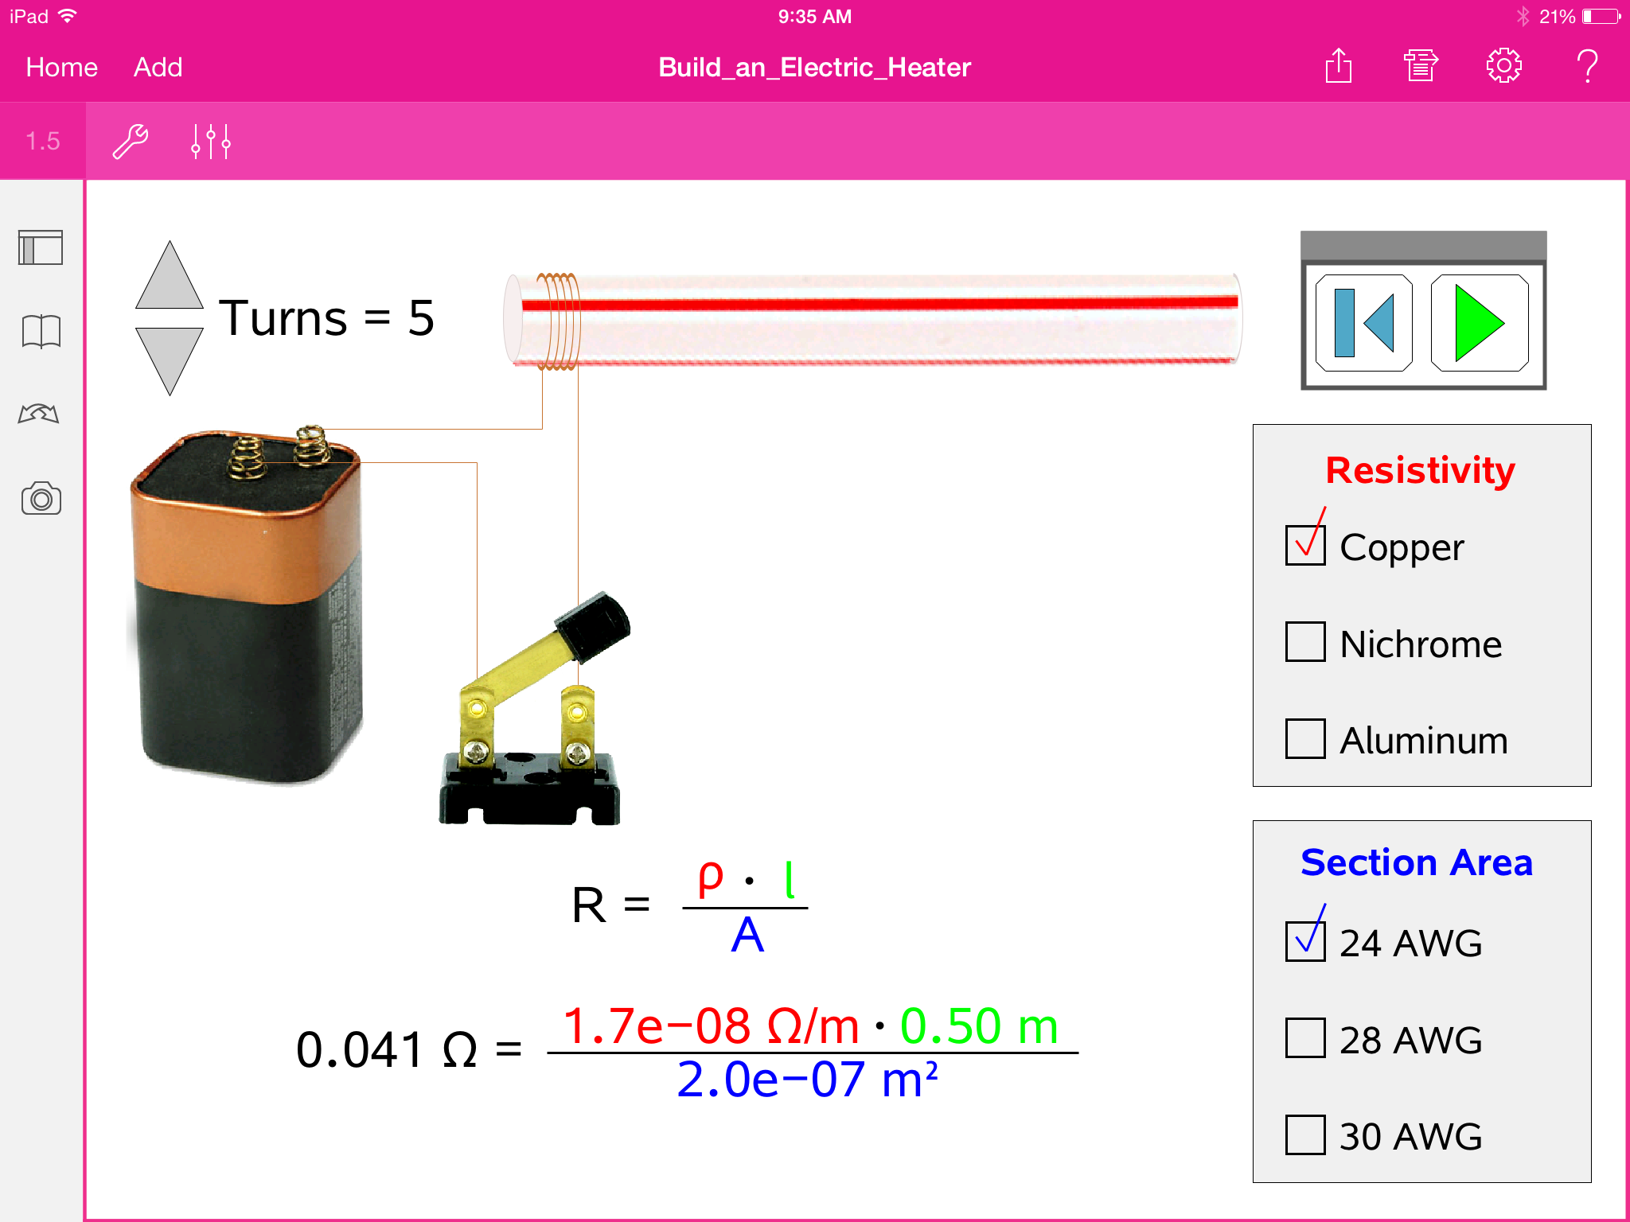
- Design/Prototype: Once you have researched the engineering goal, create a plan for the building of your design. Your design may include drawings, labels, materials lists, cost lists, etc. The prototype may be a first-time attempt at building the final product to learn how to put it together. Share your design and prototype with others, listen to their suggestions and decide for yourself the very best design.

- Create/Build: Use your design and prototype experience to build your product to your specifications.

- Evaluate/Test: Design an experiment that will help you to decide the best design to accomplish the engineering goal. You can use the Vernier Go Wireless™ Temp probe. On page 3.2 you will find data collection page for the Temp probe.

- Analyze: Determine a method to analyze the collected temperature data that will help you to decide the best design. You might consider: change in temperature, best-fit linear regression, and exponential decay models

- Refine: After you have built your design and tested it, think about what you like and do not like about the design. Show your product to your friends and family and listen carefully to their comments. Include the best suggestions from your customer feedback into your design and rebuild your deign to make it better!

- Describe the shape of your graph.

- What was your starting temperature?

- What was your final temperature?

- As the slope of the graph changed, describe what was happening.

- Present: Prepare a brief presentation of your creation in a cloud-based collaborative environment such as Google Drive. Share your presentation with your teacher, family and friends.

