Activity Overview:  In this activity, you will use the construction tools in the Geometry application to construct several cyclic quadrilaterals.  Materials  - Technology needed (TI-Nspire™ handheld, computer software) | 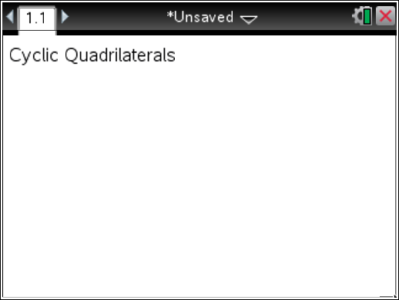
Steps

Step 1: Preparing the document  - Open a new document by clicking c > New Document > Add Notes.  - Type: Cyclic Quadrilaterals.  Note: To obtain capital letters, press the g key, then the letter.  - Press ~ > File > Save As….  Type: Cyclic_Quadrilaterals.  Tab to ¾, and press ·.  Note: To obtain the underscore, press / _.  4. To add a new page, press / ~ > Add Geometry.  5. To hide the scale in the right corner of the screen, go to Menu > View > Hide Scale.  6. Press Menu > Settings. Select “Fix 1” for display digits. Tab to Graphing Angle. Select “Degree”. Tab to Geometry Angle. Select “Degree”. Then press e to move from one field to the next and press x to uncheck each of the boxes. Tab to OK and press x or ·. | 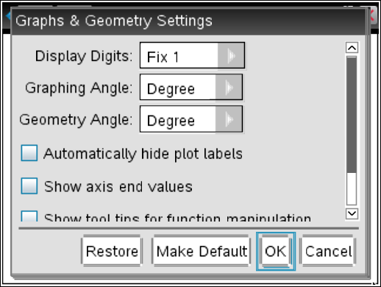
Step 2: Creating a circle  1. Press Menu > Shapes > Circle.  2. Move the cursor to a desired location. Press · to mark the center of the circle. Immediately press g O to label this as point O.  3. Use the Touchpad arrows to drag to a desired radius and press x or ·. Press d to exit the Circle tool. | 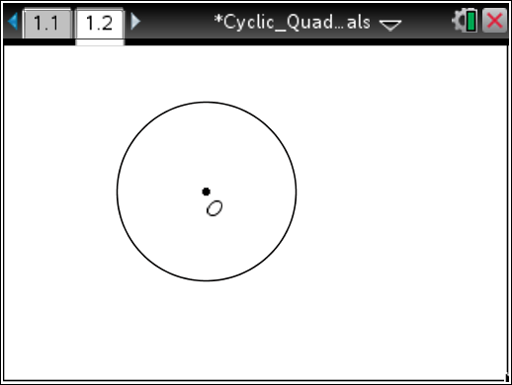
Step 3: Creating a cyclic quadrilateral  1. Press Menu > Shapes > Polygon.  2. Place a point on the circle by pressing x or · when the words point on appear. Once the point is ON the circle, immediately type g A to label it as point A.  3. Move to the next vertex and repeat step 2 for points B, C, and D.  4. Press · to lock the last vertex D. Press d to exit the Polygon tool. | 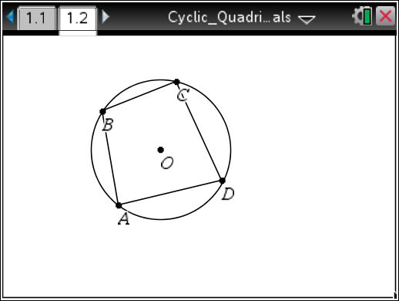
Step 4: Making several copies  1. Press / £ to open the page sorter view.  2. While the current page is selected, press / C to copy the page.  3. Press / V three times to paste three copies of the screen.  4. Arrow to the second page, and press ·.  5. Page 1.2 should now be the active page. | 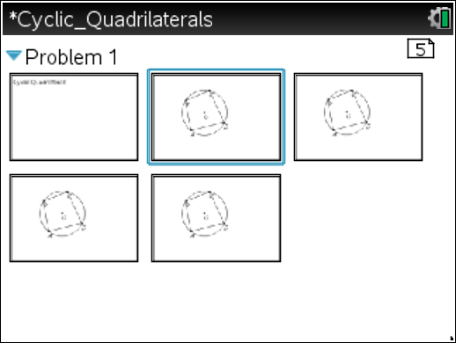
Step 5: Finding angle measurements  1. Press Menu > Measurement > Angle.  2. To measure ∠ABC, move the cursor to point A and press x or ·, and then move to point B and press x or ·. Finally, move to point C and press x or ·. After the third point has been selected, an angle arc and measurement will appear.  3. Repeat step 2 for the other three angles.  4. Press d to exit the Angle measurement tool.  Note: You may wish to move some of the angle measurements to a location on the screen where they are easier to read. | 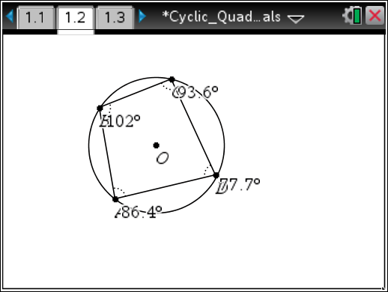
Step 6: Typing an Expression  This expression will be used later to explore angle relationships.  1. Press Menu > Actions > Text.  2. Move anywhere on the screen and press ·.  3. In the textbox, type the expression a+b. Press ·.  4. Press d to exit the Text tool. | 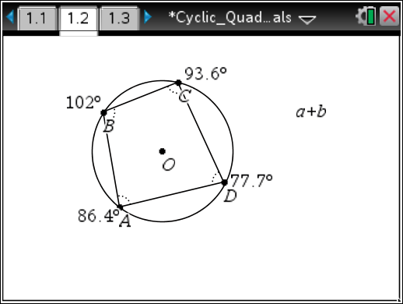
Step 7: Getting page 1.3 ready  1. Move to page 1.3.  2. Press Menu > Actions > Hide/Show.  3. Move the cursor to the circle and press x or ·. (The circle should become gray.)  4. Move the cursor to point O and press x or ·.  5. Press d to exit.  6. This should hide the circle and its center point O.  7. Repeat for page 1.4 as well  Note: The circle and point O still exist, but are hidden from view. They can be “shown” later, if necessary. | 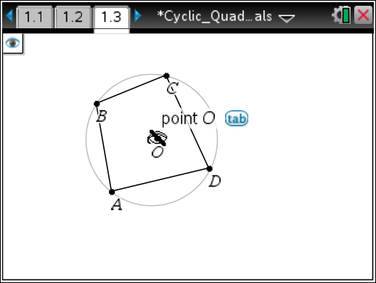  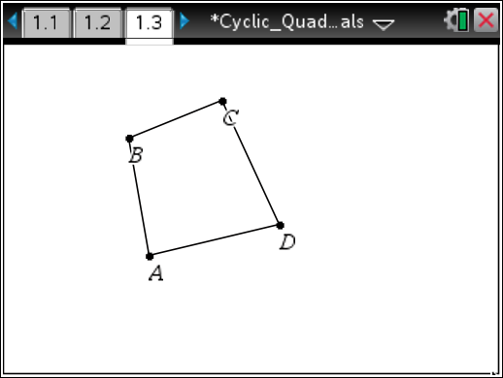
Step 8: Saving the document
1. Press / S.

