Open the TI-Nspire™ document Center_and_Spread.tns.  Measures of center are often given as summary measures of data. In this activity, you will explore measures of both center and spread and how the shape of a distribution influences these measures. | 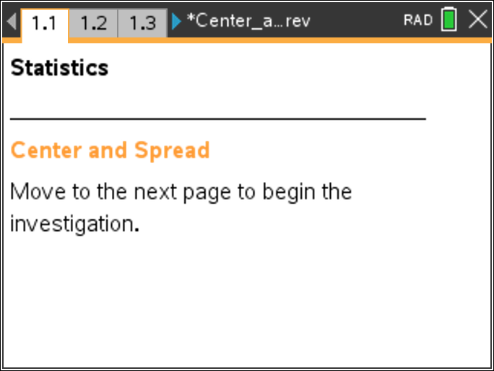
Tech Tip: Selecting a vertical line in a plot reveals the associated plot values. Selecting an empty space hides the associated plot values. After moving a point, release it by selecting an empty space before dragging another point. Otherwise, multiple points will be moved.

Tech Tip: Moving the cursor over a box plot reveals the values of the quartiles, extremes, and outliers.

Tech Tip: Selecting the quartiles, extremes, and outliers reveals the associated plot values.

Move to page 1.3.

The graphs show the heights (in inches) of fifteen hypothetical statistics students. The vertical lines in the lower graph represent the mean and the mean plus or minus one standard deviation.
1. a. In the table below, fill in the row for the given dot plot: sketch, mean, standard deviation (SD), median, and interquartile range (IQR).

b. Keeping the range constant, move points on the dot plot to match one of the other distribution shapes listed in the table. Record your results.

c. Repeat these steps for the other shapes listed in the table.
Shape (sketch your dot plot) | Mean | Median | SD | IQR
Skewed right

Shape (sketch your dot plot) | Mean | Median | SD | IQR
Skewed left

Symmetric – unimodal

Symmetric – bimodal

2. a. What do the mean and median measure?

b. What do the standard deviation and IQR measure?

3. Use the information in the table you completed in question 1 to describe the relationship between the shape of a distribution and the relative positions of the measures of center.

4. Use the information in the table to describe the relationship between shape of a distribution and the relative sizes of the measures of spread.

Move to page 1.4.

5. On this page, the graphs show the heights (in inches) of fifteen hypothetical statistics students. Move points in the dot plot to create the four distribution shapes listed in the table below. Use the arrow to reset the dot plot after each shape change. Fill in the rows of the table as you work.

Shape  (sketch your dot plot) | Mean__Median  <, =, > | Which measure of center seems to provide a more accurate description of the data? | Which measure of spread seems to provide a more accurate description of the data?
Skewed right

Skewed left

Symmetric - unimodal

Symmetric – bimodal

Move to page 2.2

6. The graph shows the weights (in pounds) of seven hypothetical statistics students. Measures of center and spread are displayed in the spreadsheet.
a. Fill in the table below for the “Before” Distribution Shape. Then, move one point to the extreme right of the distribution and fill in the table for the “After” Distribution Shape.
Distribution Shape | Mean, Standard Deviation | Median, IQR
Before

After

b. Measures that are essentially unchanged by the shape of a distribution are said to be resistant. Which measures appear to be resistant? Explain why.

c. Would your answer to b change substantially if you moved a different point? Explain.

- Based on your work in question 6, give at least one reason why either mean and standard deviation or median and IQR are paired when talking about measures of center and spread.

