Open the TI-Nspire document Reflection_Properties_of_Conics.tns.  Conic sections can be visualized as the intersections of a plane cutting through a double cone. They can also be defined as curves made up of points that satisfy certain distance relationships with special points (foci) and/or a special line (directrix). In this activity, you will see another special property of conic sections related to reflections. This is a property that makes conics important in practical applications. | 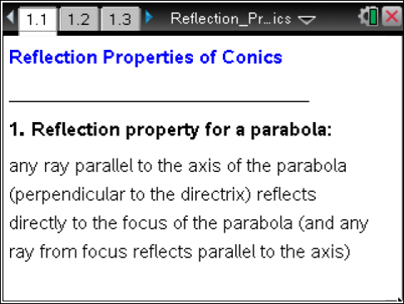

1. Reflections off a flat surface.
When light reflects off a flat mirror or a ball caroms off a flat wall, the angle of incidence is equal to the angle of reflection.
- The angle the ray of light makes with the surface of the mirror or the angle the straight path of the ball makes with the wall is the angle of incidence.
- The angle the ray of reflected light or the angle of the carom path of the ball makes with the wall is the angle of reflection.
a. Draw the path of the reflected ray in the picture below.
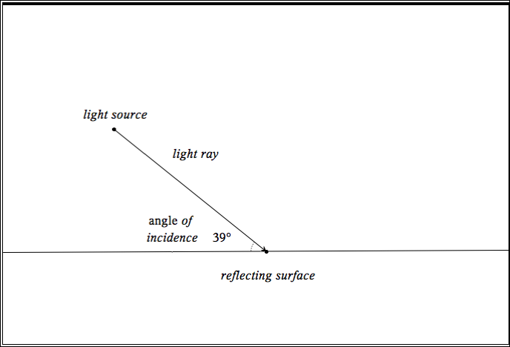

b. If a perpendicular were drawn to the reflecting surface at the point of contact, what would its relationship be to the angle formed by the light ray and its reflected ray?

2. Reflections off a curved surface.
What happens when a light ray reflects off a curved mirror or a ball caroms off a curved wall? The reflection property is the same where the tangent line to the curve at the point of impact is the reflecting surface. For example, if you bounced a ball off a circular wall, it would bounce in the same direction as if it bounced off a straight wall along the tangent line at that same point.

In the picture below, a circular wall with center O is shown along the path of a ball striking the wall at point P from its starting point at R. Sketch the carom path of the ball, and describe how you could determine it precisely.
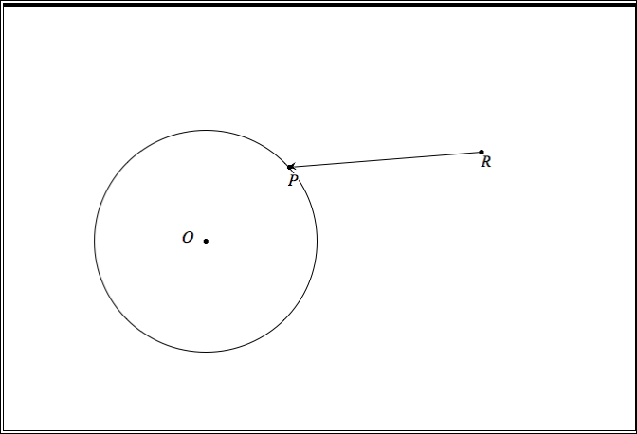
- For more general curved surfaces, this reflection property works in the same way – the angle of incidence to the tangent line is the equal to the angle of reflection to the tangent line.

Reflective surfaces shaped like conics have remarkable properties.

Move to page 1.2. | Press / ¢ and / ¡ to navigate through the lesson.
3. This page shows the graph of a parabola with focus F on the positive y-axis and horizontal directrix. The point P can be grabbed and moved along the parabola. The point P’ is located on the directrix so that segment PP’ is perpendicular to the directrix. (If you move the focus F, you will also change the directrix and the shape of the parabola.)
a. Measure segments FP and PP’. Drag the point P. What is special about the relationship between these two segments for any parabola?

Move to page 1.3.

b. Here is the same parabola with a tangent line at point P shown. A ray of light from point R reflects off the parabola. Move point R around to see the different reflected rays. What is special when R = F?

Note: Car headlights have mirrored surfaces in the shape of paraboloids (every cross-section through the center is the same parabola). For “high beams” a bulb located at the common focus of all the parabolas is lit. All of the reflected light rays from the mirrored surface point straight out!

Move to page 2.2.

4. This page shows the graph of the top half of an ellipse with foci F₁ and F₂ on the x-axis. The point P can be grabbed and dragged along the ellipse. (You can change the shape of the ellipse by moving points A or B to change the length of the major or minor semi-axis length.)
a. Measure segments F₁P and F₂P and add their lengths. Drag the point P. What is special about the relationship between the lengths of these two segments for any ellipse?

Move to page 2.3.

b. Here is the same ellipse with a tangent line at point P shown. A ray of light from point x reflects off the ellipse. Move point x around to see the different reflected rays. What is special when
x = F₁ or F₂?

Note: A “whispering room” has walls and ceilings in the shape of an ellipse rotated about a common axis (with two common foci F₁ and F₂ ). If one person stands at one focus and whispers, a person standing far away at the other focus can easily hear it while those close to the speaker might not. The reason is that all of the sound waves emanating from the speaker bounce off the walls toward a single common point – the other focus! There are also special billiard tables in the shape of an ellipse that have a single pocket located at one focus. If one shoots a ball from the other focus in any direction, it will carom off the railing directly into the pocket!

Move to page 3.2.

5. This page shows the graph of the top half of two branches of a hyperbola with foci F₁ and F₂ on the x-axis. The point P can be grabbed and dragged along one branch of the hyperbola. (You can change the shape of the hyperbola by moving points A or B.)
a. Measure segments F₁P and F₂P and calculate the difference of their lengths. Drag the point P. What is special about the relationship between the lengths of these two segments for any hyperbola?

Move to page 3.3.

b. Here is the same hyperbola with a tangent line at point P shown. A ray of light from point R reflects off the hyperbola at point P. Move point R around to see the different reflected rays. What is special when the ray RP points directly at F₂?

Note: The reflective properties of a parabola and a hyperbola are combined in spectacular fashion to make reflecting telescopes. Read how on page 4.1. When the telescope is pointed at a distant object, all of the light rays from that object are practically parallel to the axis of the parabolic mirror (because of the great distance). Hence, these light rays all bounce off the sides of the telescope to the focus of the parabola. However, before the light rays can hit that focus, they reflect off a hyperbolic mirror having one focus the same as the parabola and the other focus at the eye of the spectator.

Move to page 4.2.
See a dynamic illustration of the telescope on this page. Move the source point R anywhere in the “bowl” of the telescope and note how the combined reflections always go directly to the eyepiece.

