Open the TI-Nspire™ document Muddy_Water.tns.  Anyone who has done any canoeing or kayaking knows that the water in streams, rivers, and lakes can sometimes look “muddy,” or “turbid,” especially after a rainstorm. In this investigation, you will explore how run-off from a rainstorm can affect the turbidity in local waters. | 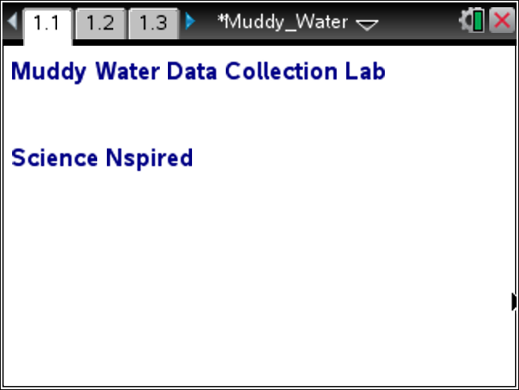
Read the background information for this activity.

Turbidity is the cloudiness created when dirt and other foreign particles get stirred up and suspended in the water. When rain hits the land, whatever is not absorbed into the earth flows into the local waterways. As the rainwater flows over surfaces, it gathers speed and picks up foreign particles, such as soil. As the water moves faster and increases in volume, more particles are carried into the local bodies of water.

Move to page 1.2.

1. Align the flashlight, container of water, and the light sensor so that the light passes through the container of water directly into the light meter.  2. Turn on the flashlight. |  |  | 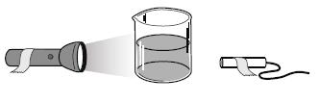
Move to page 1.3.

3. Plug the light sensor into the Vernier EasyLink or TI-Nspire Lab Cradle and connect to the TI-Nspire technology.

4. Select Mode: Selected Events. Then, select the Start button. |  |  |  |  |  | 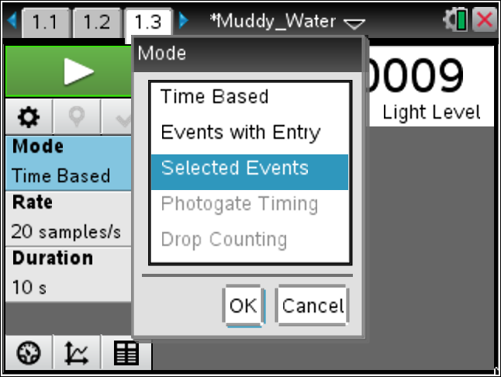
5. When the light intensity reading is steady, select the Keep button. The value is collected.
6. Add 10 g of dirt to the water and stir.
7. When the dirt is dissolved in the water and the light reading is steady, select the Keep button to collect the reading.
8. Repeat steps 6 and 7 until 50 g of dirt have been added to the water.
9. After you have added all of the dirt and collected the last light reading, select the Stop button. A scatter plot is displayed showing the light reading for each test. Click Table View to display the data table on the handheld. Record the values in the table below.

 | Amount of Dirt (g) | Intensity of Light Passing Through Water
 | 0
 | 10
 | 20
 | 30
 | 40
 | 50
10. Draw and label the graph of your data on the axes provided. |  |  |  |  | 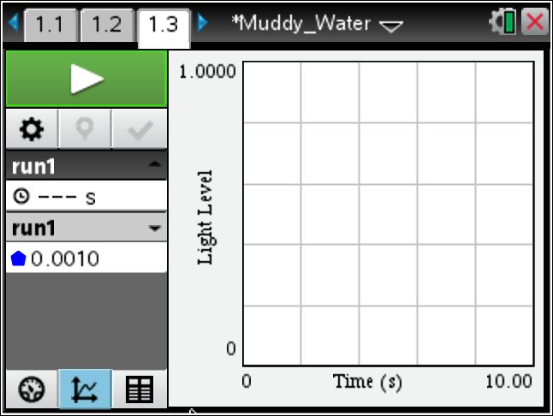
Move to pages 1.4 - 1.9.
Answer questions 1 - 6 below and/or in your .tns file.

Q1. Describe the shape of the graph.

Q2. What does the y–intercept represent in this situation?

Q3. What did the flashlight represent?

Q4. Between which amounts of dirt did the intensity of light change the most?

Q5. Between which amounts of dirt did the intensity of light change the least?

Q6. Describe how storm water run-off affects local water turbidity. When will the most devastating effect on water clarity occur?

