Open the TI-Nspire document SD_How_Far_is_Typical.tns.  Some observations are close to the mean and some are not. In this activity, you will explore how standard deviation helps you think about where the observations fall with respect to the mean. | 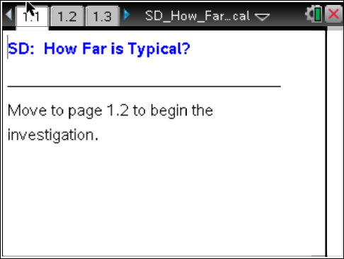

Move to page 1.3. | Press / ¢ and / ¡ to navigate through the lesson.
Tech Tip: To de-select a point, move the cursor to a white space on the screen and click. If you do not de-select a point you have moved, it will move again along with the next point you choose.

Move to page 1.3.
The dotplot at the bottom of this page displays the amount of snowfall (in inches) for the six largest cities in a Midwestern state during one winter month for a given year. The vertical line segment indicates the value of the mean amount of snowfall for these cities.
The difference between the amount of snowfall for a given city and the mean amount of snowfall for all cities (so, Actual for the city – Mean of all cities) is called the residual for that city; this difference may also be referred to as the deviation from the mean for that city.
1. If the amount of snowfall is changed on the dotplot, the residuals change.
- How many residuals are shown? Why?

- What are the largest and smallest values you can get for the sum of the residuals? Explain.

- Is the mean of the residuals a good measure for describing the spread of the snowfall amounts? Why or why not?

If you want to use the residuals to create a measure of spread, there are two ways to deal with negative residuals. You can take the absolute value of the residuals, or you can square the residuals. The questions that follow investigate both of these options.

Move to page 1.4.

2. The top graph on page 1.4 displays the absolute values of the residuals from page 1.3, and the vertical line represents the standard deviation.
a. Suppose you could vary the amount of snowfall for the six cities to represent different years. Move the data points to investigate the relationship between the value of the standard deviation and the absolute value of the residuals.
b. How does the value of the standard deviation seem to be related to the residuals?

Move to page 2.2.

3. The amount of snowfall (in inches) during one winter month for the same six cities is displayed in the dotplots on the right-hand side of the screen.
- The upper left plot displays the standard deviation of the snowfall amounts as a vertical line.
- The vertical line in the lower left plot displays the mean of the absolute values of the residuals obtained from the differences between the amount of snowfall (in inches) for a particular city and the mean amount of snowfall for all of the cities.
- Change the amounts of snowfall by moving the data points in the right plot, and observe the changes in the plots on the left.
- How does the mean of the absolute values of the residuals compare to the standard deviation?

Move to page 2.3.

4. Suppose you squared the residuals to eliminate negative residuals instead of using the absolute values of the residuals.
- The amount of snowfall (in inches) for one month for the same six cities is displayed in the dotplot on the right hand side of the screen.
- On the left hand side of the screen, the squared residuals are plotted in both dotplots.
- Recall that a residual is the difference between the amount of snowfall (in inches) in a particular city during one winter month and the mean amount of snowfall for all of the cities in that month. What are the units of the squared residuals? Explain.

  - The upper left plot displays the square of the standard deviation.
  - The lower left plot displays the mean of the squared residuals.
- Change the amount of snowfall by moving the data points in the right plot, and observe the squared standard deviation and mean of the squared residuals in the plots on the left.
- How does the value of the squared standard deviation compare to the value of the mean of the squared residuals?

- In what units is the squared standard deviation measured? Why might this be problematic, and what suggestions do you have to address the problem?

5. a. Based on your answer to question 4, write a description of what standard deviation measures.

- Suppose the large cities in two different states have the same mean amount of rain per year, but the standard deviation for cities in one state is substantially larger than that for cities in the other state. What does that tell you about the amount of rain in the two states?

