 | Math Objectives  - Students will recognize the function $g\left(x\right)= \log_{b}{x}$ as the inverse of $f\left(x\right)= b^{x}$ where $b>0$and $b ≠1$.  - Students will apply this inverse relationship and solve simple logarithmic equations.  Vocabulary  - exponential function • domain • one-to-one function  - logarithmic function • range • inverse function  About the Lesson  - This lesson involves the one-to-one function f(x) = b^{x}. In acknowledging the existence of its inverse, students will:  - Use the domain and range of f(x) to determine the domain and range of f^{–1}(x).  - Interpret the graph of f^{–1}(x) as the reflection of f(x) across the line y = x.  - Use this inverse relationship to write an equation for the graph of the inverse.  - Recognize the logarithmic notation needed to define the inverse function.  - Use the inputs and outputs of two inverse functions to complete a table and find patterns within the table.  - As a result, students will:  - Solve simple logarithmic equations and verify solutions using the corresponding exponential equations.  Teacher Preparation and Notes.  - This activity is done with the use of the TI-84 family as an aid to the problems.  Activity Materials  - Compatible TI Technologies: TI-84 Plus*, TI-84 Plus Silver Edition*, TI-84 Plus C Silver Edition, TI-84 Plus CE  * with the latest operating system (2.55MP) featuring MathPrintTM _{functionality.} |  | 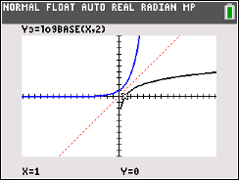  Tech Tips:  - This activity includes screen captures taken from the TI-84 Plus CE. It is also appropriate for use with the rest of the TI-84 Plus family. Slight variations to these directions may be required if using other calculator models.  - Watch for additional Tech Tips throughout the activity for the specific technology you are using.  - Access free tutorials at http://education.ti.com/calculators/pd/US/Online-Learning/Tutorials  Lesson Files:  Student Activity  What_is_Log_84CE_Student.pdf  What_is_Log_84CE_Student.doc
You may have noticed the log button on the handheld. What does log mean? Right above the log button is an exponential key ${10}^{x}$. Why is the ${10}^{x}$ placed above the log button? You will investigate these questions in this activity. |  | 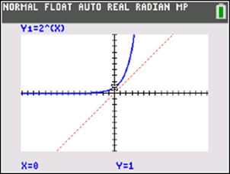

Go to the y = screen and follow the directions below.

1. In $Y_{1}$, graph the function $Y_{1}= 2^{x}.$
a. What are the domain and range of this function in $Y_{1}?$

Answer: The domain is $(-∞, ∞)$ and the range is $(0, ∞)$.

b. Recall that $f\left(x\right)= 2^{x}$ is a one-to-one function, so it has an inverse reflected over the line y = x. Graph this line into $Y_{2}$. What are the domain and range of f^{–1}(x)?

Answer: The domain is $(0, ∞)$ and the range is $(-∞, ∞)$.
Teacher Tip: This may be a good time to discuss words like invertible. A function is invertible if each output of f is mapped from a unique input value. A function is invertible if it is a one-to-one function.
c. Press graph, then trace. The coordinates you see at the bottom of the screen is a point on the function $f\left(x\right)= 2^{x}$. Move the cursor left and right using the arrows, on the axis below, sketch what you think the reflection over the line $y=x$ would look like. Write a corresponding equation for what you think the function is.

Answer: $x= 2^{y}$
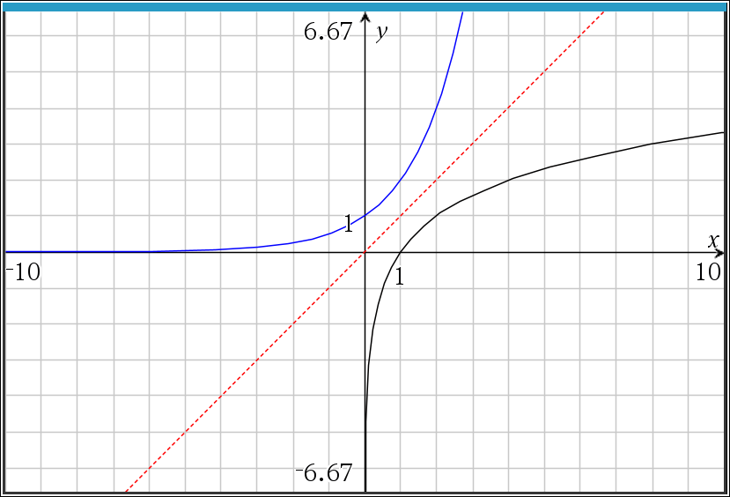
d. The equation x = 2^{y} cannot be written as a function of y in terms of x without new notation. The inverse of f(x) is actually $f^{-1}\left(x\right)= \log_{2}{x}$. In general, log_{b} x = y is equivalent to b^{y} = x for x > 0, b > 0 and b ≠ 1. Why do you think x and b must be greater than 0? Why can b not be equal to 1?
Answer: x must be greater than 0 because the range of f(x) = b^{x} is $(0, ∞)$ and thus the domain of f^{–1}(x) = log_{b}(x) must be $(0, ∞)$. b must be greater than 0 because negative values for b will result in negative values for x, and x has to be greater than 0. b cannot be equal to 1 because when b = 1, the function is linear, not exponential.
e. Enter the following function into $Y_{3}$ and press graph: $Y_{3}= \log_{2}{x}$. On the graph screen, while using trace, use the left/right arrows to trace a function, use the up/down arrows to toggle between functions. While on the exponential function, press the number 1 then enter. This point has coordinates of (1, 2). The point (1, 2) on f(x) = 2^{x} indicates that 2¹ = 2. Move the cursor to the logarithmic function and press 2 then enter. This point has the coordinates. The point (2, 1) on indicates that log₂ 2 = 1. Use this relationship between exponential expressions and logarithmic expressions to complete the following table. (Use the trace function as necessary.)

P | P' | Exponential Expression | Logarithmic Expression
(1, 2) | (2, 1) | 2¹ = 2
(2, 4) | (4, 2) | $$2^{2}=4$$ | $$\log_{2}{4=2}$$
(3, 8) | (8, 3) | $$2^{3}=8$$ | $$\log_{2}{8=3}$$
(0, 1) | (1, 0) | 2⁰ = 1 | $$\log_{2}{1=0}$$
$$\left(-1,\frac{1}{2}\right)$$ | $$\left(\frac{1}{2}, -1\right)$$ |  | $$\log_{2}{\frac{1}{2}=-1}$$
 | $$\left(\frac{1}{4}, -2\right)$$ | $$2^{-2}=\frac{1}{4}$$ | $$\log_{2}{\frac{1}{4}=-2}$$
$$\left(-3,\frac{1}{8}\right)$$ | $$\left(\frac{1}{8}, -3\right)$$ | $$2^{-3}=\frac{1}{8}$$

Teacher Tip: Students may need to be reminded that $2^{-n}= \frac{1}{2^{n}}$ and thus $\log_{2}{\frac{1}{2^{n}}= -n}$.

2. You have discussed the idea of reflecting the exponential function over the line $y=x$. The result of
this reflection is the logarithmic function. Now we will discuss any tabular relationships that are formed
between an exponential function and a logarithmic function.

Using the first and second columns from the table above, fill in the following tables.

$$x$$ $$f\left(x\right)= 2^{x}$$  -3 $$1/8$$  -2 $$1/4$$  -1 $$1/2$$  0 1  1 2  2 4  3 8 | $$x$$ $$f^{-1}\left(x\right)= \log_{2}{x}$$  $$1/8$$ -3  $$1/4$$ -2  $$1/2$$ -1  1 0  2 1  4 2  8 3

- Briefly explain your process of filling in the tables on the previous page.
Possible Answer: From the discussion earlier, the domain of function is equal to the range of the inverse of that function and the range of the function is equal to the domain of the inverse.

- With a classmate, discuss and describe the patterns you see in each individual column.
Possible Answer: Each input value of the function, which are also the output values of function’s inverse, increase by one of the previous value. Each subsequent output value of the function, which are also the input values of the function’s inverse, double the previous value.

- Write down a rule for each table that you can use to classify the function as either exponential or logarithmic.

Possible Answer: If the input values increase/decrease at a constant rate (increase/decrease over equal intervals), and the output values are proportional (each successive output is the result of repeated multiplication), then the function is exponential. If the input values are proportional (each successive output is the result of repeated multiplication), and the output values increase/decrease at a constant rate (increase/decrease over equal intervals), then the function is logarithmic.
3. Solve the logarithmic equation log₂ 32 = y using the patterns from questions 1 and 2. How does the exponential equation verify your result?
Answer: $n=5$ since $2^{5}=32$
4. Solve the equation using the patterns from questions 1 and 2. How does the exponential equation verify your result?

Answer: $n=-4$ since $4^{-4}=\frac{1}{256}$

5. Maya solved the logarithmic equation. She says the answer is 4 since 4 × 4 = 16. Is her answer correct? Why or why not?

Answer: Maya is not correct. The logarithmic equation $\log_{4}{16}=y$ is equivalent to the exponential equation $4^{y}=16$. Although $4 ∙4=16$, the solution to the equation is an exponent and $4^{4} ≠16$. The correct solution is $y=2$. Therefore, $\log_{4}{16}=2$.

6. Alex says that when solving a logarithmic equation in the form log_{b} a = y, he can rewrite it as bª = y. Is this a good strategy? Why or why not?

Answer: Alex is not correct. There is an inverse relationship between logarithms and
exponentials, but the correct exponential equation is $b^{y}=a$.

Wrap Up
Upon completion of the discussion, the teacher should ensure that students understand:
- For all positive real b, where $b ≠1$, $\log_{b}{x}=y$ if and only if $b^{y}=x$.

Assessment
Determine the value of the following logarithmic expressions and then justify each answer using an exponential expression.
- $\log_{3}{27}$
- $\log_{5}{1}$
- $\log_{7}{7}$

- $\log_{6}{\frac{1}{6}}$

- $\log_{4}{\frac{1}{64}}$

