Open the TI-Nspire document Arctic_Wars_Lynx_vs_Snowshoe_Hare.tns.  In this activity, you will investigate how different variables affect the dynamics of the lynx and snowshoe hare populations.  One of the most studied predator/prey relationships in nature is the lynx and snowshoe hare cycle. The lynx is a large cat about a meter in length, with an adult mass of 10–15 kg. |  |  |  | 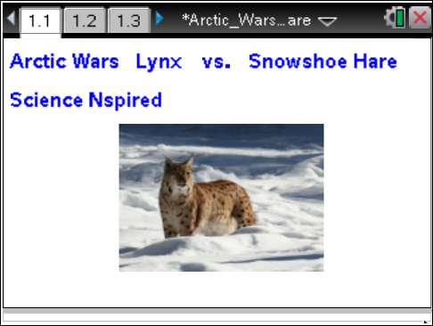
Lynx live a solitary life, which averages 10–15 years. Female lynx give birth to 2–3 kittens in the spring of each year, and the kittens remain with their mother for several months. The snowshoe hare is its favorite prey.
Snowshoe hares, which are very closely related to rabbits, reach lengths of about half a meter and a mass of 1–2 kg. During their 2–4 year lifespan, hares have 2 to 3 litters per year with 3–4 young in each litter. They have several arctic predators, including the lynx.
Move to pages 1.2–1.4. Answer Questions 1 and 2 here or in the .tns file. Answer Questions 3 and 4 here. |  |  |  | Press / ¢ and / ¡ to navigate through the lesson.
1. Analyze the graph on page 1.3. |  |  |  | 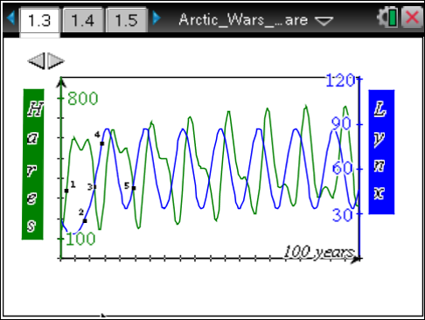
Q1. What is happening at Point 1 on the graph?
A. The predator population is rapidly increasing. | B. The prey population is rapidly increasing. |  | C. Both populations are rapidly increasing.
Q2. What is happening at Point 2 on the graph?
A. The prey population is rapidly decreasing. | B. The predator population is gradually increasing. |  | C. The prey population is staying the same.
Q3. Describe what is happening at Point 3 on the graph.

Q4. Analyze the rest of the graph. What overall pattern does the graph indicate?

Move to page 1.5. Answer Question 5 here or in the .tns file. Answer Questions 6–8 here.
2. Return to page 1.3 and click the ¢ icon in the top left of the screen. Analyze the graph for the new situation.
Q5. What could have caused the hare population to behave as it did in the new situation?
A. abundance of food for the hares  B. disease that affected the hares |  | C. excessive predation by the lynx  D. excessive hunting of the lynx
Q6. For each of the answer choices that you did not select in Question 5, explain why it is incorrect.

Q7. On the graph, draw a line that shows the predicted population of the lynx.

Q8. Explain your rationale for the predator graph you drew in Question 7.

Move to pages 2.1 and 2.2. Answer Question 9 here or in the .tns file.  Q9. Follow the directions on page 2.1 and draw the lynx graph below. |  |  |  | 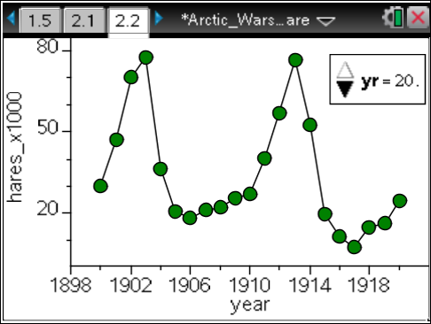
Move to page 2.3. Answer Question 10 on the activity sheet.
3. On page 2.2, add the lynx data by pressing Menu > Plot Properties > Add Y Variable.
Q10. How did your prediction match the actual data? Explain.

