Open the TI-Nspire document Products_of_Linear_  Functions.tns.  You already know that if you start with a quadratic function, you can sometimes factor it into the product of two linear functions. In this activity, you will start with linear functions and manipulate them to make their product into a certain type of quadratic. You will also have an opportunity to investigate the impact of three linear functions on their product. | 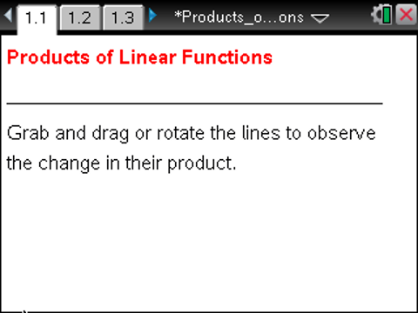

Move to page 1.3. | Press / ¢ and / ¡ to navigate through the lesson.
1. The graphs of linear functions f1 and f2 are plotted on Page 1.3. Their product, f3, is also plotted here. As you drag or rotate the linear functions, f3 changes dynamically.
a. Before you move f1 and f2, predict what they will need to look like to create a product function f3 that crosses the x-axis at -3 and 2. Explain why you predicted this.

b. Move f1 and f2 to test your prediction. Were you correct? If not, what mistake did you make?

2. a. Predict what f1 and f2 should look like in order for the graph of their product to be an upward opening parabola. Explain your reasoning.

b. Move f1 and f2 to test your prediction. Were you correct? If not, why do you think your prediction didn’t work?

c. Are there any other possible arrangements of f1 and f2 that would result in the graph of their product being an upward opening parabola? Explain your reasoning.

3. a. Predict what f1 and f2 should look like in order for the graph of their product to be a parabola that intersects the x-axis in only one place. Explain your reasoning.

b. Move f1 and f2 to test your prediction. Were you correct? If not, why do you think your prediction didn’t work?

c. Are there any other possible arrangements of f1 and f2 that would result in the graph of their product being a parabola that intersects the x-axis in only one place? Explain your reasoning.

4. a. Predict what f1 and f2 should look like in order for the graph of their product to be a parabola that never intersects the x-axis. Explain your reasoning.

b. Move f1 and f2 to test your prediction. Were you correct? If not, why do you think your prediction didn’t work?

c. What do you know about the roots of a quadratic function that never crosses the x-axis? How does this connect to your prediction and your test of your prediction?

5. Is there any way for the graph of the product of f1 and f2 to be something other than a parabola? Explain your reasoning.

6. a. Predict what f1 and f2 should look like in order for the graph of their product to be a very wide parabola.

b. Move f1 and f2 to test your prediction. Were you correct? If not, why do you think your prediction didn’t work?

7. Write a paragraph summarizing the different arrangements of f1 and f2, and the effects of these arrangements on the graphs of their products.

Move to page 1.5.

8. Make two predictions about the impact of three linear factors on the appearance of the graph of their product. Record your predictions, and explain your thinking.

9. Test your predictions by moving f1, f2, and f4. Were your predictions correct? If not, why do you think your prediction didn’t work.

10. Explore the results of moving f1, f2, and f4. Then write a paragraph summarizing the different arrangements of f1, f2, and f4, and the effects of these arrangements on the graphs of their products.

This page intentionally left blank.

