Open the TI-Nspire™ document Nailing_Density.tns.  In this activity, you will determine the mass and volume of five nails. The total mass and total volume as the number of nails is increased will be graphed. By analyzing the graph, you will discover a physical property of the nails. | 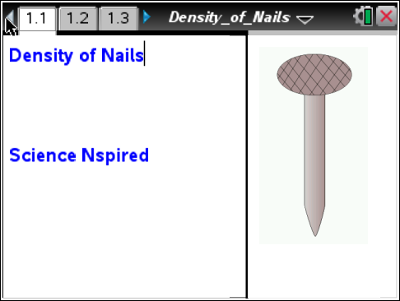

Mass can be measured using a balance.
Volume can be calculated from the dimensions of a regularly shaped object. For example, the volume of this rectangular prism can be calculated by multiplying its length, width, and height measurements.

length
height
width

For irregularly shaped solids, water displacement can be used to determine the volume.

The volume of water is measured before and after the irregular solid is added to the measuring device. The difference in volume is the volume of the object.

Another property of matter is density. Density is defined as the mass per unit volume of a substance, or the amount of matter for 1 unit of volume. The formula for density is mass divided by volume, or where D is density, m is mass, and V is volume. If the mass and the volume are known, the density can be calculated using the formula.

Mass is often measured in grams, or g, and volume is often measured in milliliters, mL, or centimeters cubed, cm³. So, the units of density, mass divided by volume, are often g/mL or g/cm³ for liquids and solids. For gases, the density is often expressed in g/L since gases are much less dense than solids or liquids. Density is an intensive property that is NOT dependent on the amount of the substance that is measured.

Move to pages 1.2 – 1.5. Answer questions 1-4 here and/or in the .tns file.
Q1. The volume of an irregular object is most easily determined by____________.

A. using the formula V = LWH
B. using the formula
C. using the formula
D. using water displacement

Q2. Which do you think is heavier?

A. a pound of feathers
B. a pound of lead
C. neither

Q3. Explain your answer to the previous question.

Q4. Density is defined as_________________________.

A. volume per unit mass
B. mass per unit volume
C. the heaviness of an object

In this activity you will be calculating the density of the material used to build nails. You will do this by gathering data for five such nails.

First you will measure the volume of a container of water, without anything in the water.
Next, you will measure the mass of the first nail then calculate its volume through displacement.
Then you will measure the mass of the next nail and measure the displacement for the combined masses.
Continue doing this until you have measurements for all five nails. Then measure the cumulative data and analyze the resulting graph.

Move to pages 2.1 – 2.2. Answer questions 5 and 6 here and/or in the .tns file.  Nails will be provided by your teacher.  1. Add enough water to the graduated cylinder to cover the tallest nail (do NOT add the nails to the water yet).  2. Read the volume of the water to the nearest 0.1 mL. Record it in the spreadsheet on Page 2.1 under t_vol for 0 nails. | 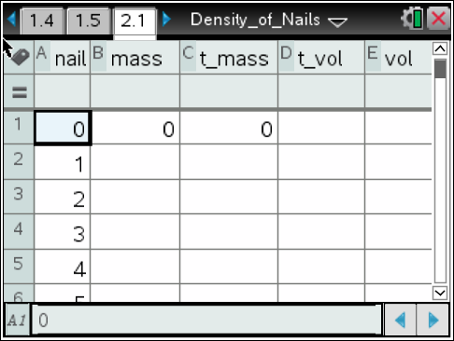
3. Measure the mass of the first nail to the nearest 0.01 g. Record it under mass for 1 nail.
4. Gently drop one nail, head first, into the cylinder. Record the new volume under t_vol for 1 nail.
5. Repeat this procedure for the four remaining nails, accumulating all of the nails in the graduated cylinder.
6. In column C, calculate the total mass (t_mass) of the nails. Using cell notation, add each mass to the previous total mass. For example, in cell C2 type =C1+B2. Repeat for the four remaining nails.
7. In column E, calculate the volume (vol) of each nail. Using cell notation, subtract the previous water volume from the current water volume. For example, in cell E2 type =D2–D1. Repeat for the remaining four nails.
8. In column F, calculate the density of the nails. Divide the mass of the nail(s) by its volume. Type = mass/vol in the formula bar under density.

Q5. Record your data and calculations from page 2.1 in the table below.

Column A | Column B | Column C | Column D | Column E | Column F
Number of nails | Mass of Nail (g) | Total mass (g) | Total Volume (mL) | Volume of Each Nail (mL) | Density (g/mL)
0 | 0 | 0
1
2
3
4
5

Q6. Looking at the column for density, what do you notice?

Move to page 2.3.  9. Plot the total mass vs. number of nails. On the horizontal axis, add the variable nail and on the vertical axis, add the variable t_mass. | 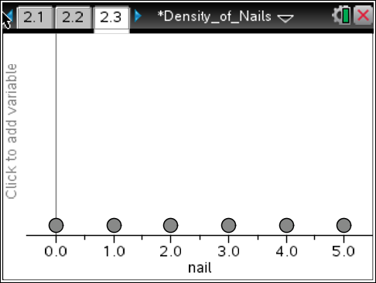
Move to pages 3.1 – 3.9. Answer questions 7-15 here and/or in the .tns file.

Q7. Plot the total mass vs. number of nails. What do you notice about the graph of the volume of the nails as the number of nails increases?

10. Plot the total volume vs. number of nails. Change the variable on the vertical axis to t_vol.

Q8. What do you notice about the graph of the mass of the nails as the number of nails increases?

11. Plot the density vs. number of nails. Change the variable on the vertical axis to density.

Q9. What do you notice about the graph of the density of the nails as the number of nails increases?

12. last, plot all three graphs, volume, mass, and density by placing the total volume (t_vol) and total mass (t_mass) back on the vertical axis of the graph.

Q10. From looking at the data in the table and the graph, what statement could you make about the density of nails?

Q11. If you added another nail to the cylinder of water, which variable(s) would you expect to change and which variable(s) would you expect to stay the same?

Q12. If you cut a nail in half and added just one of the halves to the cylinder of water which variable(s) would you expect to change and which variable(s) would you expect to stay the same?

Q13. Suppose you repeated this experiment using marbles, each made of the same material. As you added each marble to the water, how would you expect the density to change?

A. The density would increase.
B. The density would stay the same.
C. The density would decrease.

Q14. Why are the densities you calculated not exactly the same for each nail?

A. The nails have different masses.
B. Due to experimental errors in the mass and volume of the nails.
C. Due to the variation in size and shape of the nails.
C. The nails are made of different materials.

Q15. Summarize what you have learned about density from this experiment.

