Activity Overview
This activity uses mathematical properties to explore equivalent expressions. The lesson uses the Calculator application to verify equivalence with fractions, decimals, factors, exponents, and order of operations.

Materials
- Technology needed (TI-Nspire™ handheld, computer software)

Part 1—Using Notes

Step 1: Preparing the title page and naming the document  1. Press c > New Document > Add Notes.  2. Type: Checking Equivalence.  3. Press ·.  NOTE: To obtain capital letters, use the g key.  4. Press ~ > File > Save As….  5. Type Checking_Equivalence ·.  NOTE: To obtain the underscore, _, press / _. | 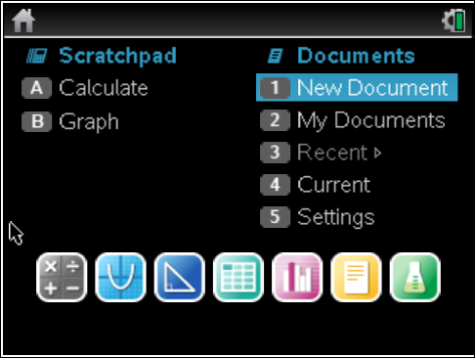
Step 2: Decimals and Fractions
1. To insert a new page, press /~ > Add Calculator.
2. Enter the decimal value 0.725 onto the calculator page and press ·.
The output is the same decimal that you entered.
3. To recall your entry and copy it to the entry line, press £ £ ·.
4. To convert to a fraction, select Menu > Number > Approximate to Fraction, and press · to see the result.
Step 3: Checking for Equivalence
To copy the decimal and set it equal to the fraction to confirm their equivalence:
To recall 0.725, press £ £ £ £ ·.
Press =, then press £ ·. Finally press · again to see if the equation is true or false.

Step 4: Other Fractions That Are Equivalent?

- Another fraction that is equivalent to is .
- Type = by pressing / p > 29 > e > 40
> e = / p > 58 > e > 80 > · to see it is true.
3. What is one way to obtain from ?
4. Find two other fractions that are equivalent to 0.725 and test the truth value.

Answer these questions.
Insert a new calculator page: Press /~ > Add Calculator.

- Use the process from above to convert the following to fractions. Find two other equivalent fractions and test the truth value in the calculator application.
0.875 | 2.8 | (0.56 · 8.456)

- Perform the following operations with fractions, and then find both a decimal and a fraction that are equivalent to your result.

- Mike tried to find an expression equivalent to .  Correct his work so that the equivalence is true. | 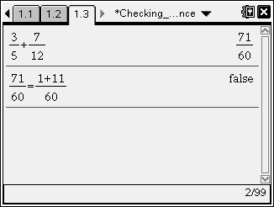

Prior to starting Part 2: Insert a new calculator page: Press press /~ > Add Calculator.

Part 2—Prime Factorization

Use the Factor Menu to find the prime factorization of a number.

- Select Menu > Number > Factor (or you can type the word factor).
- Find the factors of 10050 by entering factor(10050).
This command gives the prime factorization of the number.
- Find an expression that is equivalent to the prime factorization. Then check it.

Answer this question.

- Complete the table below. Use the Calculator application to check your equivalent expressions.

Value | 360 | 10890 | 36549
Prime Factorization
Equivalent Expression

Part 3—Exponents
Answer these questions.
- Predict the value of each of the following. Create an equivalent expression, and test it.

a. ________ | b. ________ | c. ________

Explain your results:

- Simplify each of the following without using the calculator application. Leave the result in exponential form. Check each of the simplifications and rewrite as another true statement.
a. | b. | c. | d.
________ | ________ | ________ | ________

Part 4—Order of Operations
- Answer this question.
- Are the following equal? If not, change the right-hand side of the equation to create true statements.

a. 4+3(6) = 7(6) | b. 24÷ 6 2 = 24 ÷ 12 | c. – 3 36 – (–3) 54 = –3 (36 + 54)
____________ | _________ ___ | ________________________

