Problem 1 – A Flat Triangular Stack
In this problem, you are stacking bricks according to the pattern shown at the right. Each row contains one more brick than the row above it.  How many bricks will be in the stack when it is 50 rows high? |  |  |  | 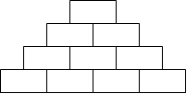
You can solve the problem easily by creating a polynomial model to describe the number of bricks in the stack, f(x), given a number of rows x.  Look for a pattern using a small table. Press … Í and enter the numbers in L1 as shown.  L1 = the number of rows in the stack  L2 = the number of bricks in the stack |  |  |  | 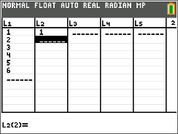
Complete list L2.  Which polynomial model should you use—linear, quadratic, cubic, or quartic?  To decide, calculate the successive differences.  Enter the first differences in L3, the second differences in L4, and the third differences in L5. Record your lists at the right.
  L1 | L2 | L3 | L4 | L5
  rows | bricks | 1st Diff | 2nd Diff | 3rd Diff
  1 | 1
  2
  3
  4
  5
  6
If the first differences are constant or close to constant, a first degree (linear) model is a good fit for the data. If the second differences are constant or close to constant, a second degree (quadratic) model is a good choice, and so on.

1. Which set of differences is constant?

2. What degree polynomial is the best fit for this data?
Return to the HOME screen. Use the regression command to create the model for the data.  Press …, arrow to the Calc menu, and choose appropriate Reg command. Enter L1, L2, Y1 after the command.  3. Record the equation of the model here: |  |  | 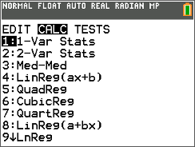
Check your model graphically by plotting the points with the model. Press y ,, select Plot1, and match the settings shown at the right.  Press q and select ZoomStat.  If the model is correct, its graph will pass through all the data points. |  |  | 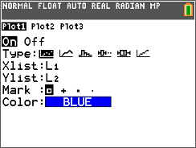
Now check your model by calculating the coefficient of determination, R². The closer the R² value is to 1, the better the model fits the data.  Press z, select ON next to STATDIAGNOSTICS, and press y 5.  Press Í to run the regression again. |  |  | 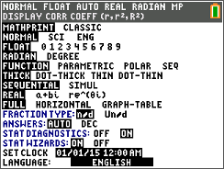
4. What is the R² value for your model? What does that mean?

5. If your model is correct, use it to calculate the number of bricks in a stack 50 rows high. (Remember that Y1(X) is the number of bricks and X is the number of rows.)

6. Discuss the shortcomings of the model for this situation. For what numbers of rows is it valid? For what numbers of rows does it not make sense?

7. Write a domain for this model.

Problem 2 – A Pyramidal Stack
In this problem, you are stacking bricks in pyramids.
The diagram below shows the stacks from above. | To see the pattern more clearly, the layers of the pyramids are shown separately below.
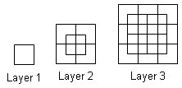 | 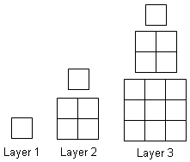
Use the method from Problem 1 to find the number of bricks in a pyramid with 50 layers. Calculate the successive differences and record the values in the table.  8. Choose and perform and polynomial regression. Record it here.
  L1 | L2 | L3 | L4 | L5
  layers | bricks | 1st Diff | 2nd Diff | 3rd Diff
  1 | 1
  2
  3
  4 |  |  |  | --
  5 |  |  | -- | --
  6 |  | -- | -- | --
9. Look at the R² value for the regression. What is it? What does this mean?

10. Check your model. Graph total bricks vs. number of layers as a scatter plot together with your model. Does the model go through all the points?

11. If your model is correct, use it to calculate the number of bricks in a pyramid 50 layers high.

12. Discuss the shortcomings of your model for this situation. For what numbers of layers is it valid? For what numbers of layers does it not make sense?

13. Write a domain for this model.

