Activity Overview
In this activity, you will create and use sliders to investigate transformations of quadratic functions in a Graphs application.

Materials
- Technology needed (TI-Nspire™ handheld, computer software)

Step 1: Preparing the document  - Open a new document by clicking c > New > Add Notes.  - Type: Transformations Quadratics. Format as desired.  - Add other words as needed (See image to the right.)  Note: To obtain capital letters, press the g key, then the letter. | 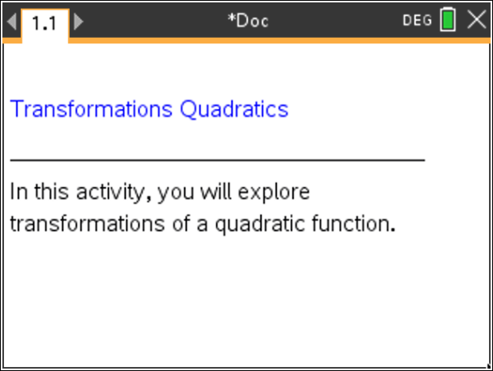
- Press ~ > File > Save As ….  Type: Transformations_Quadratics  Tab to ¾ and press ·.  Note: To obtain the underscore, press / _. Save the document throughout the creating. | 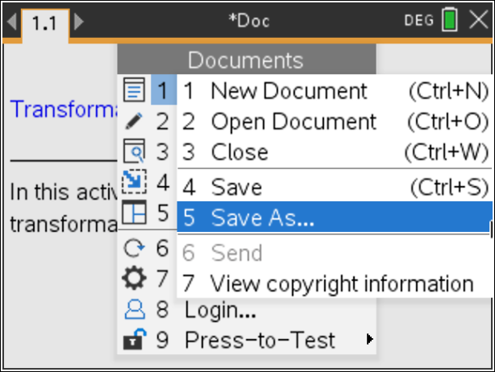
- To add a new page, press / ~ > Add Graphs.  - Press Menu > Settings. Press e to move from one field to the next and press x to uncheck all the boxes except Show axis end values. Tab to OK and press x or ·. | 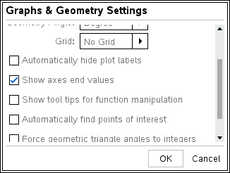
Step 2: Type a function into f1(x)  1. Press e until the cursor is in the f1(x) = entry line at the top of the screen.  2. To graph the equation y = a · x², type A r X q ·. | 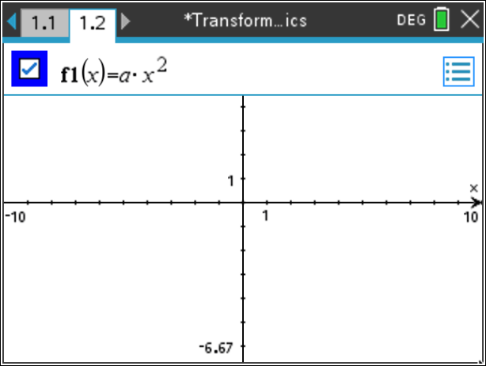
Step 3: Sliders  A dialogue window will appear prompting you to determine the parameters for which you want a slider to be created. Press · or click on OK.  Note: Do not click on the screen or otherwise de-select the slider window. | 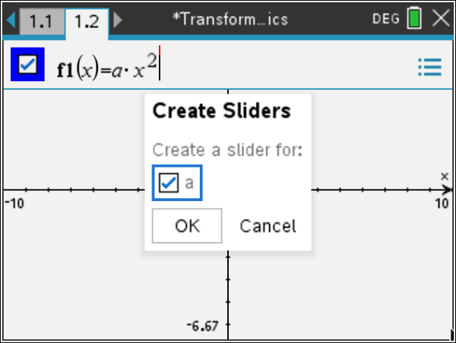
Step 4: Open the slider settings menu  With the slider for a selected, click press / b, and choose Settings….  The slider settings shown at the right are displayed. If desired, change the settings.  - Press e to move to the next field.  - For those settings that are not visible in the screen to the right, keep the default values.  - Press · or click on OK to close the slider settings. | 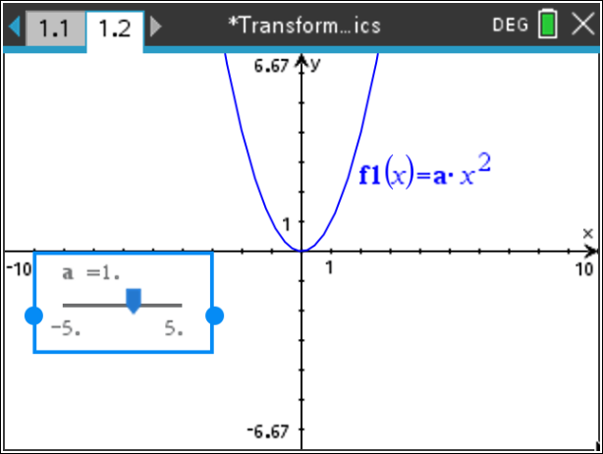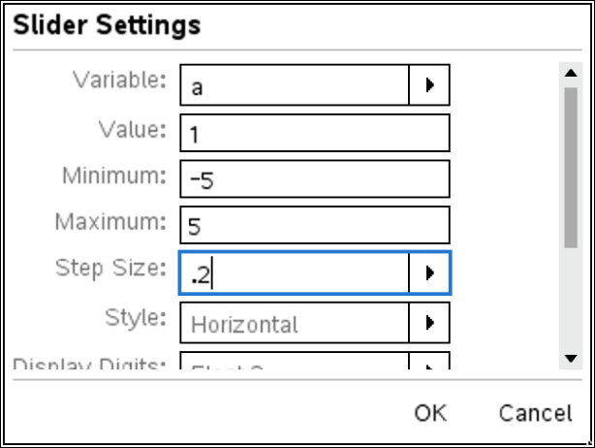
Step 5: Move the Slider  Use the Touchpad to move the slider for parameter a to the upper-left corner of the screen and then press x or ·. | 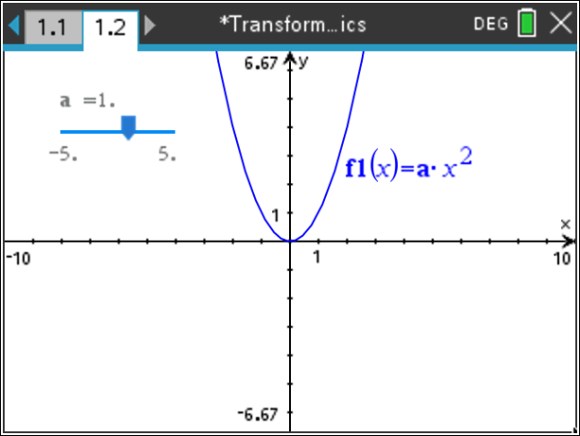
Step 6: Investigate the Math  To change the values of a parameter, use the Touchpad to move the cursor over the slider controller. When an “open hand” (÷) appears, press / x to grab the slider controller.  Drag the slider controller using the Touchpad to change the values of the parameters. Observe the effects on the graph.  - What math concepts can be explored with this activity?  - What questions could be asked to highlight the math? |  | 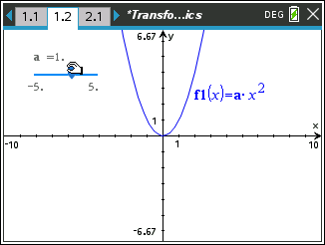
Step 7: More Slider Settings  A slider can be horizontal, vertical, or minimized. To minimize the slider, move the cursor over the slider, click to select, and press / b to display the context menu. Select Minimize.  To change the value of the variable, click the right or left arrow. Alternately, press ¡ or ¢ on the Touchpad. |  | 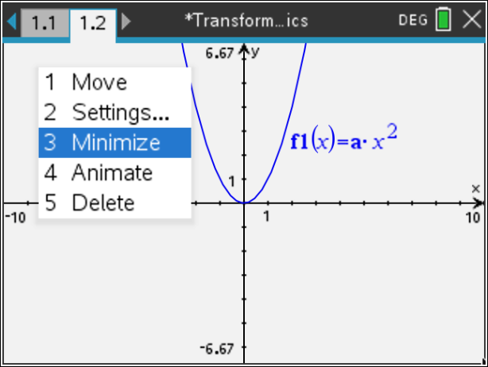
Step 8: Add a new problem  - To add a new problem, press ~ > Insert > Problem.  - Add a new Graphs page: press Menu > Add Graphs. Using previous steps 2 through 7, insert a slider to control the variable c in the equation:  - Have the slider go from –5 to 5 in steps of 1 with an initial value of 0. | 