Open the TI-Nspire™ document Exploring_Domain_and_Range.tns.  What can a graph tell you about domain and range? In this activity, you will explore visual representations of relations to determine their domains and ranges. | 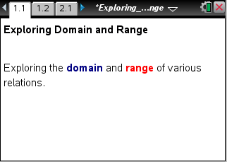

Move to page 1.2.
- Grab and move point P to each point on the scatter plot. As you move from point to point, the coordinates of each point will be displayed in the top left corner. Record the coordinates in the table.
 | List the domain: { }  List the range: { }
  Domain | Range
  x | y
Move to page 2.2.

- Grab and move point P back and forth along the entire line segment.
    - What does the highlighted portion along the x-axis represent?

    - What does the highlighted portion along the y-axis represent?

    - The set of all possible x-values for a relation is called the domain of the relation. Describe the domain of the function in the graph. Explain your reasoning.
Domain: _____ ≤ x ≤ ______. Translate the inequality into words.

    - The set of all possible y-values for a function is called the range of that function. Describe the range of the function in the graph. Explain your reasoning.
Range: _____ ≤ y ≤ ______. Translate the inequality into words.

    - If the endpoints of the line segment were open circles, how would the domain and the range change?

Move to page 3.2.

- Grab point P and move it along the graph.
    - Identify the domain using an inequality and using words.

    - Identify the range using an inequality and using words.

Move to page 4.2.

- Grab point P and move it along the graph.
    - Identify the domain using an inequality and using words.

    - Identify the range using an inequality and using words.

Move to page 5.2.

- Grab and move the endpoints of the line segment to satisfy each of the following conditions.
    - The open endpoint is (–3, –5) and the closed endpoint is (5, 4). Identify the domain and range using inequalities and using words.

    - The domain is between –2 and 1, including 1, and the range is between –6 and 5, including –6. Write the domain and range as inequalities. Identify the endpoints of the line segment, and indicate which endpoint is open.

    - The domain is –3 < x ≤ 6 and the range is y = 3. Identify the endpoints of the line segment, and indicate which endpoint is open.

    - The domain is x = 6 and the range is –5 < y ≤ 3. Identify the endpoints of the line segment, and indicate which endpoint is open.

