Open the TI-Nspire document Real_Graphs.tns.  In this investigation, we will interpret the rate of change and initial value of functions in light of the situation it models and its graph.  We will be exploring the plots of several sets of data that have been already been collected. We will be looking for data pairs that show a linear relationship and that reveal some contextual pattern. That is, if the plot of two data sets seems to form a linear pattern, does the relationship seem to make sense in the context of the data? | 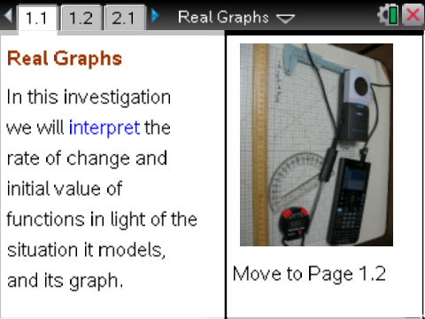

When looking at a plot, determine 1) if the plot represents a function; 2) if the function is linear; and, 3) if both of these are true, what is the function that models the pattern? When a linear function is obtained of the form y = mx + b, examine the slope and y-intercept both numerically and contextually. That is, explore what the values of m and b are and what they mean in the real world.
To truly “know” a situation, explore it graphically (with a graph plot), numerically (with a table of data), and analytically (with an equation or function). In addition to these, provide a context for the situation and the ability to communicate about all of these items.

Move to page 1.2.

The following sets of data exist in this Problem.

Set Name | Meaning
bounce_height | Height of the bouncing ball above the ground.
c_temp | Current temperature in degrees Celsius.
Distance | Distance from the start.
Dollar | Number of dollar Bills.
f_temp | Current temperature in degrees Fahrenheit.
Humidity | The current Relative Humidity, in percentages.
k_temp | Current temperature in Kelvin, a unit of measurement for temperature.
Nickel | Number of nickels.
Price | The amount charged for an item.
Profit | The amount of money made.
Second | The number of seconds that have passed.
Step | Steps taken in the walk.
Temp | The current temperature.

1. To start looking at the plots of these data sets, select the x-axis and select the Independent variable; then select the y-axis, and choose a corresponding Dependent variable to produce a plot. Create a plot for one data set pair and answer the following:
a. What was the choice for the Independent variable?

b. What was the choice for the Dependent variable?

c. Is there a pattern? Explain:

2. Look for functions that are linear. Repeat the process in step 1, and document your work. Record the following information: x-variable, y-variable, the plot, whether there is a pattern or not, whether it is a function or not, and whether the function is linear or not.

3. If a relationship between two sets of data seems to have a pattern, determine a function that best models the pattern found. Are the two variables related?
- It might be possible to see if the relationship makes sense before the function is named.
- Looking at individual data points on the plot might give some insight also. To do this, hover the cursor over a point.
Note: Also look at the full lists of data by using a Calculator Page by pressing h · within the page.

4. It is also possible to look at these lists on a Lists & Spreadsheet page. Add a new Lists & Spreadsheet page, and move the cursor to the top of the column. Type the name of a data list, OR press h to choose the name from a listing of all data lists.
Tech Tip: To add a Calculator page, select 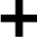 at the top of the screen. Then select 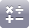 Calculator. On the keyboard, press 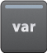 , select the data list you wish to view from the pop-up menu, then press ENTER. To add a Lists & Spreadsheet page, select at the top of the screen. Then select  Lists & Spreadsheet. Press the top of the spreadsheet to bring up the keyboard. Then select the top of a column, press . From the pop-up menu, select the data list you wish to view. To add or modify data in a spreadsheet cell, double-tap the cell.

As we try to make sense of any relationship we might see, we want to determine which data pairs seem to be connected in a cause and effect manner. In other words, is there a relationship between the data for price and the data for humidity? How would someone explain that a price of $1,000 somehow determines a Relative Humidity of 49%?

5. Consider this as different plots are analyzed:
a. Initially, choose only pairs to plot that might be related. If something appears to be linear, can the pattern be defended?

b. Report the data pairs that appear to produce functions that are linear, and give the functions in the y = mx + b form.

6. Looking at the slope of the functions of note in the previous problem, report the value, units, and meaning of these slopes.
a. Value:

b. Units:

c. Meaning:

7. Repeat the process from the previous question for the y-intercepts. Don’t forget to give the units and meaning in the context of the ordered pairs.
a. Value:

b. Units:

c. Meaning:

Move to page 2.1.

Here are some more data sets to examine. Again, we are looking at patterns.

Set Name | Meaning
Area | The surface area of a wire.
Calorie | The number of calories in food.
Degree | The angle measure in degree units.
Fin | The number of 5 dollar bills.
Heat | The temperature at some point.
Hour | The hour in a day.
Mass | The amount of mass in an object.
Month | The number of months from January some year.
Quarter | The number of quarters you have.
Radian | The angle measure in radians.
relative_humid | The Relative Humidity in percent.
Sunlight | The amount of sunlight landing on a surface.
Temperature | The current temperature.
8. Make a plot for one data set pair, and answer the following:
a. Choice for the Independent variable?

b. Choice for the Dependent variable?

c. Pattern? Explain:

9. Look for functions that are linear. Repeat the process in step 8, and document your work. Record the following information: x-variable, y-variable, the plot, whether there is a pattern or not, whether it is a function or not, and whether the function is linear or not.

10. Report the data pairs that appear to produce functions that are linear, and give the functions in the
y = mx + b form.

11. Looking at the slope of the functions of note in the previous problem, report the value, units, and meaning of these slopes.
a. Value:

b. Units:

c. Meaning:

12. Repeat the process from the previous question for the y-intercepts. Don’t forget to give the units and meaning in the context of the ordered pairs.
a. Value:

b. Units:

c. Meaning:

