Open the TI-Nspire document Derivative_Function.tns.  If a function f is differentiable at x = a, then its graph will appear to become linear as you zoom in on the point (a, f(a)).  The derivative f′(a) is the slope of the tangent line to the graph of y = f(x) at the point (a, f(a)).  In this activity, you will define a new function, f′(x), for the derivative at every value of x. | 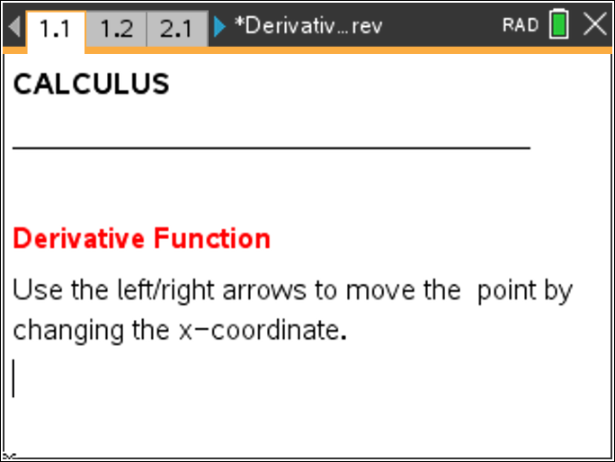

Move to page 1.2.

1. The graph shown on the left is y = f(x) = x² with one point (a, f(a)) boxed in. A magnified “zoomed-in” view of the box is shown on the right with the slope f′(a) of the tangent line to the graph at that point. In fact, the graph becomes indistinguishable from the tangent line when you zoom in close. Increase or decrease the value of a by using the up/down arrows.
a. What is f′(2)?

b. At what value(s) of a is the derivative f′(a) = –2?

c. Fill out the following table of values for a and f′(a).
a = | –2 | –1.3 | –0.5 | 0 | 0.7 | 1.5 | 2.1
f′(a) =

Move to page 2.1.
2. Grab the white point labeled x on the x-axis and move it to see the slope of the tangent line change as you move along the graph of y = f(x) = x².
a. Describe any pattern you see in the slopes of the tangent lines.

b. Describe the relationship between each value of x and the slope of the tangent line at (x, f(x)).

Move to page 3.1.
3. If you plot the value of the derivative f′(x) as the y-coordinate for each value x, the ordered pairs (x, f′(x)) trace out the graph of a new function y = f′(x), the derivative function. Use the up arrow for x in the top window to see the graph of the derivative traced out.
a. What can you say about the graph of y = f(x) = x² when f′(x) < 0?

b. What can you say about the graph of y = f(x) = x² when f′(x) > 0?

c. What can you say about the graph of y = f(x) = x² when f′(x) = 0?

d. What is the equation of the graph of f′(x)? What is a general rule that gives a relationship between x and f′(x)? Explain.

Move to page 4.1.
4. The graph shown in the left window is of y = f(x) = sin(x) with one point (a, f(a)) boxed in. Again, a magnified “zoomed-in” view of the box is shown on the right along with the slope f′(a) of the tangent line to the graph at that point. Increase/decrease the value of a using the up/down arrows.
a. What is f′(0)?

b. At what values of a (in this window) is the derivative f′(a) = 0?

c. Fill out the following table of values for a and f′(a).
a | –π |  |  | 0 |  |  |  | π
f′(a) =

Move to page 5.1.
5. Grab the white point labeled x on the x-axis and move it to see the slope of the tangent line change as you move along the graph of y = f(x) = sin(x).
a. What can you say about the slope of the tangent line when the graph of f(x) = sin(x) is decreasing?

b. What can you say about the slope of the tangent line when the graph of f(x) = sin(x) is increasing?

Move to page 6.1.
6. Use the up arrow for x in the top window to plot the graph of the derivative function f′(x).
a. What can you say about the graph of y = f(x) = sin(x) when f′(x) < 0?

b. What can you say about the graph of y = f(x) = sin(x) when f′(x) > 0?

c. What can you say about the graph of y = f(x) = sin(x) when f′(x) = 0?

d. Does the graph y = f′(x) look familiar? What is the equation of the graph of f′(x)? What is a general rule that gives a relationship between x and f′(x)? Explain.

Move to page 7.1.
7. Increase the value of a using the up/down arrows.
a. What is f′(0)?

b. For how many values of a (in this window) is the derivative f′(a) = 0?

Move to page 8.1.
8. Grab the white point labeled x on the x-axis and move it to see the slope of the tangent line change as you move along the graph of y = f(x).
a. For approximately what values of a (in this window) is the slope of the graph negative?

b. For approximately what values of a (in this window) is the slope of the graph positive?

Move to page 9.1.
9. Use the up arrow for x in the top window to plot the graph of the derivative function f′(x).
a. What can you say about the graph of y = f(x) when f′(x) < 0?

b. What can you say about the graph of y = f(x) when f′(x) > 0?

c. What can you say about the graph of y = f(x) when f′(x) = 0?

