Open the TI-Nspire document Definition_of_Functions.tns.  In this activity, you will learn the definitions of relationships and of functions. You will create relationships between sets and explore whether or not these relationships are functions. | 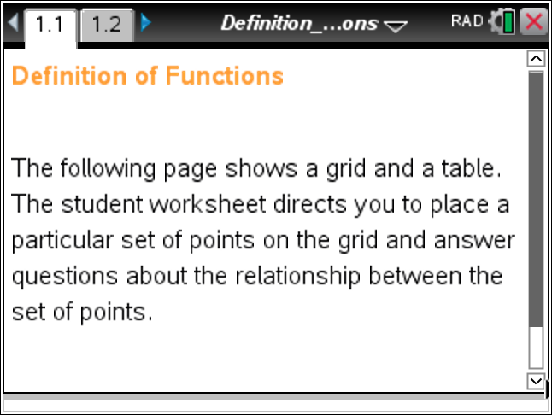

Move to page 1.2.
Tech Tip: To move point P to the graph, move the cursor to the point until you see the open hand ÷. Grab the point by pressing /x. The hand will close {. Then, you can move the point to any spot on the grid.

A relationship between sets A and B is a collection of ordered pairs in which the first number of the ordered pair is an input element and a member of set A and the second number of the ordered pair is an output element and a member of set B. The set of all inputs is called the domain, and the set of all outputs is called the range.
In this activity, sets A and B will both be equal to the set .
A function is defined as a relationship between two sets of numbers where each member of the domain is paired with only one member of the range.
1. A relationship R is defined as. On Page 1.2, plot the first ordered pair of this relationship by dragging a point onto the grid at the location for that point.
a. How do you know that you plotted the point correctly?

b. Describe what the arrow in the table represents.

2. Plot the remaining points of the relationship.
a. List the domain and range of this relationship.

b. Does this relationship meet the definition of a function? Why or why not?

3. Use the arrow for “function test” to determine if your answer to question 2b was correct. If it was correct, how do these representations help you solidify your understanding of the definition? If you were incorrect, how can these representations help you correct your misunderstandings?

4. On page 1.2, use the arrow for “reset”. Define a new relationship S as .
a. What is the domain and range of this relationship?

b. Is this relationship a function? Why or why not?

c. Plot these ordered pairs, and test whether or not it is a function. Do the graph, table, and test support your answer to 4b? Why or why not?

5. Select the arrow for reset. Define a new relationship T as.
a. What is the domain and range of this relationship?

b. Joey says that T is not a function because the number 1 shows up more than once in range. Is Joey correct? Why or why not?

6. It is your turn to define a new relationship.
a. Create a relationship between sets A and B that is a function. What is the domain and range of this relationship? Share it with a partner. Have them check that your relationship is a function and verify it using Page 1.2. Did you successfully create a relationship that is a function? If not, how could you fix it?

b. Create a relationship between sets A and B that is NOT a function. What is the domain and range of this relationship? Share it with a partner. Have them check that your relationship is not a function and verify it using Page 1.2. Did you successfully create a relationship that is not a function? If not, how could you fix it?

