Activity Overview:  In this activity, you will create a new document and add a Graphs application. You will then use the application to explore mathematical properties.  Materials  • Technology needed (TI-Nspire™ handheld, computer software) | 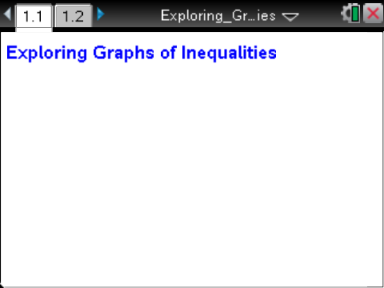

Preparing the Document  Step 1: Create a new document by pressing c> New Document > Add Notes.  Step 2: Type Exploring Graphs of Inequalities.  Note: To obtain capital letters, press g, then the letter.  Step 3: Press ~ > File > Save As …  Type Exploring_Graphs_of_Inequalities,  Tab to ¾ and press ·.  Note: To obtain the underscore, press / _.  Step 4: To add a new page, press / ~ > Add Graphs. | 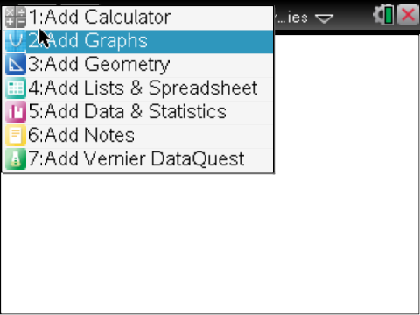
Step 5: Press b > Settings. Press e to move from one field to the next and press x to uncheck all the boxes, but keep the box that says Show axis end values. Tab to OK and press x or ·. | 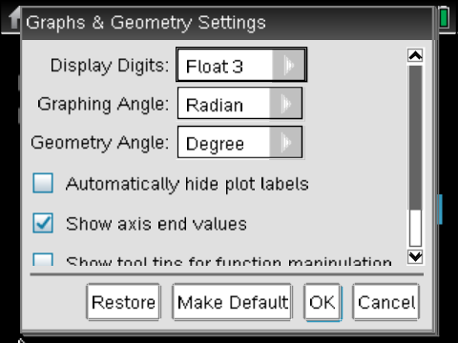
 | 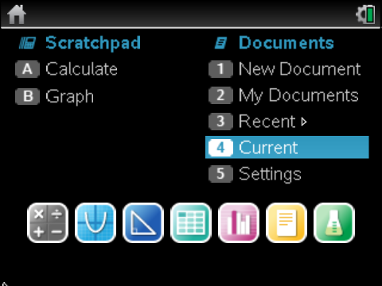
Enter the Inequality into f1(x) =.  Step 1: The cursor will be flashing in the f1(x) = entry line at the bottom of the screen.  Step 2: To erase the = sign, press .. A menu will pop up showing inequality options. Use the ¤ or £ to highlight the < sign. Press ·. The display shows y <.  Step 3: Enter 2x + 1. Press ·. | 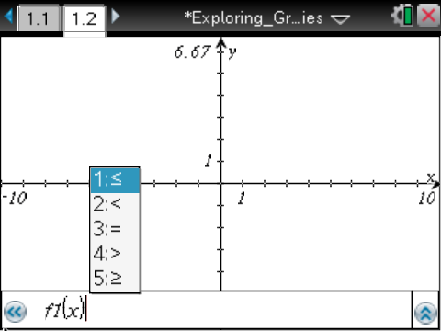  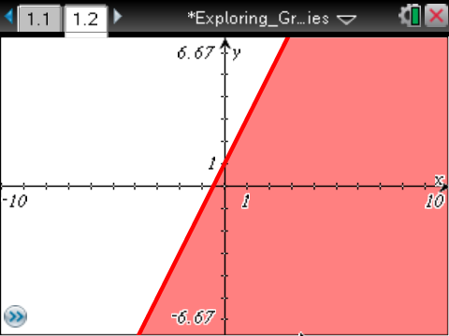
Show the Grid and Adjust the Window Settings  Step 1: Select b > View > Grid > Dot Grid.  Step 2: Select b > Window / Zoom > Window Settings. Type in the settings shown at the right. Note: use e to move between fields. Once you e to OK, press ·. This will create a “square” window. | 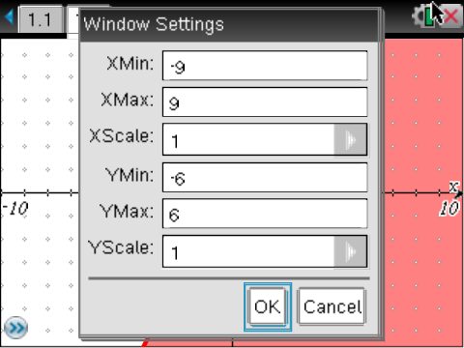
Place a Point on the Grid  Step 1: Select b > Points & Lines > Point On.  Step 2: Move the ø until grid is displayed, then press · twice. A point will appear at this location.  Step 3: Press d. | 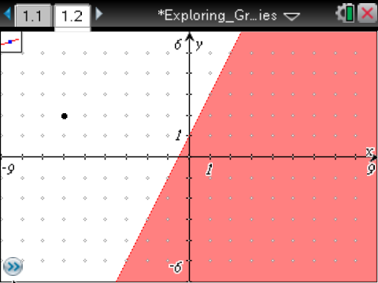
Display the Point’s Coordinates  Step 1: Select b > Actions > Coordinates and Equations.  Step 2: Move the ø until the word point is displayed. The coordinates of the point will be faintly displayed.  Step 3: Press · twice.  Step 4: Press d to close the Actions menu. | 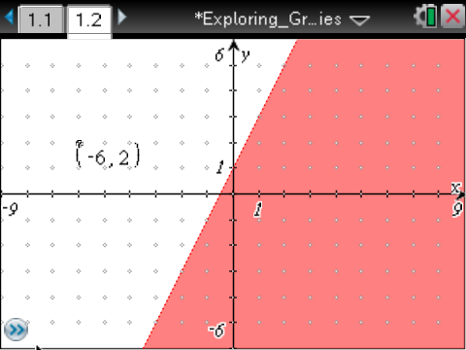
Move the Point  Step 1: Move the cursor until ÷ and point appears around the point on the grid.  Step 2: To grab that point, press / x .The ÷ will change to {.  Step 3: Use the Touchpad or Clickpad to move the point around the screen. Notice that the coordinates change as you move the point.  Step 4: Press d to stop moving the point. | 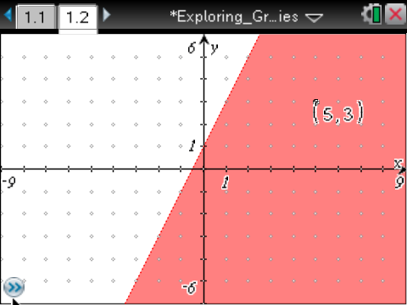
Save the Document
Step 1: Press / S.

Change the Inequality Sign (Optional)  Step 1: Show the entry line by pressing / G.  Step 2: Press £ to display the current relation.  Step 3: Press ¡ until the cursor is between < and 2  Step 4: Press . to erase the <. A menu will pop up showing inequality options.  Step 5: Press the ¤ until the ≥ symbol is highlighted. Press ·.  Note: Do not resave this document after completing this last optional step. | 