Open the TI-Nspire document Barometric_Presssure_in_Hurricane_Katrina.tns.
In this simulation, you will examine parts of a hurricane. You will discover how barometric pressure changes in relation to a hurricane.
Move to pages 1.2. Read the background information for this activity.

Hurricane Katrina was the deadliest and most destructive Atlantic hurricane of the 2005 Atlantic hurricane season. It is the costliest natural disaster, as well as one of the five deadliest hurricanes, in the history of the United States. Among recorded Atlantic hurricanes, it was the sixth strongest overall. At least 1,836 people died in the actual hurricane and in the subsequent floods.

Air molecules are so tiny you cannot see them, but they still have weight and take up space. The force put on you by the weight of air molecules is called air pressure. Another name for air pressure is barometric pressure. The space between air molecules can vary, so the barometric pressure can also vary. In high pressure air, the air molecules are closer together than in low pressure air. Weather forecasters measure air pressure with a barometer. Barometric pressure is measured in millibars.

Part 1: Exploring Barometric Pressure and Parts of a Hurricane
Move to page 1.3.
Read the directions for the simulation.

1. Slowly move the cursor across the image near the center of the hurricane until you see the cursor change from å to a plus sign +. Notice that there is a barometer on the left side of the screen. Move the cursor in a straight line from left to right across the entire screen and observe the barometer. |  | 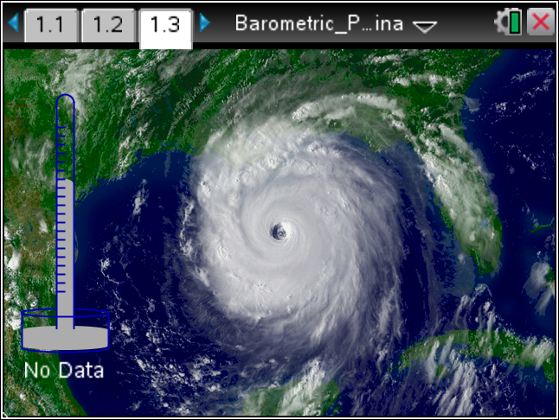
Tech Tip: To observe the pressure measurements around the eye of the hurricane, press your finger to the eye of the hurricane and drag it left and right.
Tech Tip: To access the Directions again, select b or Document Tools () > Hurricane Katrina > Directions.
Tech Tip: To access the Directions again, select > Hurricane Katrina > Directions.
Q1. Describe what happens to the barometer as you move the cursor across the screen.

2. Observe the structure of a hurricane in the diagram to the right. The eye is a circular area at the center of a hurricane. Just outside the eye is the eyewall, where the hurricane’s most intense rain and wind are found. | 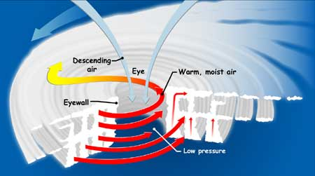  [http://spaceplace.nasa.gov/hurricanes/]
- Select d to clear data points that may have previously been selected. Move the cursor to the eye of the hurricane and select it using a. Then, move the cursor to the edge of the coast and select it. |  | 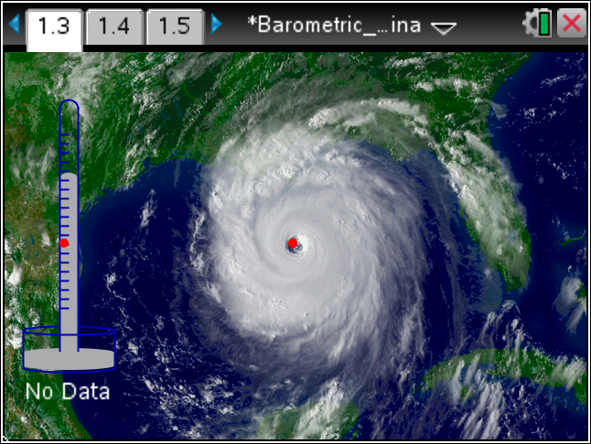
Tech Tip: To select data points, drag your finger across the screen and lift it to select a point. To clear data points, select > Hurricane Katrina > Erase Measurements.
Move to page 1.4.
- A chart shows the data you collected from the points you selected. The distance is measured in kilometers from an unknown location on land. |  | 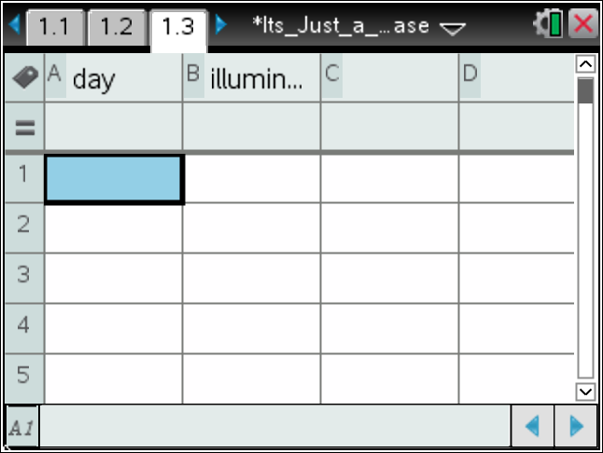
Q2. Complete the table shown below.

Location of  Data Point | Distance (km) From Unknown Location
Eye of Hurricane
Coast

Q3. True or False: Based on your data, the eye of Hurricane Katrina is more than 1,500 kilometers away from the coast.

- Clear the data points that have previously been placed. This will also clear the spreadsheet and the scatter plot on pages 1.3 and 1.5. |  | 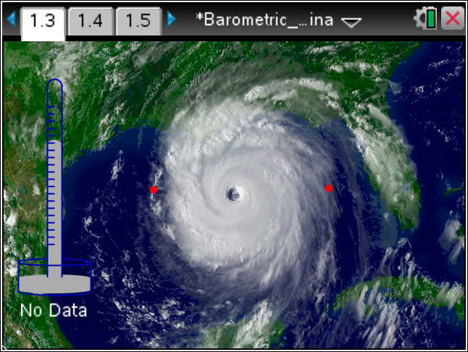
Q4. Notice that Hurricane Katrina has a circular shape. Collect two data points at the outer edges of the hurricane to find its diameter. Complete the table shown below here on this activity sheet.

Location of  Data Point | Distance (km) From Unknown Location
Right Side
Left Side

Q5. Based on your data, what is the approximate diameter of Hurricane Katrina?

A. 60 kilometers
B. 550 kilometers
C. 800 kilometers
D. 1,250 kilometers

Part 2: Analyzing Barometric Pressure
- You’ve seen what happens to the barometer when you moved the cursor across the screen. Now you will collect more data and analyze what happens to the barometric pressure. Clear the data points that have been collected.
- Move the cursor horizontally across the screen and collect 12 data points in a straight line. Start on land and move east, out into the Atlantic Ocean and across Hurricane Katrina. Be sure to collect data from the coast, the outer edges of the hurricane, and the eye of the hurricane. | 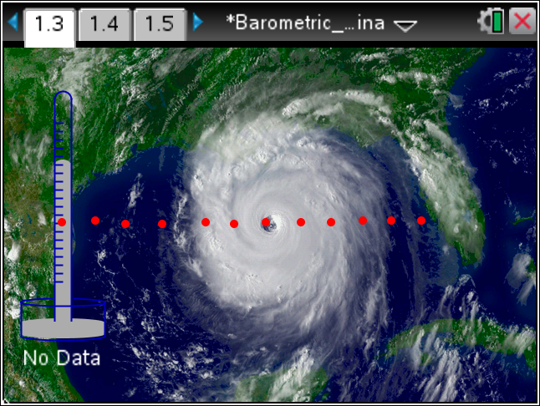
Q6. Go to page 1.4 that shows the spreadsheet with data you collected. Copy your data from the spreadsheet to complete the table shown below.

Data Point | Distance (km) | Barometric Pressure (mb)
1
2
3
4
5
6
7
8
9
10
11
12

Move to page 1.5.  Q7. Look at the line graph. Describe the line graph. Where is barometric pressure highest on the graph? Where is barometric pressure lowest on the graph? In what part of the hurricane is barometric pressure lowest? | 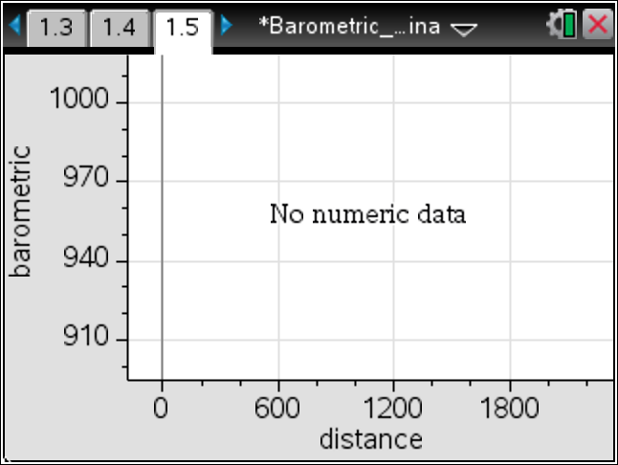
How do hurricanes work? Hurricanes form when warm, moist air over the ocean rises up from the surface, causing an area of lower barometric pressure below it. Higher pressure air from surrounding areas then pushes into the low pressure area, warming it and making it rise too. As the warm air rises, the surrounding air keeps rushing in to take its place. The warm air cools as it rises, and the moisture in the air condenses to form clouds. This cycle of rising, swirling, and cooling air creates a system of clouds and wind that grows, fed by heat and moisture from the ocean.

Q8. What causes strong winds in a hurricane?

As the hurricane rotates faster and faster, an eye forms in the center. The lower the barometric pressure in the eye of the hurricane, the more intense the storm is considered.

Q9. Based on your data, what was the barometric pressure in the eye of Hurricane Katrina?

Q10. Suppose the eye of Hurricane X had a barometric pressure of 975 millibars. Which hurricane was more intense? Why?

Part 3: Classifying a Hurricane
Hurricanes are classified according to their central pressure, wind speed, and potential to cause damage.
Central pressure is the pressure in the eye of the hurricane. The table below shows the Saffir/Simpson Hurricane Scale, which is used to classify hurricanes.

SAFFIR/SIMPSON HURRICANE SCALE
Category | Central Pressure (mb) | Winds (mph) | Damage
1 | >980 | 74-95 | Minimal
2 | 965-979 | 96-110 | Moderate
3 | 945-964 | 111-130 | Extensive
4 | 920-944 | 131-155 | Extreme
5 | <920 | 155+ | Catastrophic

Q11. Use the data you found in Question 9 for the central pressure of Hurricane Katrina to classify it on the Saffir/Simpson Hurricane Scale. What category is Hurricane Katrina? Explain.

Q12. Based on the Saffir/Simpson Hurricane Scale, what category is Hurricane X?

Q13. Based on the Saffir/Simpson Hurricane Scale, did Hurricane X cause more or less damage than Hurricane Katrina? Explain.

