Open the TI-Nspire document Heat_Transfer.tns.  In this investigation, you will explore a closed box containing particles of a substance. You can change the system by either changing the mass, or by heating or cooling the particles. As you adjust the parameters of the system, you will observe heat transfer in the form of conduction, convection, and radiation. As you make change to the system, both the motion and colors of the particles will change, revealing these mechanisms of heat transfer. |  | 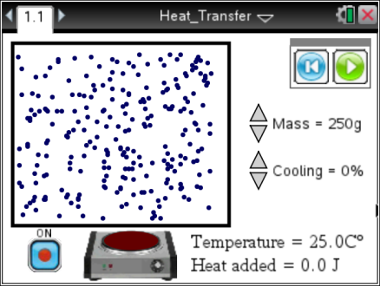
As you explore the box of particles, you will explore the relationship between temperature change and the behavior of the particles.

Temperature is a measure of the average kinetic energy of the particles in a system. This energy is represented in this simulation by the motion and color of the particles, which you will discover in this activity.

Part 1: Exploring the System
1. After reading the directions for the simulation, you can close the pop-up Directions box by selecting . You can view the directions again by selecting b. |  |  | 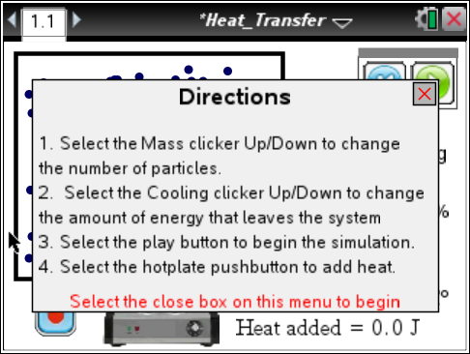
 | Tech Tip: To bring up the directions again, select  > Bring the Heat > Directions. You may need to back-out to the main Tools Menu to see the desired menu option.
2. Start the simulation by selecting the Play button . Select the up or down arrows of the sliders to change the mass and cooling percentage.  To pause the simulation select . To reset select . |  |  | 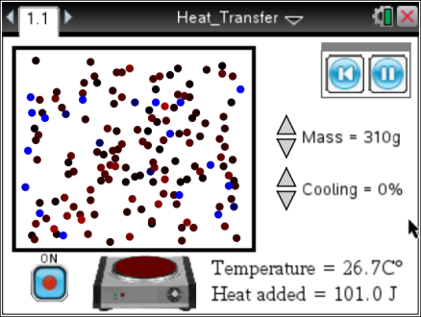
Q1. What do you observe in this simulation? Write down your answer and share this with a neighbor and the class as requested.

3. Now you will identify the variables in the simulation. Change the settings and run the simulation over again to explore how each variable impacts the system. Remember to reset the simulation between trials. Take note of the variables and answer the question below.

Q2. Fill in the table below based on your exploration. Check with other students as you identify all of the variables.

Variable | How it changes the system | Range of values

4. Both the motion and color of the particles are related to the average kinetic energy in the system. Since temperature is a measure of the average kinetic energy, you can connect the temperature with the particle characteristics, motion and color. Explore the simulation again, focusing on the color and speed of motion of the particles. Vary the mass to see how motion is affected.

Q3. Describe how color and speed of the particles are related to the temperature of the system.

Part 2: Heating the System
5. Now you will explore the relationship between the amount of heat added to the system and the behavior of the particles. Your teacher will assign you a value for mass and a length of time to heat your system. You can use the Stopwatch_en.tns from the TI Science Tools as a timing device. Record your assigned values below, and then run the simulation with your assigned settings.
Note: Your cooling rate should be zero and the hot plate should be ON.

My starting mass _______________________
My time to heat the system _____________________
Q4. Describe what happened as you ran the simulation with your settings. Include the initial and final temperature and the number of Joules of energy added.

Q5. Compare your answers with others in the class. Find other students that used the same settings as you. Then, compare your findings with students that used more or less mass than you. Summarize your findings.

6. You can determine the specific heat of the substance in the simulation using the data you collected. Specific heat is the amount of energy needed to change one gram of a substance one degree Celsius.

Q6. How would you calculate the specific heat using the data you collected?

Q7. What mechanism(s) do you think are responsible for the heat transfer that caused the temperature to increase

Part 3: Cooling the System
7. Now you will explore the cooling rate for the system. To cool the system, open the system so that heat is allowed to escape by setting a cooling rate. Your teacher will assign you a cooling rate, and you will use 200 grams as your starting mass. Make sure your hot plate is off. Record your rate below.

My cooling rate _______________
Q8. Describe what you observe as your particles cool. Note the time it takes to stop cooling and the temperature at which it stops. Also discuss the movement and color of the particles.

Q9. Compare your results with the class. What pattern do you see?

8. Now keep your cooling rate constant. Repeat the simulation first with a larger mass and then with a smaller mass.

Q10. What can you say about the amount of material you have to cool as it relates to the time it takes to cool completely?

Q11. What mechanism could account for this cooling?

Part 4: Cooling and Heating the System – Optional Extension

9. The system can be set up to heat and cool at the same time. Some possible questions to explore:
- Could you have a cooling rate that cancels the input of heat from the hot plate so that the temperature stays the same?

- Could you heat the system to a higher temperature and then turn off the hot plate and then start cooling?

