Open the TI-Nspire document Ring_of_Fire.tns

What causes earthquakes and volcanoes to occur? Is there a pattern to these natural hazards? In this activity you will plot actual earthquake and volcano data on a map of the world. Using this data you will discover the relationship between these events and the major tectonic plates that make up our Earth’s lithosphere.
The border between tectonic plates is called a plate boundary. Tectonic plates move in different directions relative to one another. For each different type of relative movement, there is a different type of plate boundary. Plate boundaries can be convergent, divergent, or transform.

Move to pages 1.2 – 1.3. Answer questions 1 and 2 below and/or in your .tns file.
Q1. Volcanoes and earthquakes can be found in the same locations.
A. Always |  |  | B. Sometimes |  | C. Never
Q2.The edge of a continent is the same thing as a plate boundary. True or False?

Move to pages 1.4 – 1.5. Answer questions 3 - 5 on this activity sheet.
1. Read the explanation on page 1.4. Then on page 1.5, read the directions overlaying the map. Select to close the directions box.  2. Select MENU > Ring of Fire to explore the options available in this simulation:  1: Volcano  2: Earthquake  3: Clear Pins  4: Directions  5: About |  |  |  |  |  | 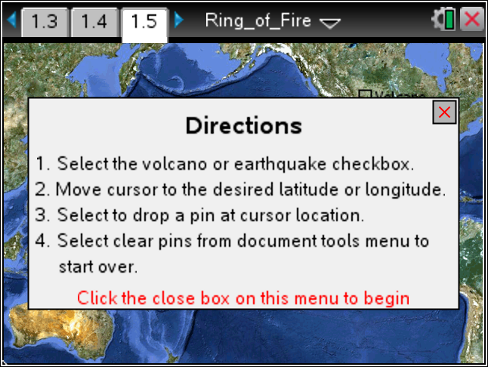
 | Tech Tip: To explore the options available, select 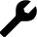 > Ring of Fire. Then select Volacano, Earthquake, Clear Pins, Directions, or About. You may need to back-out to the main Tools Menu to see the desired menu option.
Take a few minutes to practice moving the cursor and dropping both earthquake and volcano pins. Earthquake pins will be yellow and Volcano pins will be red.

Notice how the Latitude and Longitude values change as you move the cursor around the page using the touchpad.
Tech Tip: To drop the pins, select the box for Volcano or Earthquake at the top right of the screen. Then move the cursor around until the coordinates at the bottom of the map match the desired Latitude and Longitude. Select that location to drop a pin. (You don’t have to be exact. Just plot them in the approximate locations.)
Tech Tip: To drop the pins, the box for Volcano or Earthquake at the top right of the screen. Then place your finger on the screen and drag it until the coordinates show the desired Latitude and Longitude. Lift your finger from the screen to drop the pin.
Before you begin plotting the actual earthquake data, make sure you have correctly answered questions 3 - 5 on your activity sheet.
Q3. For a pin on California, what compass directions would you use (i.e.: NW, NE, SW, or SE)?

Q4. For a pin on Australia, what compass directions would you use?

Q5. Where on the map does W turn to E? Where on the map does N turn to S?

Notice that you are not able to clear an individual pin. “Clear pins” removes all the pins you have placed!

After practicing, be sure to clear all pins before you begin to plot the 19 Earthquake Coordinates from the table on your activity sheet below. To clear pins on the handheld, select MENU > Ring of Fire > Clear Pins.
Tech Tip: To clear pins, select > Ring of Fire > Clear Pins. You may need to back-out to the main Tools Menu to see the desired menu option.
Earthquake Coordinates:
If you accidently drop a wrong pin, leave the pin and make a note to ignore it. You cannot remove individual pins. If you select MENU > Clear pins, you will remove all pins! It is okay if you are a few degrees off in any direction.
REMEMBER: Earthquake pins should be YELLOW.

Location | Latitude | Longitude
56km NNE of Isangel, Vanuatu | 19°S | 169°E
South of the Fiji Islands | 24°S | 179°W
264km E of Vostok, Russia | 49°N | 153°E
40km E of Akutan, Alaska | 54°N | 165°W
11km W of Cobb, California | 39°N | 123°W
12km W of Progreso, Mexico | 33°N | 116°W
6km SW of Xochistlahuaca, Mexico | 16°N | 98°W
84km WSW of Sardinal, Costa Rica | 10°N | 86°W
51km NE of Wewak, Papua New Guinea | 3°S | 144°E
116km ENE of Lambasa, Fiji | 15°S | 180°W
131km E of Miyako, Japan | 40°N | 143°E
198km SSE of False Pass, Alaska | 53°N | 162°E
56km SW of Amukta Island, Alaska | 52°N | 172°W
65km SW of Redoubt Volcano, Alaska | 60°N | 153°W
4km NW of Okanogan, Washington | 48°N | 120°W
8km WSW of Volcano, Hawaii | 19°N | 155°W
196km NNE of Chichi-shima, Japan | 29°N | 143°E
234km SW of Hachijo-jima, Japan | 31°N | 138°E
60km SW of Tok, Alaska | 63°N | 144°W

Move to pages 1.7 – 1.8. Answer questions 6 and 7 below and/or on your device.

Q6. Describe the pattern of earthquakes on the map.

Q7. Did the earthquakes occur on the edges of continents?
A. Always |  |  | B. Sometimes |  | C. Never
Move to page 1.9.

3. Read the directions on page 1.9. Then go back to page 1.5 to drop pins for the volcano locations using the Volcano Coordinates on your activity sheet below.

CAUTION: IF YOU ACCIDENTLY SELECT “Clear pins” YOU WILL
LOSE THE EARTHQUAKE DATA YOU HAVE ENTERED!

Volcano Coordinates:
If you accidently drop a wrong pin, leave the pin and make a note to ignore it. You cannot remove individual pins. If you select MENU > Clear pins, you will remove all pins! Remember: It is okay if you are a few degrees off in any direction.
REMEMBER: Volcano pins should be RED.

Volcano | Latitude | Longitude
Mt. Adams, WA | 46°N | 121°W
Alamagan, Mariana Islands | 18°N | 146°E
Aniakchak, Alaska | 57°N | 158°W
Gareloi, Aleutian Islands | 52°N | 179°W
Aoba, Ambae Island, Vanuatu | 15°S | 168°E
Biliran, Philippines | 12°N | 125°E
La Madera, Nicaragua | 11°N | 86°W
Cleveland Volcano, Alaska | 53°N | 170°W
Daisetsu, Hokkaido, Japan | 44°N | 143°E
Pisgah, California | 35°N | 116°W
Redoubt, Cook Inlet, Alaska | 61°N | 153°W
Newberry Volcano, Oregon | 44°N | 122°W
Pavlof , Alaska | 55°N | 162°W
Gamchen, Kamchatka | 55°N | 161°E
Paricutin, Mexico | 20°N | 102°W
Fuss Peak, Kurile Islands | 50°N | 155°E

Move to pages 1.10 – 1.11. Answer questions 8 and 9 below and/or on your device.

Q8. Did the volcanoes occur in the same locations as the earthquakes?
A. Always |  |  | B. Sometimes |  | C. Never
Q9. Which of the following is true based on the data points you plotted? (Select all that apply.)

A. Volcanoes always form on continent boundaries.
B. Volcanoes can form in the ocean.
C. Volcanoes cause earthquakes.
D. Volcanoes and earthquakes occur in similar locations on earth.

Move to pages 1.12 – 1.17. Answer questions 10 - 13 below and/or in your .tns file.

4. Read the information on page 1.12. Then use the diagram on 1.13 (shown below) and the map on page 1.5 to answer the questions that follow.

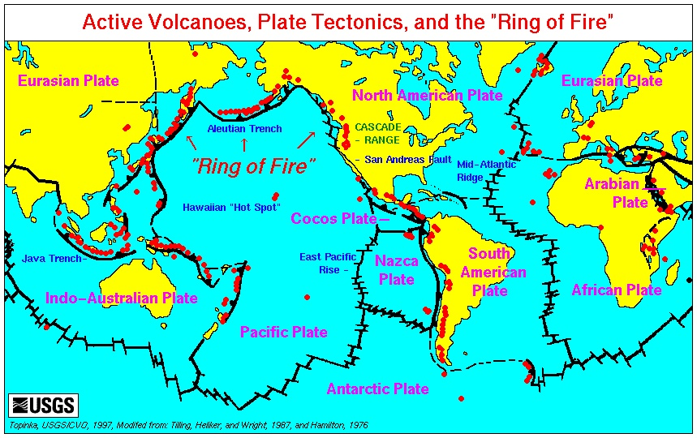
Q10. Compare the map you created on page 1.5 to the diagram on page 1.13. What crustal plate does your earthquake and volcano data identify?

- North American Plate
- Pacific Plate
- Eurasion Plate
- Nazca Plate
- Cocoas Plate
- Indo-Australian Plate
- Antarctic Plate

Q11. Do the plate boundaries always fall on the continent edges? Yes or No?

Q12. Tectonic plates don't quite match the continents and oceans on the Earth's surface. True or False?

Q13. What other surface features occur near plate boundaries? (Select all that apply.)
A. Mountains |  | B. Trenches |  | C. Rift Valleys |  |  | D. Volcanoes
Move to pages 1.18 – 1.23. Answer questions 14 - 16 below and/or in your .tns file.

5. Read the information on pages 1.18 – 1.20. Then use the map on page 1.5 to answer the questions that follow.

Q14. What type of plate boundary is near Alaska?
A. Convergent |  |  | B. Divergent |  | C. Transform
Q15. What type of plate boundary is near Japan?
A. Convergent |  |  | B. Divergent |  | C. Transform
Q16. What type of plate boundary is near California?
A. Convergent |  |  | B. Divergent |  | C. Transform

