Open the TI-Nspire™ document Discriminant_Testing.tns.  Can you tell how many roots a quadratic function will have without solving an equation? This lesson investigates the relationship between the discriminant of a quadratic equation and the nature of the roots of the quadratic function. | 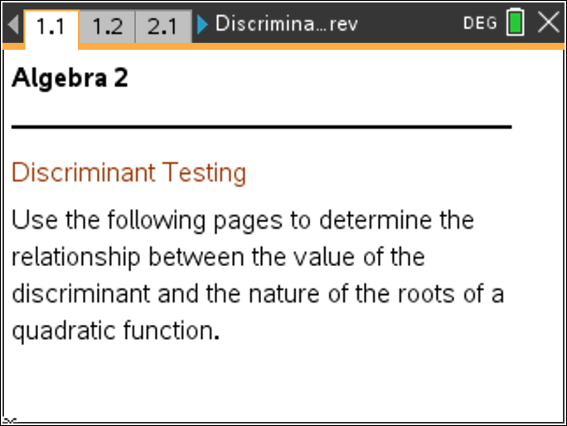
The discriminant comes from the quadratic root formula, , where a, b, and c are the parameters of the quadratic equation The discriminant is

Move to page 1.2. | Press / ¢ and / ¡ to navigate through the lesson, or use the Touchpad and click a .
How is the quadratic formula related to the graph of a quadratic function? What potential problems emerge in using the quadratic formula? The discriminant can help us with these issues.

- Use the slider (click the up or down arrow) to produce graphs of quadratic functions. Notice the number of times the graphs intersect the x-axis. Describe the nature of the roots for the set of quadratic functions you can generate on page 1.2.

- a. Describe the value of the discriminant for all of the functions you can generate on page 1.2.

b. Explain how the value of the discriminant relates to your response to question 1.

Move to page 2.1.

3. Use the slider to produce various graphs of quadratic functions. Notice the number of times the graphs intersect the x-axis. Describe the nature of the roots for the set of quadratic functions you can generate on page 2.1.
4. a. Describe the value of the discriminant for all of the functions you can generate on page 2.1.

b. Explain how the value of the discriminant relates to your response to question 3.

Move to page 3.1.

5. Use the slider to produce various graphs of quadratic functions. Notice the number of times the graphs intersect the x-axis. Describe the nature of the roots for the set of quadratic functions you can generate on page 3.1.

6. a. Describe the value of the discriminant for all of the functions you can generate on page 3.1.

b. Explain how the value of the discriminant relates to your response to question 5.

Move to page 4.1.

7. Test your conclusions with random quadratic functions by clicking the slider and using the Scratchpad to calculate the discriminant. Press » on the TI-Nspire™ Touchpad or press c and choose Calculate on the left side under Scratchpad. Return to the document by pressing d. Fill in the chart for 6 functions.

a | b | c | Discriminant | Nature of the Roots | Root(s)

Use your completed chart to answer the following questions:
- Why are there three possibilities for the number of x-intercepts (zero, one, or two intercepts) for all graphs? How is that determined?

- When is the part of the discriminant negative?

- What determines whether you have real roots versus non-real roots?

- How do the sizes of a, b, and c affect the discriminant?

- Will you ever have one real and one non-real root? Why or why not?

- If a and c are both negative, will there ever be two real roots? Why or why not?

- When will the roots be rational? Explain mathematically.

- When might the roots be integer values? Explain mathematically.

