Problem 1 – Squares on Sides Proof
1. Why is the constructed quadrilateral a square? | 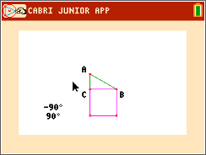
2. Record three sets of area measurements you made by dragging points A, B, and/or C.
Square on | Square on | Sum of squares | Square on

3. What conjecture can you make about the areas of the three squares? Does this relationship always hold when a vertex of ABC is dragged to a different location?

Problem 2 – Inside a Square Proof
4. Prove that constructed quadrilateral EFGH is a square. | 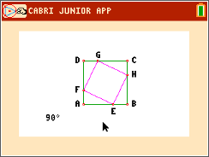
5. ABCD is a square with all sides of length (x + y).  The area of the square ABCD is (x + y)² = x² + 2xy + y²  Each of the triangles, EFA, FGD, GHC and HEB, is a right triangle with height x and base y. So, the area of each triangle is . | 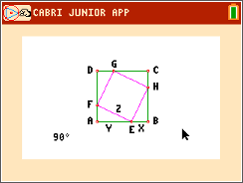
EFGH is a square with sides of length z. So the area of EFGH is z².
Looking at the areas in the diagram we can conclude that:
ABCD = EFA + FGD + GHC + HEB + EFGH
Substitute the area expressions (with variables x, y, and z) into the equation above and simplify.

6. Record three sets of numeric values for HEB.
BE | BE ² | HB | HB² | BE ² + HB² | EH | EH ²

7. Does BE ² + HB² = EH ² when E is dragged to a different location?

8. Does BE ² + HB² = EH ² when A or B is dragged to a different location?

