Open the TI-Nspire document Inclined_Plane.tns.
In this simulation a mass is pushed up an inclined plane to explore how this simple machine makes it easier to push the mass up a certain distance. Yet, even though the simple machine aids in pushing the mass up, the amount of work used is the same as lifting it straight up. But even in the context of the conservation of energy, this inclined plane simplifies the effort.
Background
An object of mass m has a weight equal to mg, where g is the acceleration due to gravity. Lifting the mass a distance h, results in work equal to mgh. | 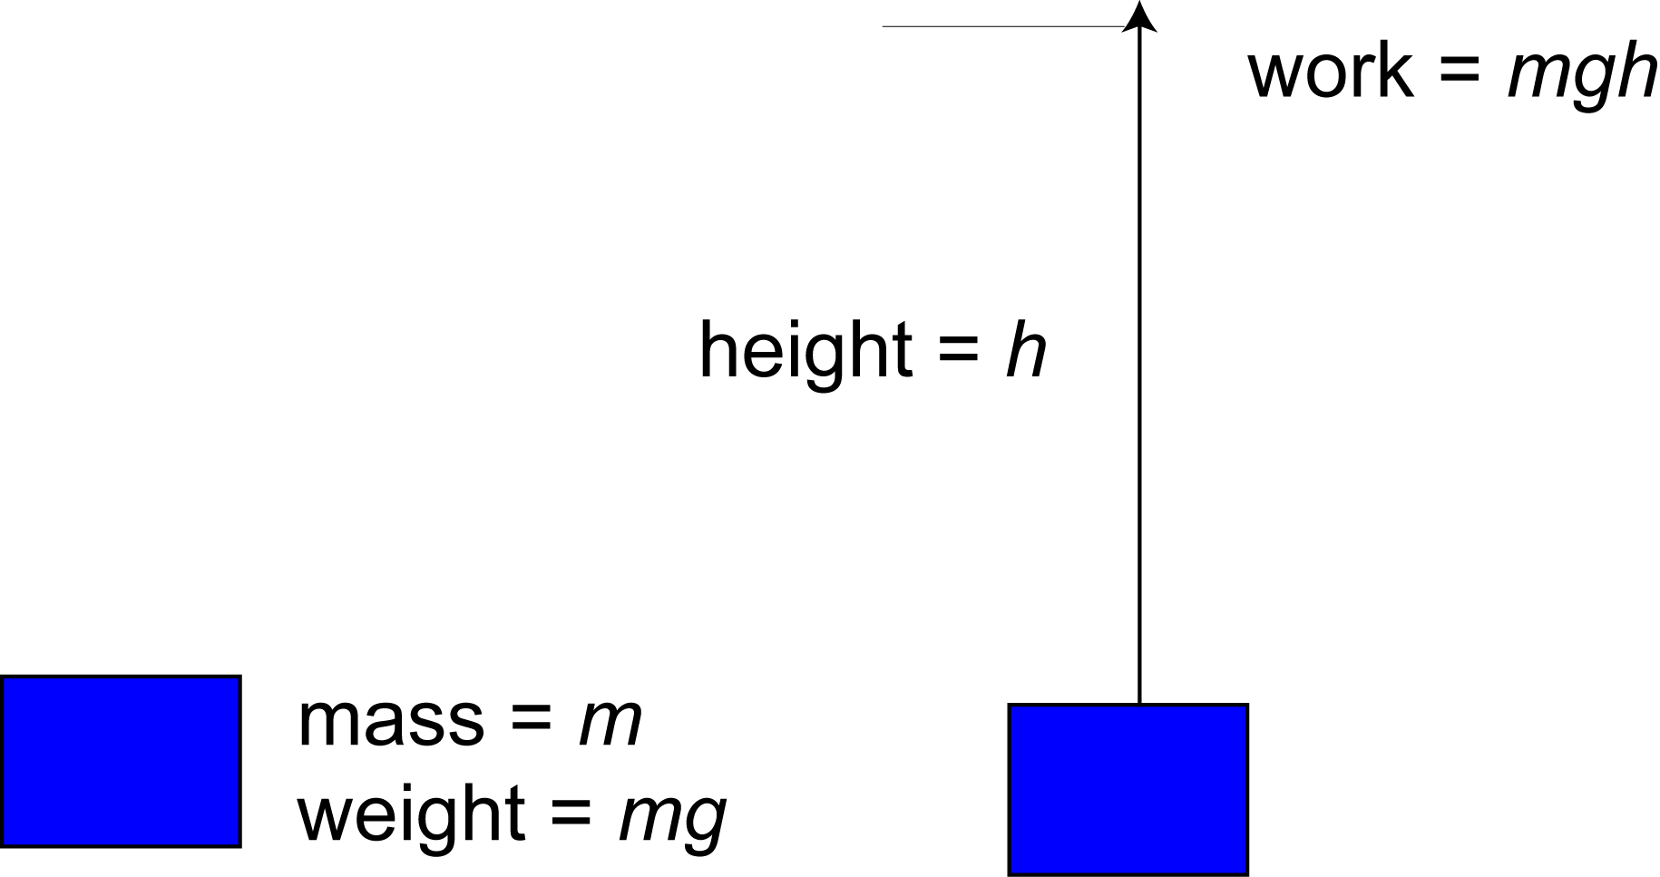
Now think of a real world situation. Someone lifting boxes from the ground to an elevated platform. If you’ve done this, you know this can literally be back-breaking work. This is where an inclined plane comes in handy. | 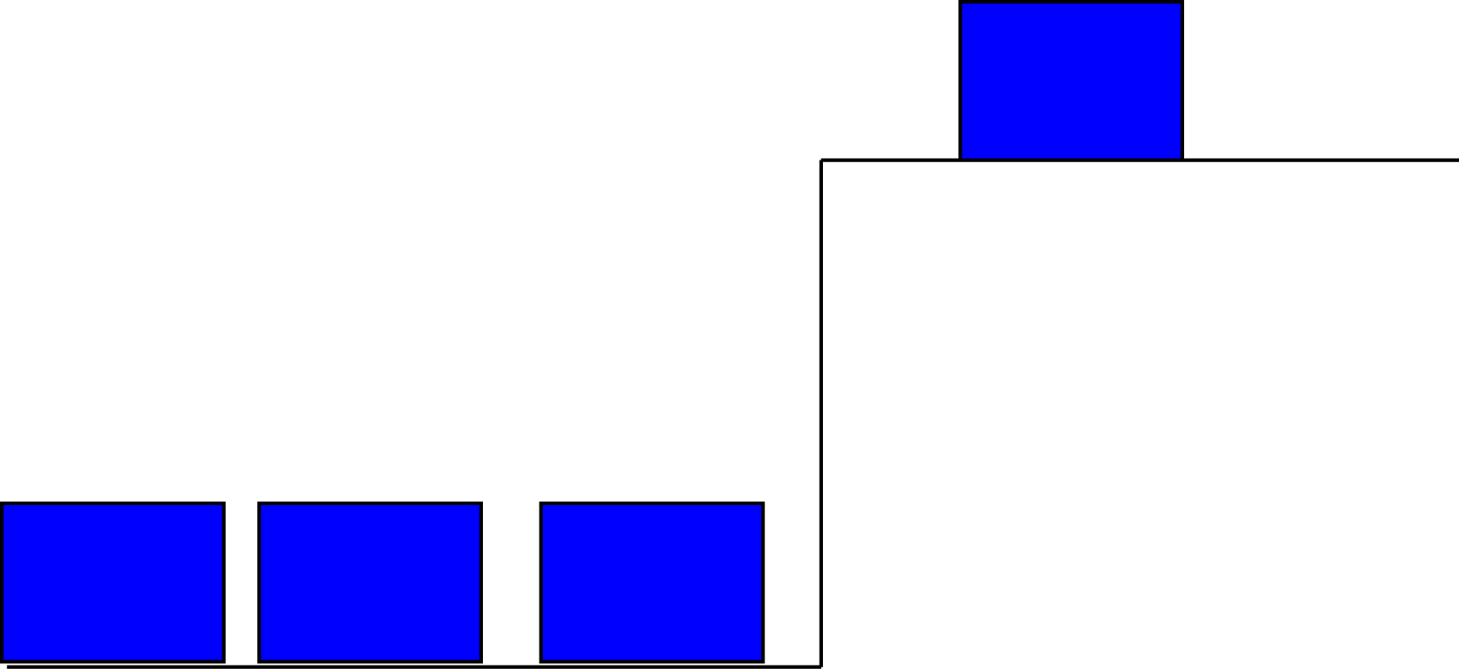
What an inclined plane does is simplify the task of lifting the object. Less force is required to push the mass along the inclined plane. In exchange, the mass has to be pushed a longer distance. The amount of work needed to push the mass is the same as lifting it straight up. | 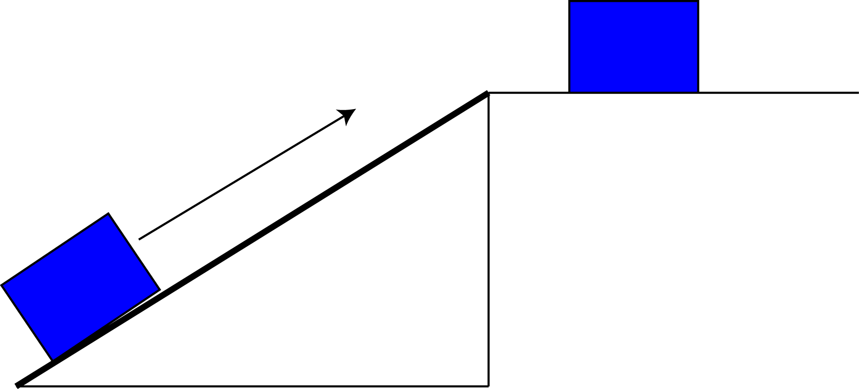
Part 1: Varying the Mass of the Block
Move to page 1.2.  1. Read the directions. When finished, select in the top right corner to close the pop-up box. Select b if you need to view the directions again.  The default setting for the simulation is 1 kg. The vertical distance is always 2 meters. The angle displayed is the bottom left angle of the incline. |  | 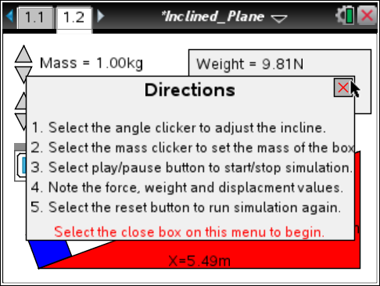
Tech Tip: To view the directions again, select 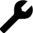 > Inclined Plane > Directions. You may need to back-out to the main Tools Menu to see the desired menu option.
Q1. The formula for calculating the amount of work is Work = Force • Distance. Calculate the work done in lifting the mass vertically. Note: The weight shown in the gray box in the top right corner of the page is the force.

2. Select the Play button to see the blue block move up the ramp. The displacement is the amount of distance traveled along the inclined plane.

Q2. Calculate the work required to push the block, using the force applied and the displacement.

Q3. What do you notice about the work involved in lifting the blue block straight up and the work involved in sliding it along the inclined plane?

Q4. Choose five different values of mass between 1 kg and 20 kg and use the simulation to complete the table. Note: Before choosing a new mass, select the Reset button .

Mass | Weight | Work to Lift Vertically | Force  Applied | Displacement | Work to Slide on Plane

Q5. What do you notice about the work involved in lifting the mass vertically and sliding it along the plane?

Mechanical Advantage

An inclined plane is an example of a simple machine. It simplifies the effort to lift a mass up a vertical distance. The mechanical advantage is the ratio of the weight of the mass to the force needed to slide it along the plane.
Q6. Copy the mass, weight, and force applied for each trial from the table in Q4. In the last column of the table below, calculate the mechanical advantage.

Mass | Weight | Force Applied | Mechanical Advantage

Q7. What do you notice about the mechanical advantage as the mass of the block changes?

Q8. How do you think you could change the plane to increase or decrease the mechanical advantage?

Part 2: Varying the Angle of the Plane

Another variable that you can manipulate is the angle of the inclined plane. In this simulation the vertical distance remains the same (2 m), but the distance along the ramp changes.

3. Select the up and down arrows of the Angle slider to change the degree of the angle of the plane. Select a mass for the block and keep it the same. Note: Before choosing a new angle, select the Reset button .
Q9. Complete the table for different angle values. Calculate the mechanical advantage.

Mass | Angle | Weight | Force Applied | Mechanical Advantage

Q10. What happens to the mechanical advantage as the angle increases in size?

An Alternative Way to Calculate Mechanical Advantage

You saw that one way of calculating the mechanical advantage is by calculating the ratio of the weight to the force applied. But with inclined planes, another method of calculating the mechanical advantage is by finding the ratio of the vertical height and the displacement.

4. Use the up and down arrows to vary the angle of the plane and the mass of the block.

Q11. Complete the table below for each trial. In all cases, the vertical distance, or height, (h) is constant at 2 m. Calculate the mechanical advantage using the two different ratios.

Mass | Angle | Weight | Force Applied | Displacement | Mechanical Advantage (W/FA) | Mechanical Advantage (D/h)

Q12. What do you notice about the mechanical advantage using the two different ratios?

Part 3: Deriving the Equation for the Force Applied

Notice that the ratio of the vertical height (h) over the displacement (D) is the same as the trig ratio for sine.  In this case the angle θ is the angle the inclined plane makes with the ground. Using this equation, we get the following formula for force applied, where m is mass and g is gravity. |  | 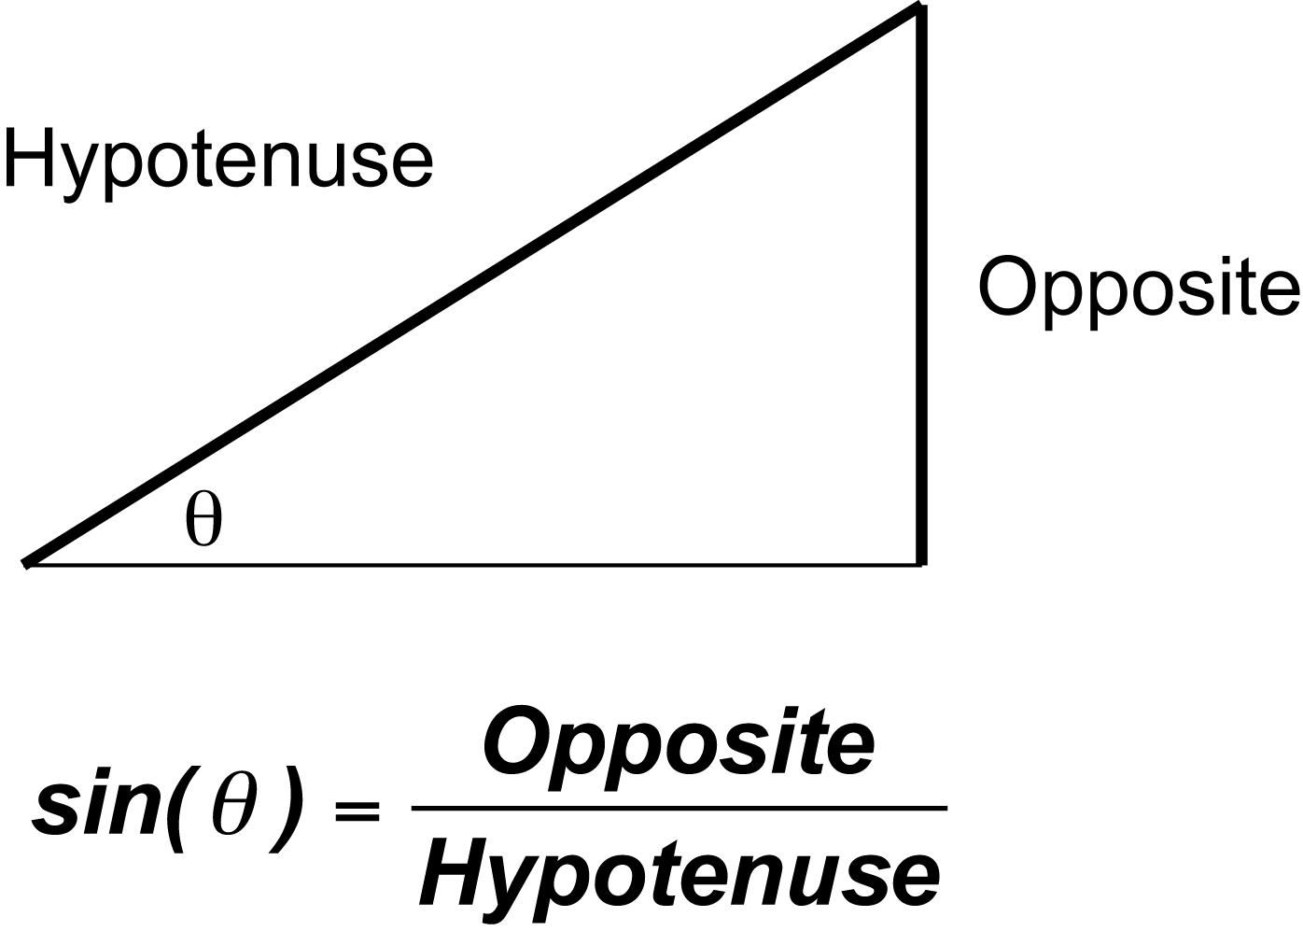
5. Compare the values for the applied force using the formula just derived and the values from the simulation. Choose different mass values and angle measures.

Q13. Record the mass and angle of the plane, and the force applied given in the simulation in the table. In the last column, calculate the force applied using the formula. (Use a value of g = 9.8 m/sec² .)

Mass | Angle | Force Applied (Measured) | Force Applied (Calculated)

Q14. What do you notice about the measured value and calculated value for the force applied?

