Activity Overview:  This activity gives directions for constructing a right triangle such that the measures of the legs have whole number values. You will explore when the measure of the hypotenuse is a whole number and discover some Pythagorean Triples.  Materials  • Technology needed (TI-Nspire™ handheld, computer software) | 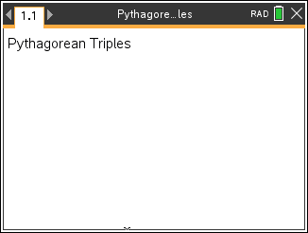

Step 1 Preparing the document  - Open a new document by clicking on  c > New Document > Add Notes.  - Type Pythagorean Triples.  Note: To obtain capital letters, press the g key, then the letter.  - Press ~ > File > Save As …  Type Pythagorean_Triples.  Tab to ¾ and press · .  Note: To obtain the underscore, press / _.  4. To add a new page, press / ~ > Add Graphs.  5. Press Menu > Settings. Select Float 4 for Display Digits. Then press e to move from one field to the next and press x to uncheck all the boxes besides Show axes end values. Tab to OK and press x or ·.  - If needed, press / G to remove the function entry line. | 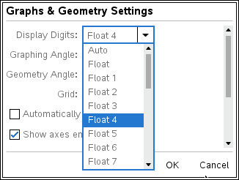  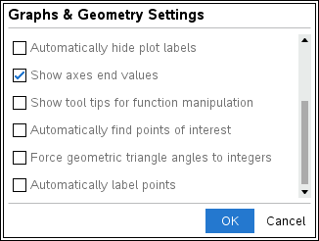  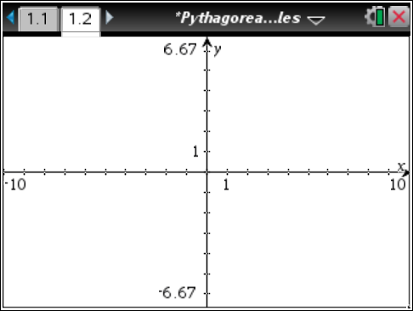
Step 2 Making a triangle  1. To make a triangle, press Menu > Geometry > Shapes > Triangle.  Note: Be sure that you place the vertices on a tick mark. You need integer measurements for the legs.  Move the pencil to the origin. It will say intersection point. Press · to place a vertex of the triangle. Label it by pressing g E.  2. Move to a tick mark on the positive y-axis. It will say point on.  Press · to place the second vertex. Press g F to label it.  3. Move to a tick mark on the positive x-axis. It will say point on. Press · to place the third vertex. Press g G to label it.  Press d to release the Triangle tool.  To make sure these vertices are on integer coordinates, drag points F and G. Both points should jump from one tick mark to another. | 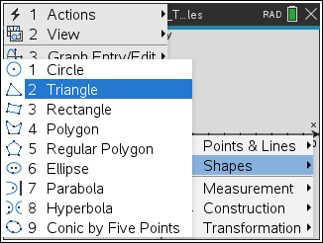  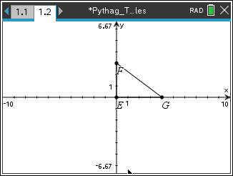
Step 3 Measuring the sides of a triangle  1. To measure the three sides of the triangle, press Menu > Geometry > Measurement > Length.  2. Move to a side of the triangle and press e until the word side appears. Press · to see the measure. Drag to position the measurement. Press ·.  3. Repeat this process for the other two sides.  4. Press d to release the Measurement tool. | 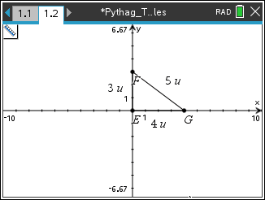
Step 4 Adjusting the window settings  1. To adjust the window settings, press Menu > Window / Zoom > Window Settings.  2. Enter the settings as shown in the screen shot to the right. Be sure to use v to enter negative numbers. Remember to  press e to move between the settings. Press e to OK and press ·.  Note: This is not a square window, so isosceles triangles will not look isosceles. | 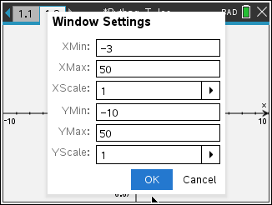  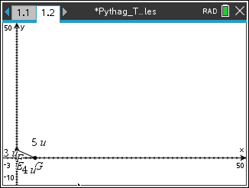
Step 5 Hiding the axes  1. To turn off the axes, press Menu > View > Hide Axes.  2. Drag points F and G to make the triangle larger.  3. Drag the measurements to position them appropriately. | 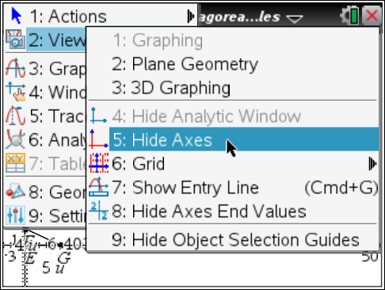
Step 6 Saving the document  - Press / S. | 