Open the TI-Nspire™ document Growing_Patterns.tns.  In this activity, you will explore growing patterns through pictures, graphs, and tables. You will represent these growing patterns algebraically. | 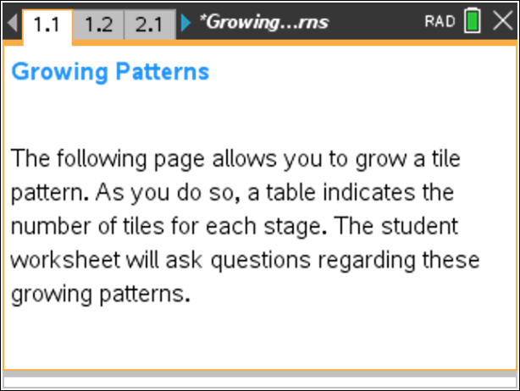

Move to page 1.2.

1. On page 1.2, the first stage of a tile pattern is shown. Use the slider for stage, to ‘grow’ the pattern.
a. What remains the same in the pattern, and what changes as it grows?

b. In the table, what does the x variable represent?

c. What remains the same, and what changes in the table as the pattern grows?

d. In the graph, what do the x- and y- coordinates of the ordered pairs represent?

e. What remains the same, and what changes in the graph as the pattern grows?

2. On page 1.2, you are limited to showing 5 or fewer stages of growth for the pattern.
a. If the pattern continued to grow in the same way, draw the 6th stage, and determine the number of tiles needed.

b. How many tiles would be in the 10th stage? How do you know?

c. Write an algebraic rule to state the number of tiles in the xth stage.

d. Would there ever be a stage in which there were 58 tiles? Why or why not?

3. When you write the rule from part 2c as an equation in which, y, the number of tiles, is related to x, the stage number, you are writing y as a function of x.
a. Write the function that represents this pattern.

b. Check that your function is correct by typing it in the text box after “y=.” (To open the text box, double click on the question mark. Be sure to ONLY select the question mark and type to the right of the equals sign. DO NOT double click on the “y=.”) Press ·. How can you tell if your rule is correct or incorrect by looking at the table and graph?

Tech Tip: To modify the text on screen, double-tap the text and the keyboard will open.

c. If your rule was correct, move on to Question 3d. If your rule was incorrect, find a new rule to relate the stage number and number of tiles. Check your rule.

d. The growth rate of the pattern is the change in the number of tiles per stage. What is the growth rate for this pattern?

e. Where does the growth rate appear in the function? In the table? In the graph?

f. Move to stage zero. Where does the number of tiles at this stage show up in your function? In the graph?

Move to page 2.2.

4. On page 2.2, use the slider for stage to grow a second pattern. Determine the growth rate and write a function that represents the number of tiles in relation to the stage number.

Move to page 3.2.

5. On page 3.2, use the slider for stage to grow a third pattern. Determine the growth rate and write a function that represents the number of tiles in relation to the stage number.

6. Design a pattern that grows at a constant rate but more quickly than all of the previous patterns. Draw the first 4 stages of your pattern and write a function that represents the number of tiles in relation to the stage number.

