Open the TI-Nspire document Transformations_Quadratics.tns.  In this activity, you will explore transformations of a quadratic function. | 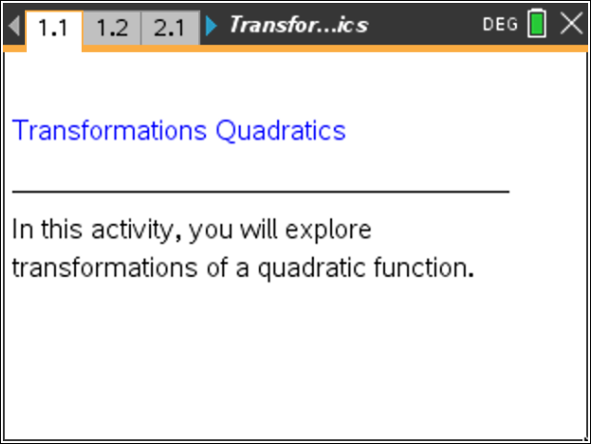

Move to page 1.2. | Press / ¢ and / ¡ to navigate through the lesson.
Step 1: Use the slider to change the value of the parameter variable. To do so, click on the right or left arrow on the slider. Observe the changes in the graph. Press d.  Step 2: Observe the graph as you change the slider and move a to the following values: 5, 1, 0.2, 0, –0.2, –1, and –5. | 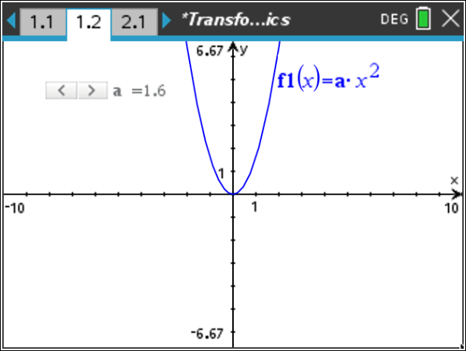
Answer these questions.

- What do you observe about the vertex of each of the parabolas?

- How does the value of a affect whether the graph opens up or down?

- How does the value of a affect the shape of the graph?

Move to page 2.1.

Step 3: Observe the graph as you click on the slider and have c become the following values:
4, 2, 0, –2, and –4.

Answer these questions.

- What did you observe about the vertex of each of the parabolas?

- How does the value of c affect the shape and whether the graph opens up or down? Explain.

6. How does the value of c affect the graph?

