Open the TI-Nspire document Radio_Station_KTNS.tns.  In this activity, you will explore a real-world example of the Law of Sines and the Law of Cosines. | 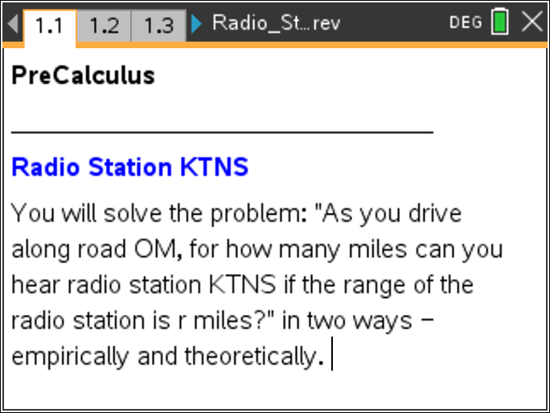

Radio Station KTNS is located at point in the figure. The range of its signal is miles, meaning that people within miles of would be able to hear the station. You are driving along road at an angle of 30° with . For how many miles, , could you hear station KTNS? | 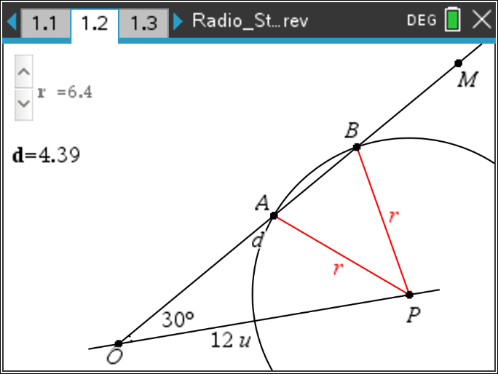
In ΔPAB, the Law of Cosines tells us that , so it is reasonable to assume that could be a linear function of . To solve this problem, you will determine in terms of in two ways:
- Find an experimental model by gathering data and fitting an appropriate regression function to the data.

- Find a theoretical model using the Law of Sines, the Law of Cosines, and algebra.

Move to page 1.2. | Press / ¢ and / ¡ to navigate through the lesson.
The figure is a scale drawing with 1 unit = 10 miles so that OP = 12 units or 120 miles.
1. In miles, the reasonable values of satisfy < ≤ 120. What is the value of ? Why?

Move to page 1.3.

Using the slider, the following data has been gathered in the spreadsheet in the four columns:

Move to page 1.4.

A scatterplot of the data has been drawn on this page.
Move to page 1.5.

2. Fit a linear regression function to the data with and in units. Select MENU > Statistics > Stat Calculations > Linear Regression (mx+b). with for X List, for Y List, and Save RegEqn to:.
Record your answer here:

Move back to page 1.4.

3. Plot the regression equation on the scatterplot, and note how well it fits. Open the entry line, move back up to , and press ·.
According to this linear model, for how many miles, , could you hear the station if miles?
Hint: Remember = 9 units corresponds to = 90 miles.

Move to page 2.1.

Theoretical Model
Find the theoretical function expressing in terms of by completing the argument below.

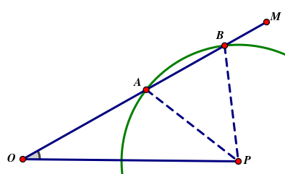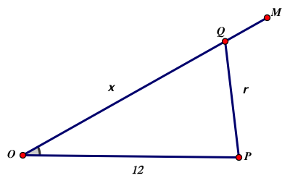

4. The figure for this problem shows an example of an ambiguous case of the Law of Sines since there are two triangles with two sides = 12, , and the non-included angle of 30°. Consequently, if we apply the Law of Cosines to a triangle with sides = 12, , and angle 30°, we obtain the equation:

____________________________________ = 0.

On the scale drawing, then, the two solutions forare and , and the distance, , is .

5. a. Find the two solutions for of this equation.______________________________ .
Hint: You can use “solve” command. Both solutions will be functions of

b. Find the difference of the two solutions and express in terms of in units:

= _________________________

6. How does your theoretical equation compare to the regression equation?

7. According to this theoretical model, for how many miles, , could you hear the station if miles?
Hint: Remember = 9 units corresponds to = 90 miles.

8. Suppose the angle between the two roads and is changed to . Express in terms of and :

= _________________________

