Open the TI-Nspire document Forces_on_an_Inclined_Plane.tns on your handheld or computer.  In this activity, you will explore the following:  - the forces acting on an object resting on an inclined plane  - the relationship between the angle of the inclined plane and the magnitude of the forces on the object  Follow along with your teacher for the first three pages. Move to page 1.3 and wait for further instructions from your teacher. | 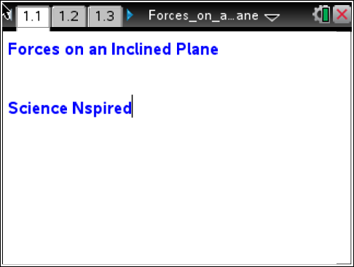
In this activity, you will collect data on the force on an object resting on an inclined plane. You will vary the angle of the plane and record how the force on the object changes. You will then use these data to determine the mathematical relationship between the angle of the plane, the weight of the object, and the forces acting on the object parallel and perpendicular to the plane. | 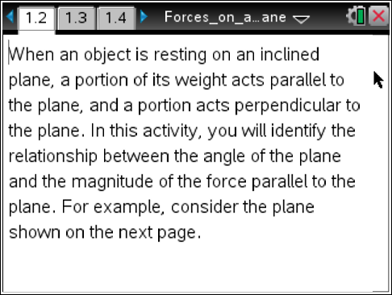
Part 1: Collecting Force Data
Read the information on pages 1.2 and 1.3, and then answer the questions below.  Q1. What value of θ will produce the largest value of Fpar? What value of θ will produce the smallest value of Fpar? Explain your answer.  Q2. What mathematical relationships do you think there are between θ, Fpar, Fperp, and Fg? Explain your answer. | 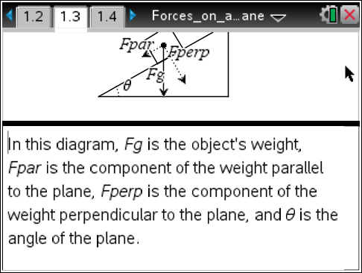
1. First, you must set up the inclined plane. Stack the books so that they are balanced and stable. Place one end of the wood on top of the books and the other end on the floor. Measure the angle between the plane and the horizontal (θ in the diagram to the right) with a protractor. If you cannot measure the angle directly, you can calculate it by measuring the length and height of the plane, finding the ratio of the height to the length, and taking the inverse tangent of that ratio. Record the angle of this inclined plane. Then, remove one book from the stack, replace the wood, and measure and record the angle again. Keep removing books and measuring the resulting angle until you have recorded 6–10 angles. Make sure to record the order in which you remove the books (if they are different sizes) so that you can reproduce each angle during the experiment. | θ  θ
2. Next, move to page 1.4, which contains an empty Vernier DataQuest application. Connect the force sensor to the EasyLink or Go!Link interface and then connect the interface to your handheld or computer. Then set up the sensor to Events with Entry mode (Menu > Experiment > Collection Mode > Events with Entry). | 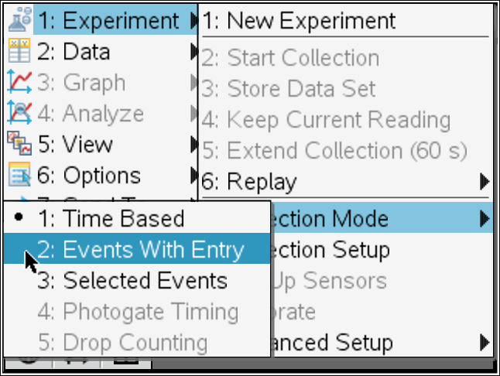
3. Next, move to page 1.5, which contains an empty Lists & Spreadsheet application. Insert the variable run1.event in column A and run1.force in column B. To assign data to a column, type the name of the variable in the title bar of the column. | 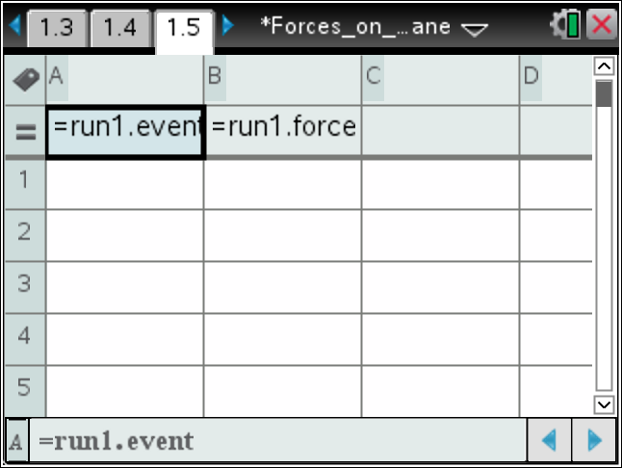
4. Next, zero the force sensor (Menu > Experiment > Set Up Sensors > Zero), return to page 1.4 and begin the experiment.
5. Next, use the string to connect the mass to the hook on the bottom of the force sensor. (Make sure the switch on the force sensor is set to the correct range. The range you use will depend on the mass you use.) Let the mass hang from the force sensor without touching anything. Once the weight reading on the force sensor has stabilized, record a data point, using 90 as the event value (because the angle is 90° from the horizontal).
6. Next, place the mass on the inclined plane at its highest angle, with the force sensor holding the mass on the plane, as shown to the right. Record another data point, using the angle of the plane as the event value.
7. Repeat Step 5, reducing the angle to each of the values you calculated or measured in Step 1. Once data collection is complete, stop the data collection, close the data collection box, and disconnect the force sensor. (Note: The data shown here are simulated; your data will vary.) When you have collected your data, you should return to page 1.5 and answer the questions below. | 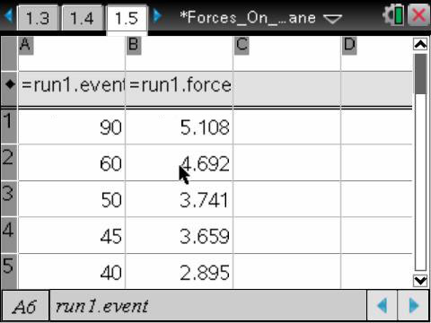
Q3. Which of the three forces (Fpar, Fperp, or Fg) do the data in column B correspond to? Explain your answer.

Q4. Do your data support your predictions from Question 1? If not, identify the errors in your reasoning that led you to make your predictions.

Part 2: Fitting a Curve to the Data
1. Next, calculate the ratio of the force on the mass at each angle  to the total weight of the mass. To do this, move to column C  on page 1.5. In the formula bar (gray box) of column C, type =b[]/b[1]. Assign these values to the variable ratio by typing  ratio in the title bar of column C. | 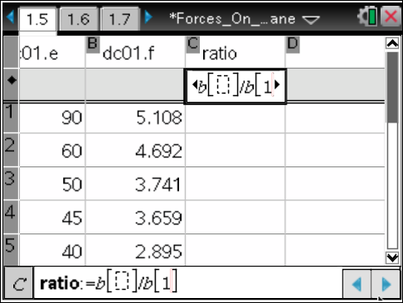
2. Next, move to page 1.6, which contains an empty Graphs & Geometry application. Change the graph to a scatter plot (Menu > Graph Entry/Edit > Scatter Plot) and plot ratio vs. angle. Remember that the angles of the inclined plane are stored in the variable dc01.event. (You may need to resize the graph (Menu > Window > Zoom-Fit) to see your data clearly.) Examine the data and then answer Question 5.  Q5. What functional form appears to fit your data?  3. Next, change the graph to a function graph. Plot different functions that you think might fit your data. Try several different functions until you find the best fit. Then, answer Question 6.  Q6. What function produced the best fit to your data? | 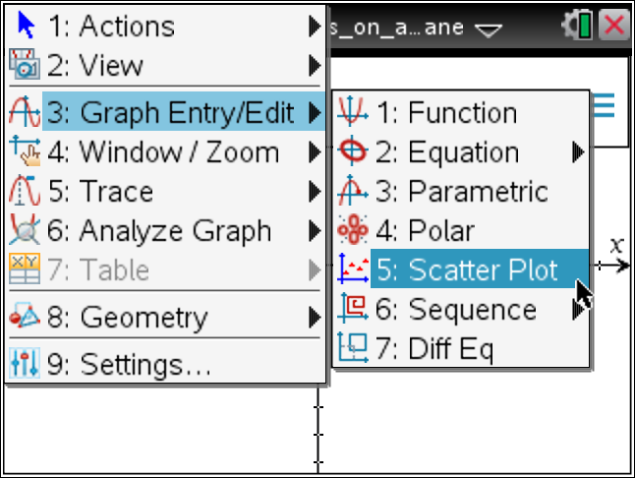
Part 3: Calculating the Normal Force
1. The forces you explored in parts 1 and 2 were the forces on the object that act parallel to the inclined plane (Fpar). In this part of the activity, you will explore the normal force on the object (the force acting on the object perpendicular to the inclined plane). Move to page 1.7, which shows an object resting on an inclined plane. In this diagram, the Fperp vector has been translated to the end of the Fpar vector. Notice that Fpar and Fperp are the legs of a right triangle. Fg is the hypotenuse of this triangle. Examine the diagram, and then answer Question 7.  Q7. Write an equation for Fperp in terms of Fpar and Fg. | 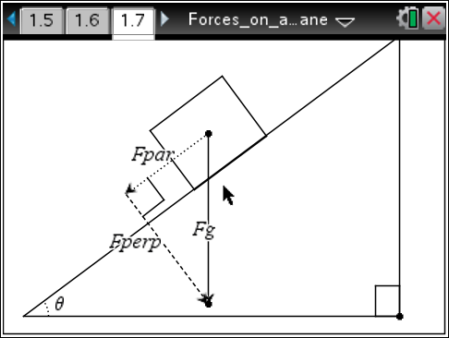
2. Next, move back to the Lists & Spreadsheet application on page 1.5 and define the variable fperp in column D using the equation you wrote in Question 7. Then, calculate the ratio of fperp to the weight of the object (in column B), and store this ratio in column E as the variable nratio.

3. Next, move again to page 1.6, change the graph to a scatter plot, and plot nratio vs. angle. Examine the graph, and then answer Question 8.  Q8. What functional form appears to fit your data? | 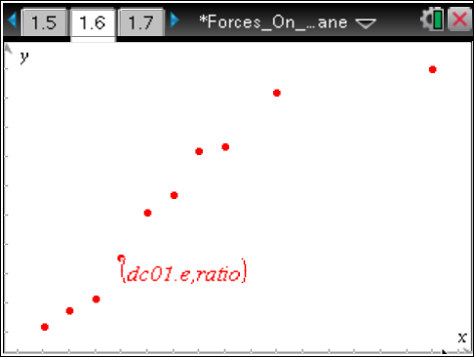
4. Next, change the graph to a function graph. Plot different functions that you think might fit your data. Try several different functions until you find the best fit. Then, answer Questions 9 – 13.  Q9. What function produced the best fit to your data?  Q10. Were the predictions you made in Question 2 about the relationships between Fg, Fpar, and Fperp correct? If not, identify any errors in the reasoning that led you to make your predictions. | 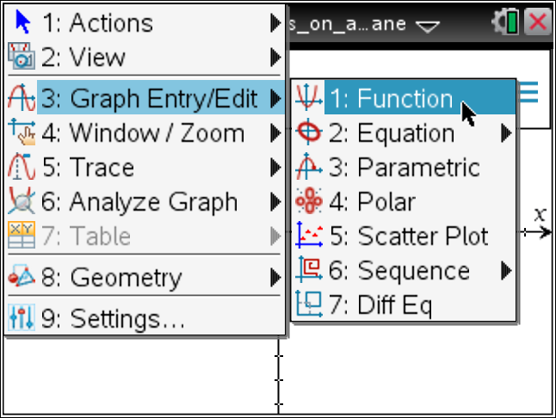
Q11. Suppose you calculated the ratio of Fpar to Fperp and plotted this ratio versus the angle of the inclined plane. What would the plot look like? Explain your answer.

Q12. A box with a weight of 8.34 N is resting on an inclined plane. The plane is inclined 13.6° to the horizontal. What is the normal force on the box? What is the force acting parallel to the inclined plane?

Q13. A student's desk has a hinged top that can open and close. She places a book on the top of the desk and then holds it in place as she opens the desk. If the book has a mass of 2.5 kg and the desk top forms an angle of 78° with the horizontal, how much force must the student exert on the book to keep it from sliding down the table? You may ignore friction in your answer.

