Problem 1 – Rolling Two Number Cubes
1. Sketch and describe the probability distribution of rolling a number cube one time.

Join your group of three.  First person: Simulate rolling two number cubes 10 times. Say the results of each roll out loud. Type your group number on the Home screen, press  , choose PRB, then rand, and press .  Second person: Calculate the means of the two numbers on the Home screen.  Third person: Record the means in L1 (press  and choose Edit) and on the worksheet. Check that this list is now clear. | 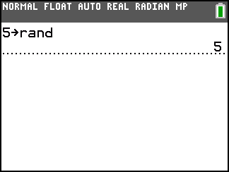  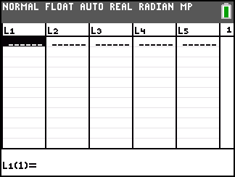
To simulate rolling two number cubes ten times, press , move to the PRB menu, and choose randInt(. Enter 1 for lower, 6 for upper, and 2 for n. Move to Paste and press . Press  on the Home screen.  Before pressing  again to simulate another roll of the two cubes, make sure the second person has recorded the numbers and the third person has recorded the mean. | 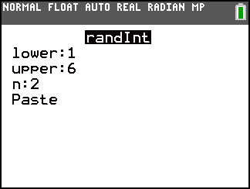
The third person in each group needs to switch with the third person in another group. Add the sample means of the other group to your list in L1. (This is like simulating another 10 rolls.) Continue to switch with other groups until you have a total of 50 sample means in L1.
When you return to your group, find the mean and standard deviation of the 50 sample means by pressing , choosing CALC, then 1-Var Stats, and then L1.
2. What is the mean and standard deviation? ,

Press  and set the values to the following.  Xmin = 0, Xmax = 7, Xscl = 1, Ymin = 0, Ymax = 40, Yscl = 1  Press   and select Plot1. Match the settings at the right. Press .  3. Sketch the histogram of the 50 sample means. | 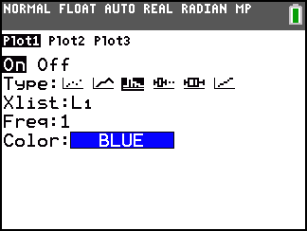
Problem 2 – Rolling Four Number Cubes
Clear list L1. Repeat the process, now for rolling four number cubes. The team member performing the simulations should use the command randInt and enter 1 for lower, 6 for upper, and 4 for n.

Again, use information from other groups so that you have data for 50 rolls of four cubes.
4. What is the mean and standard deviation? ,

5. Graph and sketch the histogram of the 50 means with the same the window settings.

Problem 3 – Rolling Seven Number Cubes
Clear list L1. Repeat the process, now for rolling four number cubes. The team member performing the simulations should use the command randInt and enter 1 for lower, 6 for upper, and 7 for n.

Again, use information from other groups so that you have data for 50 rolls of four cubes.
6. What is the mean and standard deviation? ,

7. Graph the histogram. Do not change the window settings from before. Sketch the histogram of the 50 sample means.

Problem 4 – Bringing it all Together
8. What happened to the histograms as n increased from 2 to 4 to 7?

9. What happened to the standard deviations as n increased?

10. What is true about the means of the sample means?

11. Find for 2, 4, and 7, where. Compare the results to your standard deviations.

12. State the Central Limit Theorem in your own words.

