Open the TI-Nspire™ document Quadratic_Functions_and_ Stopping_Distance.tns.  Examine data and generate regression equations to model the stopping distances under various driving conditions. Utilize these regression equations to see the effect of speed while driving under various conditions. | 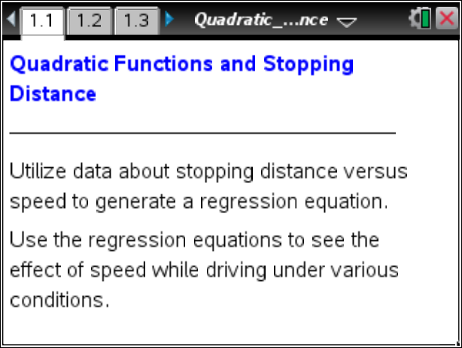

Move to page 1.2.

- Read page 1.2 and move to page 1.3 to look at the spreadsheet.
- Describe the effect that increased speed seems to have on stopping distances under normal driving conditions. Explain why this is so.

- Describe the effect that increased speed seems to have on stopping distances when the driver is using a cell phone. How does the increase in stopping distance compare to the increase in stopping distance under normal conditions?

- Describe the effect that increased speed seems to have on stopping distances in wet weather. How does the increase in stopping distance compare to the increase in stopping distance under the other two driving conditions?

Move to page 1.4.

- Read pages 1.4 through 1.5. On pages 1.6 through 1.8, you will see three Data & Statistics pages. On each page, click on the center of the bottom of the page to select speed as your independent variable. On page 1.6, click on the center of the left side of the page to select normal as your dependent variable. On page 1.7, select phone as your dependent variable, and on page 1.8, select weather as your dependent variable.

Scientists have determined that stopping distance is a quadratic function of speed. On each of the three pages, determine the quadratic function to model the data sets. Select Menu > Analyze > Regression > Show Quadratic. The graph of the quadratic function will be drawn and the equation shown. Write the equation for each of the functions.

Tech Tip: To determine the quadratic functions to model the data sets, select  > Analyze > Regression > Show Quadratic.

Normal: ______________________________________________________

Cell Phone: ______________________________________________________

Wet Weather: ______________________________________________________

- Use the regression equations to estimate, to the nearest meter, the stopping distance if a car was driving at 43 mph:
- Under normal conditions

- While talking on a cell phone

c. On wet roads

- If the model continued to approximate the stopping distance for a person driving at 65 mph while talking on a cell phone, determine the stopping distance.

- A football field is 100 yards long. How do the stopping distances in questions 3 and 4 relate to the length of a football field? (Note: 1 meter 1.09 yards)

- Which driving condition seems to have the greatest impact on stopping distance? Explain your reasoning.

Move to page 2.1.

- Read page 2.1 and then move to page 2.2. Drag the open circle to see what would happen to a pedestrian if the driver of a car tries to stop under normal conditions. Write compound inequalities to describe the speed intervals for each consequence.

Move to page 2.3.

- Drag the open circle to see what would happen to a pedestrian if the driver of a car tries to stop while the driver is talking on a cell phone. Write compound inequalities to describe the speed intervals for each consequence.

Move to page 2.4.

- Drag the open circle to see what would happen to a pedestrian if the driver of a car tries to stop in wet weather. Write compound inequalities to describe the speed intervals for each consequence.

- Examine the compound inequalities in questions 7, 8, and 9. Describe the differences of speed and conditions that would:
- Enable a driver to stop in time without injuring the pedestrian.

- Likely injure or seriously injure the pedestrian.

- Likely fatally injure the pedestrian.

- Stopping distance is determined by a combination of reaction distance and braking distance. Why do you think that the consequences for the three driving conditions vary so much?

