Open the TI-Nspire™ document Toying_with_a_Walk.tns.  In this investigation, we will determine the relationship between the number of "steps" a walker takes and the time it takes to make these "steps". You will graph your step data and identify a function that best models the situation. | 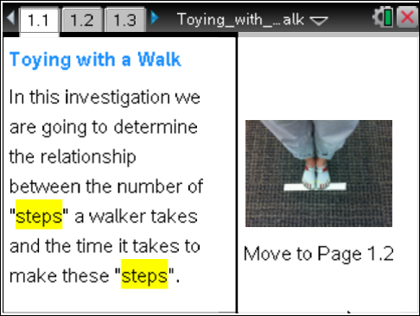

Move to page 1.2. | Press / ¢ and / ¡ to navigate through the lesson.
The Track
0 |  | 6 |  | 12 |  | 18
START

 | 3 |  | 9 |  | 15
Number of Steps (0-18)
1. Select one walker for the class, and lay down a track as shown above (your track might be longer).
- The starting point is at the leading edge of the tape (see photographs on handheld).
- The walker steps heel-to-toe (with feet touching) for the entire walk.
- The walker should make several test walks to determine if she can cover the track at a fairly constant rate.
2. As she makes her test walks, each student will be assigned a step position. Stand at your assigned position along the track.

Move to page 1.3.

3. Type your name and your assigned step position on this page.
- Estimate the time it takes the walker to get to your assigned number of steps: __________.
- How fast do you think the walker is moving? Explain how you determined this.

Move to pages 1.4 and 1.5.

4. Read the directions on Page 1.4, and use the Sean’s Stopwatch Timer on Page 1.5 to time the walker.
5. When the walker starts her walk for data collection, press · to start your timer.
6. Just after she takes the step that you have been assigned, press · again to stop the timer.

Tech Tip: To start the stopwatch, tap the green play button. To stop the stopwatch, tap the red stop button. To collect lap times, tap the blue curved arrow.

Move to page 1.6.

This page gives you the time from the stopwatch up to 3 decimal points. Use this precise number when you are recording your trial times. The number is replaced by a new number every time you turn the stopwatch on and off.

Move to page 1.7.

7. On this page, record the time for your step position under Column time_1.
8. As other students are called on, record their times for the rest of the positions in the same column.
9. Run 2 more trial walks, collect the time data in the same way, and record it under Columns time_2 and time_3.
10. When you have all of your time data, move to the time_avg column.
11. Calculate the average (mean) of the times for the three trials and record the average in this column. If you are unsure how to calculate the mean of three numbers, ask your teacher.

Move to page 1.8.

12. On this plot of your time data, select time_avg as the y-variable.
13. Examine the pattern in the plot, and discuss what you see with your peers and your teacher.

Move to page 1.9.

14. Determine the name of the line that will touch the majority of points on your plot. You may use any method that you wish, but you should document your work on your handheld.

Move to page 2.1.

15. On this page, write the function that you settled on.

Move to pages 2.2 through 2.13.

Answer the following questions on your handheld.
16. Using the equation of the line you chose, determine the time it should take your walker to cover 33 steps.
17. Using the equation of the line you chose, determine the approximate number of steps your walker would take in 190 seconds.
18. What is the meaning of the slope of the equation of your line?
19. How would the graph and the function modeling the walker change if the class collected data every 4th step, rather than after every 3rd step?
20. How might the graph and function for this event change if you switched walkers but kept the data collection techniques the same?
21. How would your data collection have to change to use time as the x-variable?
22. What would your equation look like if you used the number of steps as the y-variable?
23. Measure the length of the walker’s foot from heel to toe in centimeters.
24. If a new walker had the same pace as the first but larger feet, how would that change the slope of the function that models the collected data?
25. Rewrite your function converting steps to centimeters using the value you got for the length of the walker’s foot.
26. If the walker starts 6 paces behind the starting line and you start your time when she starts walking, stopping the timer when she gets to your spot, what would the graph of the data look like? Sketch the graph of her walk on Page 1.13.

