Overview

In this activity, you will determine the association between the number of hours spent per week playing video games and Grade Point Average (GPA). You will input data into a list, conduct a hypothesis test for the association, and find a confidence interval for the slope.

Materials
• TI-Nspire™ handheld or Computer Software

Part 1—Preparing the document  1. Open a new document by pressing c > New Document > Add Notes.  2. Type Slope – CI and Test.  3. Press ~ > File > Save As … and type Slope_CI_and_Test. Then e to ¾ , and press ·.  Note: To obtain capital letters, press the g key, then the letter. | 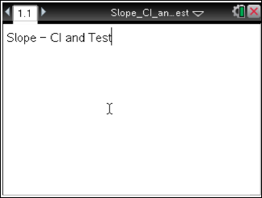

A school district wants to see if there is an association between a student’s GPA and the number of hours spent playing video games per week. The data from 14 randomly-selected high school students is displayed below. Before calculating a confidence interval or performing a hypothesis test on the slope, conditions for inference on bivariate data must be checked. You can refer to other TINspired Create documents if you do not know how to create a scatterplot, a histogram, or a normal probability plot to check for normality.

Student | Hours of Video Game Play per Week | GPA
A | 17.5 | 2.0
B | 15 | 3.0
C | 25 | 0.8
D | 15.5 | 2.7
E | 11 | 2.6
F | 12.5 | 3.6
G | 3.5 | 4.0
H | 6 | 3.2
I | 24 | 1.0
J | 13 | 2.9
K | 20.5 | 1.8
L | 9 | 3.5
M | 23.5 | 1.5
N | 2 | 3.8

Part 2—Enter the data
1. Add a new page by pressing / ¿ and selecting Add Lists & Spreadsheet.
2. On the Lists & Spreadsheet page, move the cursor to the top of Column A. Type hours to label Column A, and press ·.  3. Move the cursor to the top of Column B, and type gpa to label Column B.  4. Fill in the data for the number of hours of video game playing per week for each student. Be sure to press · after you enter each value to move to the next cell.  5. Move to the next column to fill in the data for the corresponding GPA for each student.  - If you make a mistake, move the cursor to that cell, press a to activate the cell, input the correct value, and press ·.  Note: To save your document, press / ». | 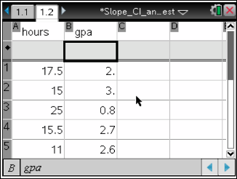
Part 3—Conduct a Hypothesis Test for the Slope  In order to conduct a hypothesis test or to create a confidence interval, certain conditions must be checked. To check these conditions, you need to calculate the regression line and the residuals. Conducting a hypothesis test and finding a confidence interval do both of these things for you, so we will first conduct the test, then go back to check the conditions.  1. Move the cursor to the first cell in Column C, and select MENU > Statistics > Stat Tests > Linear Reg t Test to begin the hypothesis test for the association. | 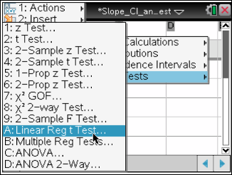
2. Fill in the boxes in the dialogue box. First, fill in the explanatory variable for X List by clicking on the arrow and selecting hours.
3. Press e to move to the Y List. Fill in the name of the response variable by clicking on the arrow and selecting GPA.
4. Save RegEqn will automatically choose where the linear regression equation will be saved.
- You can choose a different place by clicking on the arrow.
- Frequency List is automatically set at a default of 1. The frequency in this scenario is one since all students are listed.
5. Press e to move to the Alternative Hyp, and select the alternative hypothesis by clicking on the arrow and selecting the two-tailed option Ha: β & ρ ≠0.
Note: β is the true slope of the population, and ρ is the true correlation coefficient of the population.
6. Select OK to perform the hypothesis test on the association of GPA vs. number of hours of video game playing per week. The output will report the results of the hypothesis test including the regression equation, test statistic, p-value, correlation, residuals, and other characteristics. | 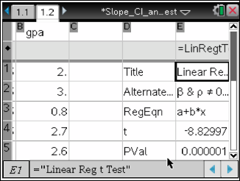
Note: Lists & Spreadsheet and Notes pages are dynamic when they are in the same problem. If you change a value in the original data set, the information will be recalculated automatically. This will be demonstrated in the pages in this activity.

Part 4 — Check the Linearity of the Scatterplot and the Residual Plot  1. Add a new page by pressing / ¿ and selecting Add Data & Statistics.  2. Move the cursor to the bottom of the screen, click on “click to add variable,” and select hours.  3. Move the cursor to the middle of the left side of the screen, click on “click to add variable,” and select GPA. | 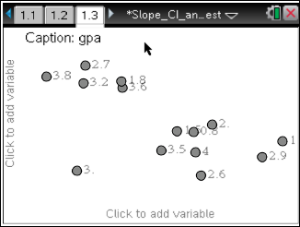
4. Select MENU > Plot Properties > Add Y Variable > stat.resid. | 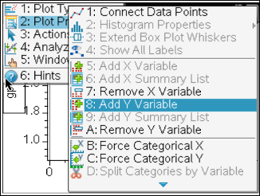
Step 5—Check the Normality of the Residuals  1. Add a new page by pressing / ¿ and selecting Add Data & Statistics.  2. Move the cursor to the bottom of the screen, click on “click to add variable,” and select stat.resid.  3. Select MENU > Plot Type > Normal Probability Plot. | 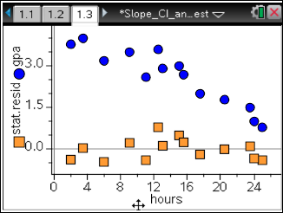

Step 6—Calculate a 95% Confidence Interval for the Slope  1. Add a new page by pressing / ¿ and selecting Add Notes.  2. Select MENU > Calculations > Statistics > Confidence Intervals > Linear Reg t Intervals… to begin the confidence interval for slope. | 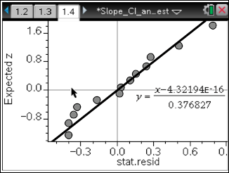  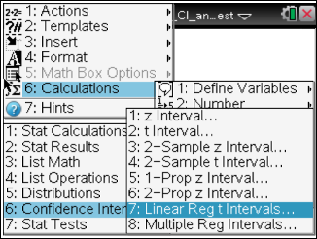
3. Select OK to find an interval for the slope. | 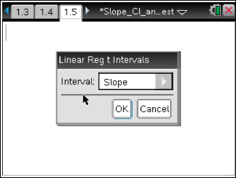
4. Fill in the explanatory variable in the dialogue box for X List by clicking on the arrow and selecting hours.  5. Press e to move to the Y List. Fill in the name of the response variable by clicking on the arrow and selecting GPA. | 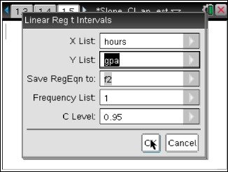
6. Save RegEqn to will automatically choose where the linear regression equation will be saved.  - You can choose a different place by clicking on the arrow.  - Frequency List is automatically set at a default of 1. The frequency in this scenario is one since all students are listed.  7. Press e to move to C Level and enter .95 into the box.  8. Select OK to calculate the 95% confidence interval for the slope. | 