Open the TI-Nspire™ document Vertex_and_Factored_Forms_ of_Quadratic_Functions.tns.  How do the parameters in the vertex and factored forms of quadratic functions determine the shape of the graph? What is the relationship of the factored form and the x-intercepts? In this lesson, you will use sliders to investigate these questions. | 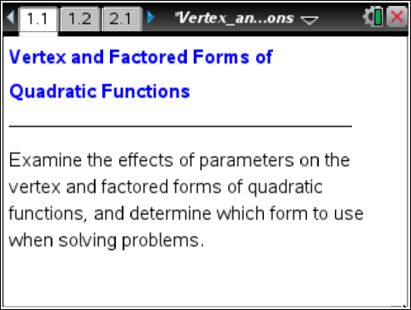

Move to page 1.2.

1. Given the vertex form of a quadratic function, f(x) = a(x – h)² + k, Sam said that a change in the value of k results in a change in the y-coordinate of each point on the graph. Do you agree or disagree with Sam? Use the sliders to investigate. Explain your reasoning.

2. Sal observed that when f(x) = 1(x – 3)², all of the x-coordinates are 3 less than they were when f(x) = 1x². Do you agree or disagree with Sal? Use the sliders to explore. Explain your reasoning.

3. Change slider a and describe its effect on the parabola. Discuss the effect of the sign of a (whether it is positive or negative), its magnitude (how big or small it is), and anything else that seems important.

4. Given the function f(x) = a(x – h)² + k, describe in general what effect changing h will have on the graph of the parabola. What does it have to do with the vertex? Use the sliders to investigate if necessary. Explain your answer.

5. Given the function f(x) = a(x – h)² + k, describe in general what effect changing k will have on the graph of the parabola. What does it have to do with the vertex? Use the sliders to investigate if necessary. Explain your answer.

6. Using the form f(x) = a(x – h)² + k, describe the graph and the function that has a vertex of (–2, –5). Is there more than one answer?

Move to page 2.1.

On this page, there is another form of the quadratic, the factored form: f(x) = a(x – r)(x – s).

- Change slider a to change the value of the variable. Suzy thinks that as the a-value gets larger, the parabola will be stretched away from the x-axis, and as the a-value gets smaller, it will be compressed toward the x-axis. Is her thinking accurate? Explain. Does a change in the value of a have the same effect as it did in the vertex form?

- Changes in the value of a seem to result in changes in all the points on the graph except for two: the x-intercepts of the parabola (the roots or zeroes). Adjust all the sliders and observe the effect that each has on the x-intercepts. How are the locations of the x-intercepts related to the values of the sliders?

- Jason said that changing the value of r moves the parabola horizontally. Jeremy said that changing the value of s also moves the parabola horizontally. Who is correct? Why? What other information do the r and s values provide?

10. In factored form, what seems to be the relationship between the vertex and the x-intercepts? Write an expression for the x-coordinate of the vertex in terms of r and s.

11. Change the sliders so that r = s. Describe the resulting parabola.

12. Write a quadratic function with zeroes at x = –2 and x = 3. Use the form f(x) = a(x – r)(x – s) and change the sliders to check your function.

- Three different forms for a quadratic function are:
Standard form: f(x) = 3x² + 6x – 24
Vertex form: f(x) = 3(x + 1)² – 27
Factored form: f(x) = 3(x + 4)(x – 2)
- Show that the three forms are equivalent.

- Determine each of the following and explain how to choose the best form of the quadratic function for obtaining your answer:
- the smallest value(s) of the function

- the x-value(s) of the zero(s) of the function

- the value(s) of the function when x = 0

- A ball is thrown up in the air. Three different forms for the height of the ball, in feet, as a function of time, x, in seconds, are:
Standard form: f(x) = -16x² + 32x + 48
Vertex form: f(x) = -16(x – 1)² + 64
Factored form: f(x) = -16(x – 3)(x + 1)
- Show that the three forms are equivalent.

- Determine each of the following and explain how to choose the best form of the quadratic function for obtaining your answer.
- the time for the ball to hit the ground

- the time for the ball to reach its maximum height

- the initial height from which the ball was thrown

- the maximum height of the ball

