Open the TI-Nspire document Sound_Beats.tns.  In this activity, you will explore graphical and algebraic representations of sound beats produced by two tuning forks. Then you will investigate the frequency conditions that are necessary to produce sound beats. Next, you will derive formulas for the wave and beat frequencies in terms of the frequencies of the tuning forks. Finally, you will apply your understanding of sound beats to problem solving. | 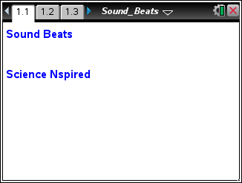
Before working through this activity, review the principle of superposition and the properties of sound waves (including period and frequency). Remember that the human ear can detect sounds in the range of 20 Hz to 20 kHz.

You should also be familiar with the sum-to-product identity: .
Throughout this activity, you will use simulations of the superposition of sound waves (represented by sine waves) that are produced by two tuning forks. Also, by varying the frequencies of these tuning forks you will be able to observe the effects on the superposition of the waves. Using these data, you will derive formulas for wave frequency and beat frequency according to the frequencies of these tuning forks. You will also determine the frequency conditions necessary to produce sound beats. This activity consists of two problems. In the first problem, you will explore the simulated superposition of sounds from two tuning forks. Then you will derive the formulas relating wave frequency and beat frequency to the frequencies of the tuning forks. In the second problem, you will apply your findings to actual problem solving.
Move to pages 1.2 and 1.3.  1. Study the graphs.  Page 1.3 shows sine wave representations of the sounds produced by the two tuning forks on page 1.2. In these graphs, the y-axis represents the pressure changes that produce the sound, and the x-axis represents time in seconds. | 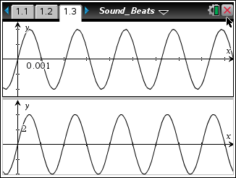

Move to pages 1.4 and 1.5. Answer the following questions here or in the .tns file.
Q1. Determine which of the graphs represents the sound produced by each of the tuning forks on page 1.2. Explain how you calculated the frequencies of the tuning forks from the graphs.

Q2. Write equations for the two graphs shown on page 1.3. (Remember that the equation for the sine wave representing a sound with frequency f is given by , where A is the amplitude of the wave.)

Move to page 1.6.  2. Study the graph. | 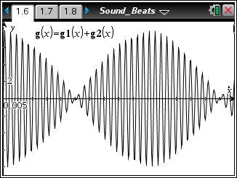
Move to page 1.7. Answer the following questions here or in the .tns file.
Q3. Describe any patterns that you see in the graph.

Q4. Determine the frequency of the high-frequency oscillation and of the low-frequency amplitude variation.

Tech Tip: To observe more of the wave pattern, grab and drag the screen to the left or right.
Return to page 1.6.
3. Analyze how the interference of the sound waves produces the beat effect.
The high-frequency wave represents the pitch of the superposed waves (i.e., the pitch of the resulting sound). The low-frequency wave (which modifies the amplitude of the high-frequency wave) represents the changes in loudness of the superposed waves. The frequency of the superposed waves is called the wave frequency, f_{wave}. The frequency at which the loudness of the superposed waves seems to change is called the beat frequency, f_{beat}.

Move to pages 1.8–1.14. Answer the following questions here or in the .tns file.
Q5. The graph g(x) on page 1.6 represents the sum of the two graphs on page 1.3. Write an equation for the function g(x) in terms of the frequencies of the two tuning forks, f₁ and f₂.

Q6. Use the sum-to-product identity to convert the equation from Question 5 into an equation involving both sine and cosine. Assume that the amplitudes of the two waves are the same. (Do not substitute the given values of f₁ and f₂ into the equation yet.)

Q7. The wave produced by adding the two original waves is a sine wave with varying amplitude. Based on the equation you wrote in Question 6, what is the amplitude of the sine wave in terms of f₁, f₂, and x?

Q8. What is the beat frequency of the combined wave?

Q9. The pitch of the resultant wave is related to the frequency of the wave. Write an expression for the frequency of the sine wave.

Q10. Substitute the values of f₁ and f₂ into the equation you derived in Question 6. Write the equation for the superposition of the waves in terms of x. Use the Calculator application on page 1.13 to confirm your equation.

Q11. Use the expressions you derived in Questions 8 and 9 to determine the beat frequency and the wave frequency for the superposed waves on page 1.6. Do your results agree with the empirical results you obtained in Question 4?

Return to page 1.2.  4. Change the frequency values for the two tuning forks. | 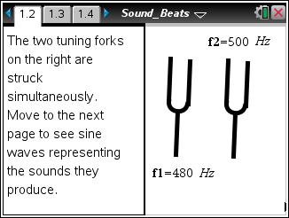
Tech Tip: To change the value, tap twice, and get the cursor first before trying to change the values. Select undo if you accidently delete the entry box while trying to change the value.

Move to pages 1.15–1.17. Answer the following questions here or in the .tns file.
Q12. How does the graph of the sound wave (page 1.3) change when you increase the frequency of a tuning fork? What happens when you decrease the frequency of a tuning fork?

Q13. What happens to the superposition of the sound waves (page 1.6) when you increase or decrease the frequencies of the tuning forks?

Q14. What is the maximum frequency difference that will still produce beats? Give your answer in terms of a ratio between the frequency difference, ∆f, and the frequency of the first tuning fork, f₁.

Move to page 2.1.  5. A Calculator application is provided on the bottom of this page for computations. | 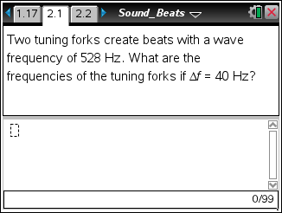
Tech Tip: To bring up the Calculator on page 2.1, tap anywhere below the gray line, and the keyboard will pop up.
Answer the following questions here or in the .tns file.
Q15. Two tuning forks create beats with a wave frequency of 528 Hz. What are the frequencies of the tuning forks if ∆f = 40 Hz?

Move to page 2.2.  6. Use the Graph Trace tool to determine wave frequency and beat frequency from the graph. (You can select / e to move between applications on the screen.) Then answer the question. You may want to insert a Calculator application to check your calculations. | 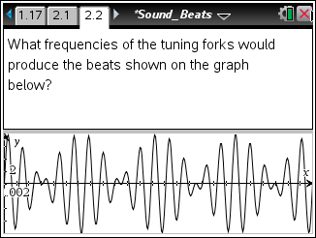
Tech Tip: To use the Graph Trace tool, select Menu > Trace > Graph Trace. To insert a Calculator application, select Doc > Insert > Calculator or Calculate using the Scratchpad »
Tech Tip: Tap the bottom of the page to activate the graph window, and then to use the Graph Trace tool, select  > Trace > Graph Trace. You may need to back-out to the main Tools Menu to see the desired menu option. To insert a Calculator application, select  > Calculator.

