Open the TI-Nspire document Scaling_The_Geometry.tns.  In this investigation, we will scale the images of objects of known measures. | 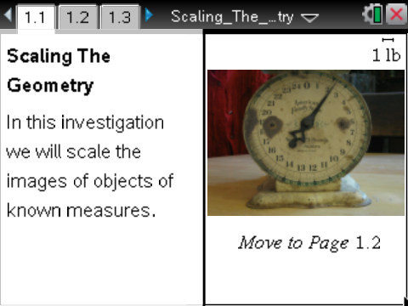

Move to page 1.2. | Press / ¢ and / ¡ to navigate through the lesson.
1. On this page, the images of the two paperclips have a reference length from the image of the inch ruler. Your goal is to draw on the screen and then measure the length of what you draw.
In the upper right corner of the screen, you can see that the Scale bar represents 1 inch. That is, the number of pixels on the screen represented by the horizontal I-Beam is scaled so that this length on the page represents one inch. If this scale works for you, then leave it as it is. If it is not good for you, you can adjust the scale.
2. Select MENU > Points & Lines > Segment. Click one point on the ruler and then another to make a line segment to be measured. Be careful to draw the shortest line segment between the chosen points.

3. Now measure the length of your segment. Select MENU > Measurement > Length, point the cursor at the line segment, and click to get the measure. Click again when you have the number on the screen where you want it.
- You might need to use e to get to the item you want to measure.

4. Now adjust the Scale, if needed, so that the measure shown is correct. Determine the value needed for the scale (create a proportion and calculate) and move your cursor to the scale. Click once on the scale, and move your cursor to change the value to what to show on the new scale.
- In this case, the distance from 51 inches to 52 inches should be one inch. However, the
TI-Nspire is showing 6.44 inches.
- Add a Calculator page by pressing / I 1 or use the ScratchPad by pressing c A to determine the scale needed. To return to the document from the ScrachPad, press c 4.

5. Now measure the small and then the large paperclip. Compare the values, using your scale from above with the True lengths of the two paperclips.
Hint: Draw vertical segments from the ends of the clips to the tape measure to help avoid any errors.

Move to page 1.3.

6. Page 1.3. shows a different ruler. Examine the bottom part of the ruler. The small marks here are millimeters. Select a length more than 2 cm, and carefully draw a line segment on the ruler. Then measure it as before and adjust the scale until the line segment you measured is correct in length.

Move to page 1.4.

7. The True width and height of the TI-Nspire CX handheld is shown on this page. Draw around the image (using the Segment or the Rectangle tools) and measure as before. Then adjust the scale so that the two measures are represented. Remember, if the Tab option appears, select the item you want to measure—perimeter or length. Recall the formula for the perimeter of a rectangle.

Move to page 1.5.

8. On this page, we want to draw a circle that represents the quarter and then create a scale with some measurements to get the True value(s). Recall the relationship between circumference, diameter, and radius and feel free to draw and measure these parts of a circle.

Tech Tips: Use e to switch the focus of your action if you don’t see what you want.
You might see the Graph Entry line; press /G to hide it.
Press d to exit the tool you are using when you don’t need it anymore.
You can grab and adjust the circle after you draw it, if you have dismissed the circle drawing tool.

Move to page 1.6.

9. On this page, we have a graduated cylinder marked in milliliters. Just as with the ruler, we can scale this image using the tick marks on the cylinder. There are 10 ml between the numbered lines. Make your line segment as short as possible but cover more than 10 ml. Measure and adjust the scale as before, but note that the units are now in milliliters and you are just simulating the reading of a scale to get a value.

Move to page 1.7.

10. On this page, we have a thermometer with a scale in degrees Fahrenheit (°F). Draw a line segment on the figure “longer” than 10 degrees. Measure and scale as before.

Optional Extensions
Move to page 1.8.

11. The clock has a measurement in seconds. We will use an arc length to model a scale, assuming that the tip of the second hand moves a given distance in a given number of seconds.

Move to page 1.9.

12. With the scale now in ounces, measure the arc of a circle to model a given weight.

Move to page 1.10.

13. Take a photo and a known measurement. Then have your teacher insert the image onto this page so you can measure it and scale as you have done before.

