Open the TI-Nspire document Ocean_Currents.tns  Have you ever been swimming in a body of water with a strong current? A water current can supply a very strong force that moves water and objects in the water through a great distance. You are probably most familiar with water currents in relatively shallow bodies of water, such as shallow streams or rivers. However, did you know that there are also water currents deep below the surface of the ocean? What causes these currents to flow? |  | 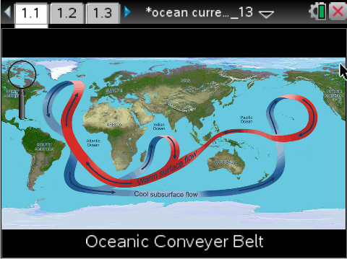
Move to pages 1.2 and 1.3. Read the background information below and/or on your device.
Ocean water is in constant motion throughout a global system of deep ocean currents known as the oceanic conveyor belt. These deep ocean currents are not the same as surface, or wind-driven currents. Deep ocean currents move at much slower speeds (around a few centimeters per second) when compared to surface currents, which can travel anywhere from tens to hundreds of cm per second. It is estimated that it can take around 1,000 years for a cubic meter of water to travel through the entire system.

In this activity, you will take a closer look at the oceanic conveyor belt and investigate the environmental factors that drive the current system. You will specifically investigate the following factors: wind, pH, temperature, and salinity. Wind is a measure of the speed of the air flowing just over the surface of the ocean, and pH is a measure of how acidic or basic the water is. Temperature measures how hot or cold the water is, and salinity is a measure of how much salt is dissolved in the water. An important concept to remember is the density of water. This is a measure of how much mass is concentrated in a volume of water. When the temperature of water increases, its density decreases. Also, when the salinity of water increases, the density increases. Less dense fluids will float, and denser fluids will sink.
Move to page 1.4.
Read the directions for the simulation.
1. To begin researching, select the magnifying glass. Place the magnifying glass over the Indian Ocean until a question mark appears on the screen. Once the question mark is displayed, select it to zoom in on the area.  2 A series of buoys will appear on the screen. Using the same process as before, select the magnifying glass and select each of the buoys on the screen.  4. As you select buoys, all of the data viewed will be stored on a spreadsheet on page 1.5.  5. Record your data in the table. | 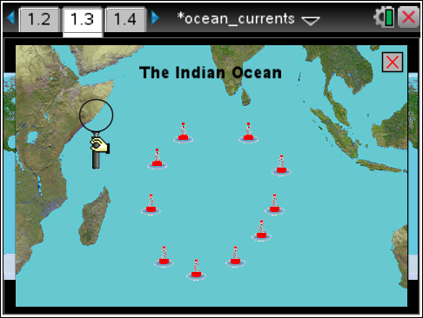
Tech Tip: To access the Directions again, select  > Directions.
Tech Tip: To access the Directions again, select b or Document Tools () > Ocean Currents > Directions.
Buoy | Temp (° C) | Salinity (ppt) | pH | Wind | Place the number next to each buoy.
1 |  |  |  |  | 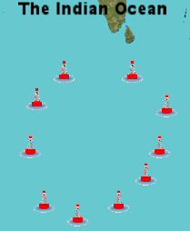
2
3
4
5
6
7
8
9
10

Move to pages 2.1 – 2.13.
Answer questions 1 – 13 below and/or in your .tns file.

Tech Tip: To scroll through data in the spreadsheet on screen 1.5, press your finger anywhere on the screen and drag it up or down.

Q1. On page 1.6, set the y-axis to temperature and the x-axis to buoy. What pattern do you notice?

Q2. Examine the oceanic conveyor belt shown on the main screen of page 1.3. When looking at the current located towards the west, closer to the coast of Africa, we can determine that this is a ___ water current.

A. warm
B. cold

Q3. As you increase the temperature of water (and keep other variables constant), what happens to the density of water?

A. The density increases.
B. The density decreases.
C. The density stays the same.

Q4. Why would temperature have an effect on the current system?

Q5. Upwelling is the process where cold, deep water returns to the surface and then becomes a shallow current. From examination of the ocean conveyor belt and buoy data, at which buoy is this process most likely to occur?

A. buoy 2
B. buoy 5
C. buoy 8
D. buoy 10

Q6. Is there any observable pattern with the pH numbers from the different buoys?

A. yes
B. no

Q7. Where is the cold water directly coming from before it gets close to the equator?

A. the North
B. the East, near Australia
C. the South, near Antarctica

Q8. Does the wind pattern match the overall flow of the current?

A. yes
B. no

Q9. What type of current is guided by wind?

A. deep water current
B. surface current
C. surface and deep water current

Q10. Deep ocean currents flowing into the Indian Ocean are very salty. When these currents upwell to the surface, which of the following would likely increase in the region of water around the upwelling?

A. temperature
B. wind
C. pH
D. salinity

Q11. The water in an arctic region is very dense, causing it to sink down towards the ocean floor. This process is called downwelling. Which of the following best describes this water?

A. warm freshwater
B. warm salty water
C. cold freshwater
D. cold salty water

Q12. Which factors have an effect on upwelling and downwelling in ocean currents? (select ALL that apply)

A. pH
B. temperature
C. wind
D. salinity

Q13. The current system is driven by a process known as thermohaline circulation. Using what you have learned throughout this simulation, explain what is meant by that term.

