Open the TI-Nspire document Two_Dimensional_Motion_and_Vectors.tns.  In physics many quantities use one- and two-dimensional position, displacement, speed, velocity, and acceleration over time. These vector quantities require special skills to manipulate. In this activity you will measure and describe one- and two-dimensional position, displacement, speed, velocity, and acceleration over time. Then you will graphically calculate the resultant of two or more vectors. Afterwards, you will manipulate vectors and observe changes in magnitude, angle, x-component, and y-component. Next, you will then explore the motion of an object subjected to forces in two directions. Finally, you will use the Pythagorean theorem and the tangent function to calculate the resultant of two or more vectors. | 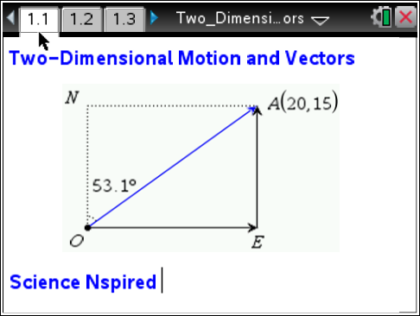

Move to pages 1.2–1.4.
1. Open the file Two_Dimensional_Motion_and_Vectors.tns and read pages 1.2 and 1.3.
2. Page 1.4 shows the displacement vector formed by moving 20 m east and 15 m north. Determine the length of the vector. Calculate vector OA and confirm by measuring.

Tech Tip: Measure the length by selecting Menu > Measurement > Length.
 Tech Tip: Select 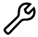 > Measurement > Length. Note that in some cases, you may need to back-out to the main Tools Menu to see the desired menu option.
Move to pages 1.5–1.7. Answer the following questions here or in the .tns file.
Q1. What is the length of vector OA in meters?

Q2. What is the length of vector EA in meters?

Q3. What is the length of vector OE in meters?

Q4. Write and solve an equation relating the length of vector OA to the lengths of vectors OE and EA.

Q5. Write an equation that relates vectors EA, OE, and OA.

Q6. Another way to reach point A is to walk 25 m in the direction 53.1° east of north. Use θ to represent the angle between vector OA and the vertical. Write equations showing the relationship between θ, the length of vector OA, and the lengths of vectors EA and OE.

Move to pages 1.8 and 1.9.  3. Read 1.8, which gives directions for 1.9. On page 1.9, you will find a similar situation to page 1.4. Grab point A and change vector OA until point A coincides with point X. | 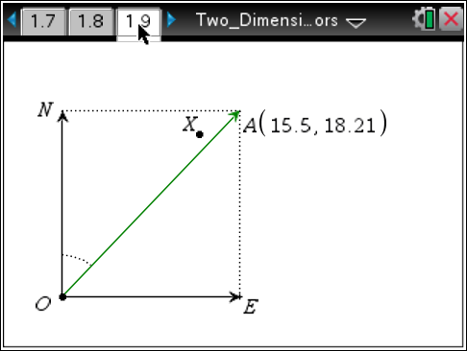
Tech Tip: To drag point A, press your finger to the point and drag it along the screen. If the point is near many other objects, you may need to tap the point and select point A from the menu.
Move to page 1.10. Answer the following questions here or in the .tns file.
Q7. How many meters north and how many meters east would you have to walk to get to point X from point O?

Q8. Describe the displacement vector of a person who walks directly from point O to point X. Explain how you got your answer.

Move to pages 1.11 and 1.12.  4. Read page 1.11, which explains the animated simulation of a boat crossing a river on page 1.12. You can change the magnitudes of the velocities of the boat and the river by double-clicking on the variables vboat and vriver. The animation will then change to show the resulting path of the boat.  Note: The direction that the “boat” is pointing represents the boat's final velocity vector, not its initial vector. This is why the boat does not point directly across the river. | 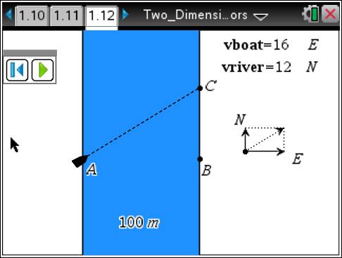
Tech Tip: To play the simulation, have students select the Play button in the toolbar of the simulation.
Move to pages 1.13–1.18. Answer the following questions here or in the .tns file.
5. Return to the animation on page 1.12 as needed.  Note: You cannot use the Measurement tool to determine lengths and angles in this animation. The dimensions of the animation have been set so that they will give incorrect values  if the Measurement tool is used. You must use the Pythagorean theorem and trigonometric relationships to answer Questions  9–15. | 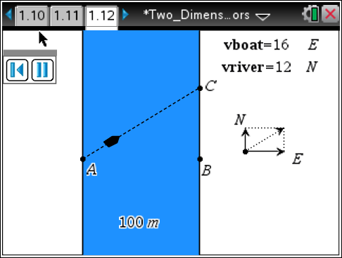
Q9. How does changing the speed of the boat affect the boat's overall path?

Q10. How does changing the speed of the river affect the boat's overall path?

Q11. If the boat moves due east at 16 m/s and the river flows due north at 12 m/s, what is the speed of the boat relative to an observer at point A? What angle does the boat make with the west bank of the river? Show your work.

Q12. If the boat moves due east at 16 m/s and the river flows due north at 12 m/s, how many seconds does it take for the boat to travel across the river? Show your work.

Q13. If the boat moves due east at 16 m/s and the river flows due north at 6 m/s, how many seconds does it take for the boat to travel across the river? Based on your answer, draw a conclusion about the factors affecting the boat's crossing time.

Q14. If the boat moves due east at 16 m/s and the river flows due north at 6 m/s, how many meters north is point C from point B? Show your work.

Q15. If the boat moves due east at 10 m/s and the river flows due north at 6 m/s, how many meters north is point C from point B?

