Open the TI-Nspire document Parabolic_Paths.tns.  This lesson involves changing the parameters of a quadratic function in vertex form and standard form , so that the path will intercept a particular point. A trainer is throwing fish to feed the seals at an aquarium. Sliders will change the position of the trainer and the seals. | 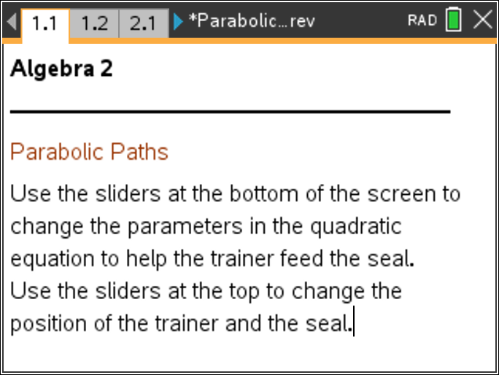

Move to page 1.2. | Press / ¢ and / ¡ to navigate through the lesson.
Use the sliders at the bottom of the screen to change the values of h and k in the quadratic equation . Help the trainer (on the vertical axis) feed the seals. The seal is pictured along the horizontal axis. The horizontal axis is representing the water; however, the seal can jump up on the rocks (represented by the black box). A message will tell you when the seal catches the fish. New problems can be generated by clicking the NEW slider on the left of the page. Try several problems before answering the questions.

1. What is the effect of changing the value of h?

2. What is the effect of changing the value of k?

3. If the trainer throws the fish over the seal, should you increase or decrease the value of h? Explain.

4. If the trainer throws the fish just short of the seal, should you increase or decrease the value of h? Explain.

5. Can there be more than one throw (quadratic equation) which will reach the seal? Explain.

Move to page 2.1.

Use the sliders at the bottom of the screen to change the values of a and b in the quadratic equation . Help the trainer feed the seals. A message will tell you when the seal catches the fish. New problems can be obtained by clicking the NEW slider on the left of the page. Try several problems before answering the questions.

6. What does the value of c in the quadratic equation represent in this scenario?

7. What do you notice happens to the graph as you change the value of a?

8. What effects did you notice as you changed the value of b?

9. If the trainer throws the fish over the seal, should you increase or decrease the values of a and b? Explain.

10. Can you always reach the seal by changing just one of the parameters?

11. Comparing the two forms of the quadratic equation, is it easier to find the quadratic equation to feed the seal using vertex form or standard form? Explain.

12. If a third point was given (for example the vertex of the parabolic path), can there be more than one throw (quadratic equation) which will reach the seal? Explain.

