Open the TI-Nspire™ document Boxplots_Introduction.tns.  In this activity, we will use boxplots to represent distributions of data of 28 heights measured in inches. You will also learn about the relationship between individual data values and the five-number summary. | 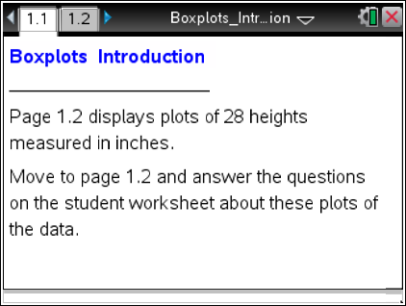

Move to page 1.2.

Note: To return to the original plot, select the up arrow located in the lower right work area.
1. In the top work area, move the cursor over the boxplot from left to right, and identify the five summary percentiles of the boxplot. These five important statistical values are called the five-number summary.

2. a. Determine the longest interval in the box. How long is it?

b. Which interval do you think has the most data points? Explain your reasoning, and then check your answer by selecting each interval.

3. Consider the dot plot in the lower work area on the same page.
a. Describe the center, shape, and spread of the distribution of heights.

b. How is the shape of the distribution visible in the boxplot?

4. a. Find the person with a height of 62.5 inches. Use the boxplot to describe how this person's height relates to the distribution as a whole.

b. Compare the conclusions you can draw about the distribution of heights by looking at just the boxplot and the conclusions you can draw by looking at just the dot plot.

5. You can move the points in the plots.
a. Select the point in the dot plot representing the largest height. Note that when a point is selected, it will be shaded. Move that point, and describe what happens.

b. Grab and drag the maximum point to the right, creating an outlier. At what value does it become an outlier?

c. Explain how you can check mathematically to see if it is really an outlier.

6. Return to the original plots by selecting the up arrow.
a. Select the points in the dot plot representing the three largest heights. Grab one point, and move it. Describe what happens in the two plots.

b. Select the upper whisker in the boxplot. Move one of the points in that interval, and describe what happens in the two plots.

7. Return to the original plots. Keep the median unchanged. Grab and drag points in the dot plot to create a symmetric boxplot.
- Describe your boxplot.

b. What did you do to get a symmetric distribution, and why?

8. Keep the same minimum and maximum values. Grab and drag points in the dot plot to create a left-skewed distribution.
a. Sketch your boxplot below, and describe how your process was different from the process you used in Question 7. If all you had were the boxplot, how would you describe the heights of the class?

b. How many data values would you expect to find in the interval covered by the box? Explain your reasoning, and then check your answer.

9. Keep the minimum, Q1, Q3, and maximum unchanged. Describe how you would grab and drag points so the median line is closer to Q3 than to Q1. Check your answer using the two plots.

10. a. Describe how you would move points to change the graph so that the left whisker gets absorbed into the box.

- Write a sentence about the distribution that you can surmise from the boxplot but not from the dot plot.

c. Write a sentence about the distribution that you can surmise from the dot plot but not from the boxplot.

11. If you observe an interval in a boxplot that is noticeably shorter than the other intervals, what does this indicate about the corresponding region in a dot plot? Explain why your dot plots are reasonable.

12. Suppose you had additional pages in your document with the following boxplots. Sketch a possible dot plot for each and describe the shape, center, and spread. Identify a set of data you think is represented by the boxplot or dot plot.
a. b. c.
