Open the TI-Nspire document Confidence_Levels_for_Means.tns.  What are confidence levels, and how are they used? In this activity, you will generate confidence intervals and use them to help you answer those questions. | 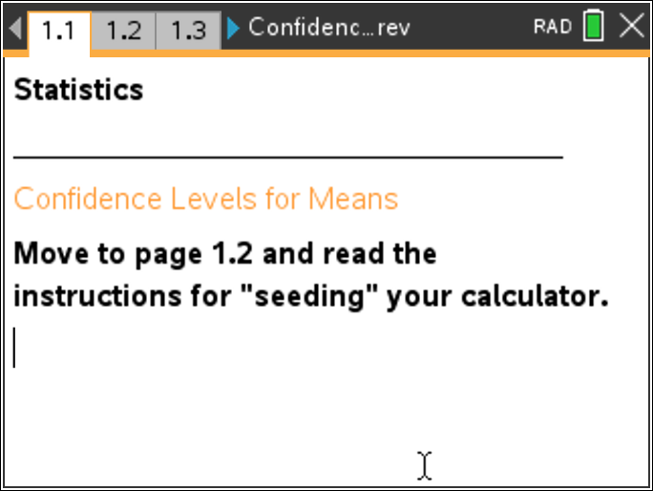

Move to page 1.2. | Press / ¢ and / ¡ to navigate through the lesson.
This activity involves generating a number of random samples from a population. In order to avoid having your results be identical to another student in the room, it is necessary to “seed” the random number generator. Read the instructions on page 1.2 for seeding your random number generator.

Move to page 2.1.

Confidence intervals are the results of a process that allows us to make an inference about unknown parameters for a population and are calculated from a random sample drawn from that population.

1. Use the arrow (▲) to draw a sample. The segment represents the calculated confidence interval for that sample.
a. What do the points on the horizontal axis represent?

b. Use the confidence interval to estimate the population mean. How confident are you that your estimate really captures the true mean of the population?

c. Although in real situations one sample is usually all you have, suppose you could draw more than one sample from the same population to find more than one confidence interval for the mean of that population. Draw another sample, and estimate the population mean from this new confidence interval. Repeat this process four more times, and write down your estimate for the sample mean each time.

Move to page 3.1.

2. a. Use the up arrow (▲) to generate five confidence intervals. Using those intervals, estimate what you think the population mean is likely to be. Explain your reasoning.

b. Use the up arrow (▲) to generate five more confidence intervals. Make another estimate of the population mean using all ten of the intervals you generated. Explain your reasoning.

c. Generate ten more confidence intervals and indicate the proportion of the 20 intervals you think might be unlikely to contain the population mean. Explain your thinking.

3. a. Make a conjecture about the number of intervals in a set of 50 intervals generated from the same population that you think might be likely to contain the population mean.

b. Generate confidence intervals until you have 50. How do the results match your conjecture?

Move to page 3.2.

4. Page 3.2 shows a vertical line representing the true population mean.
a. If you were to draw 10 confidence intervals, estimate the proportion of them that you think would be likely to contain 70.

b. Estimate the proportion of 50 confidence intervals you think would be likely to contain the actual population mean, and then generate them using the .tns file. How well did your results support your conjecture?

c. Press the down arrow (▼) to undo the confidence intervals you have on the screen. Generate 50 more intervals. Do these intervals support your conjecture? Why or why not?

5. Amie announced that in every 50 confidence intervals generated for this population, about 90% of them contain 70, the actual population mean.
a. Do you agree or disagree with Amie? Explain why or why not.

b. Use the down arrow (▼) to undo the confidence intervals you generated in Question 4. Generate a new set of 50 intervals and see whether the results support your reasoning in part a.

c. The confidence level used to generate the confidence intervals on page 3.2 was 90%. Based on your work in Questions 4 and 5, does 90% seem like a reasonable level? Why or why not?

Move to page 4.1.

6. Set the confidence level to 90%. Generate 50 samples. Describe how well your sample confidence intervals support a confidence level of 90%.

7. The up and down arrows (▲ and ▼) on page 4.1 control the confidence level. Note: the sample size stays constant.
a. If the confidence level is 95%, about what proportion of 50 confidence intervals generated from the same population for a given sample size do you think will contain the true population mean?

b. Use the down arrow (▼) to undo the confidence intervals you generated in Question 6. Set the confidence level to 95. Generate 50 confidence intervals. How do your results match your estimate in Question 7 part a?

c. Repeat Question 6 part a and b for another confidence level of your choice.

8. Use the down arrow (▼) to return to a screen with no confidence intervals.
a. Set the confidence level to 80%, and make a sketch of the resulting confidence interval, labeling the axis. Then set the confidence interval to 99% and make a sketch of that confidence interval using the same axis. What effect does changing the confidence level from a high level of confidence to a low level of confidence seem to have on the resulting intervals?

b. What happens to the width of a confidence interval as the confidence level changes for the same sample size? Generate confidence intervals for three different confidence levels, sketch them, and label each with an appropriate confidence level.

c. Think about what a confidence level represents. How does this help justify your conclusion in Question 7 part b?

9. An experiment led to the following: a 95% confidence interval for the mean number of hours that teenagers play video games is between 5.35 hours and 7.25 hours. Determine whether each statement is correct or incorrect.
a. 95% of the time, the number of hours teenagers play video games is between 5.35 hours and 7.25 hours.

b. We are 95% confident that the mean number of hours that teenagers play video games is between 5.35 hours and 7.25 hours.

c. We are 95% confident that the mean number of hours that teenagers play video games is
6.3 +/– 0.95.

d. 95% of the confidence intervals we construct will give us the interval (5.35, 7.25).

e. There is a 95% probability that the mean number of hours that teenagers play video games is between 5.35 and 7.25 hours.

10. Describe the difference between a confidence level and a confidence interval.

