Open the TI-Nspire document Light_and_Distance.tns  Have you ever noticed how a light source looks from different positions? For example, if you are close to a flashlight, you might notice that it looks very bright. However, if you are farther away from it, you will notice it seems dimmer. The brightness of light is also called the intensity of light. In this activity, you will explore how the intensity of light is related to its distance from the light source. |  |  | 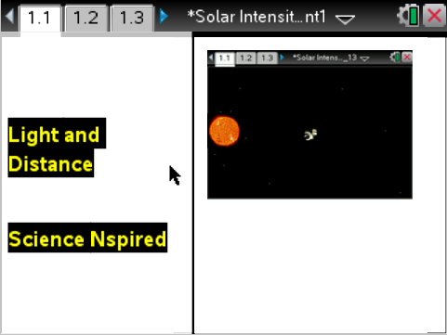
Move to page 1.2 and read the background information.
Just as the intensity of a flashlight will vary when it is observed from different locations, the intensity of sunlight varies at different locations throughout the solar system. In this activity, you will observe the intensity of sunlight at the surface of different objects in the solar system. You will then compare the intensity of light with the distance of an object from the Sun. From this information, you will determine a relationship between light intensity and distance. The distance from the Earth to the Sun is known as 1 Astronomical Unit, or 1 AU, which is equal to about 150 million kilometers. For the purposes of this activity, we will say that the intensity of sunlight on Earth is 1. The intensity of sunlight at the surface of other objects in the solar system will be measured relative to the intensity on Earth.

Move to page 1.3. Answer question 1 below and/or on your device.
Q1. 1 AU is the distance between what two celestial bodies?

A. the Sun and Neptune
B. Earth and the Moon
C. the Sun and Earth
D. Earth and the edge of the Solar System

Move to page 1.4.  Read the directions for the simulation.  1. Move the cursor over the left side of the probe that appears on the screen. When a hand appears, select and drag the probe across the dots on the screen. The dots are “hotspots” that represent objects in the solar system.  2. Select each hotspot on the screen. When you do this, a box will appear displaying the name of the object, the light intensity at the object’s location, and the distance of the object from the Sun.  3. There are 2 unknown objects to discover in addition to the 8 planets. All of the data obtained will be stored in the spreadsheet on page 1.5. | 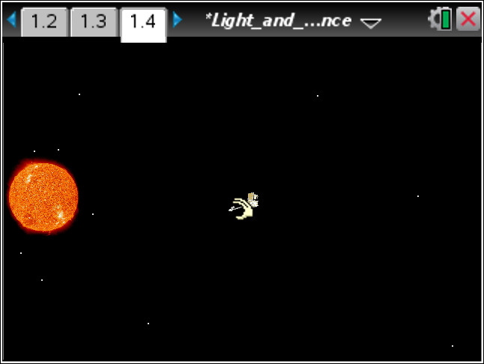
Tech Tip: To access the Directions again, select > Light and Distance > Directions.

Tech Tip: To access the Directions again, select b or Document Tools () > Light and Distance > Directions.
Move to pages 1.5 – 1.6.

After examining the data in the spreadsheet on page 1.5 and the graphic representation on page 1.6, fill in the table below. Do not solve for the asteroid or the comet distance yet.

Celestial Body | Distance (AU) | Light Intensity
Mercury
Venus
Earth
Mars
Jupiter
Saturn
Uranus
Neptune
Asteroid | ?
Comet | ?

Move to pages 1.7 – 1.10.
Answer questions 2 - 5 in the .tns file, the activity sheet, or both.

Q2. As the objects get further away from the sun, what happens to the intensity of the sunlight at the surface of the object?

A. The light intensity stays the same.
B. The light intensity decreases.
C. The light intensity increases.
D. There is no relationship between light intensity and distance.

Q3. While Earth is 1 AU away from the sun, Venus is only .723 AU away. Knowing this, how does the intensity of light on Venus compare with the intensity of light on Earth?

A. Both Earth and Venus have the same light intensity.
B. The sunlight on Venus is less intense than it is on Earth.
C. The sunlight on Venus is more intense than it is on Earth.
D. The intensity of sunlight on both planets cannot be determined from distance alone.

Q4. On page 1.6, a line graph is displayed showing the data. If you have not done so already, set the y-axis to distance and the x-axis to intensity. A linear graph is a straight line which is often used to show a series of consistent data points. Is the graph linear on page 1.6? (Ignore the two objects located at distance zero. These are the objects with unknown distance.)

A. Yes.
B. No.

Q5. Explain your reasoning for the question you just answered on the previous page 1.9.

Move to page 1.11.
3. On page 1.11, a graph will appear with an equation. You will need to use this equation to determine the distance of your unknown objects from the sun. Take a moment to reflect and compare this graph to the graph on page 1.6. |  | 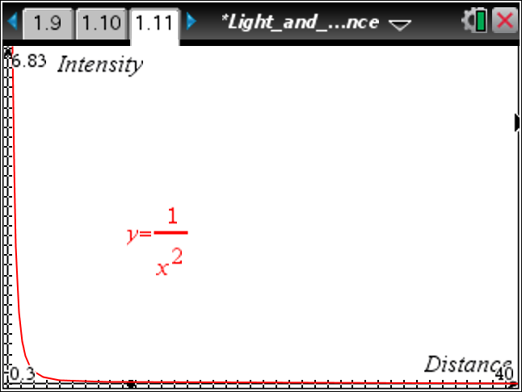
Move to pages 1.12 – 1.15. Answer questions 6 – 9 below and/or in your .tns file.

Q6. How does the graph on page 1.11 compare to the graph on page 1.6?

Q7. What equation is used on the graph located on page 1.11?

Q8. What does x represent in the equation on page 1.11?

A. distance
B. intensity
C. the celestial object
D. it varies.

Q9. Which of the following best describes the relationship between the intensity of light and the distance of an object from the light source?

A. The intensity changes according to the inverse square of the distance.
B. The intensity changes according to the square of the distance.
C. The intensity can be obtained by doubling the distance of the object.
D. The intensity can be obtained by halving the distance of the object.

Move to pages 1.16 – 1.18.
Read the information on page 1.16 on the .tns file or below. Then answer questions 10 - 11.

Solving for x in the equation shown on page 1.11 gives:
where x is the distance of an object from the light source and y is the light intensity on the surface of the object.

Q10. Find the asteroid on page 1.4. Using the formula from page 1.16, calculate the distance of the asteroid from the sun. Express your answer in units of AU. Use up to 4 decimal points in your answer and only include numbers, no letters in your response.

Q11. Find the comet on page 1.4. Using the formula from page 1.16, calculate the distance of the comet from the sun. Express your answer in units of AU. Use up to 4 decimal points in your answer and only include numbers, no letters in your response.

Move to page 1.19.

Check your answers from page 1.17 and 1.18. Then do to the following steps.
a. Go back to page 1.5.
b. On the spreadsheet, enter the distances you calculated on pages 1.17 and 1.18 for the comet and asteroid.
c. View the graph on page 1.6
d. The "dots" on the graph representing the comet and asteroid should all be lined up properly according to the equation, just as the curve looks on page 1.11.
e. If the curve does not look correct on page 1.6, correct your answers on pages 1.17 and 1.18.

