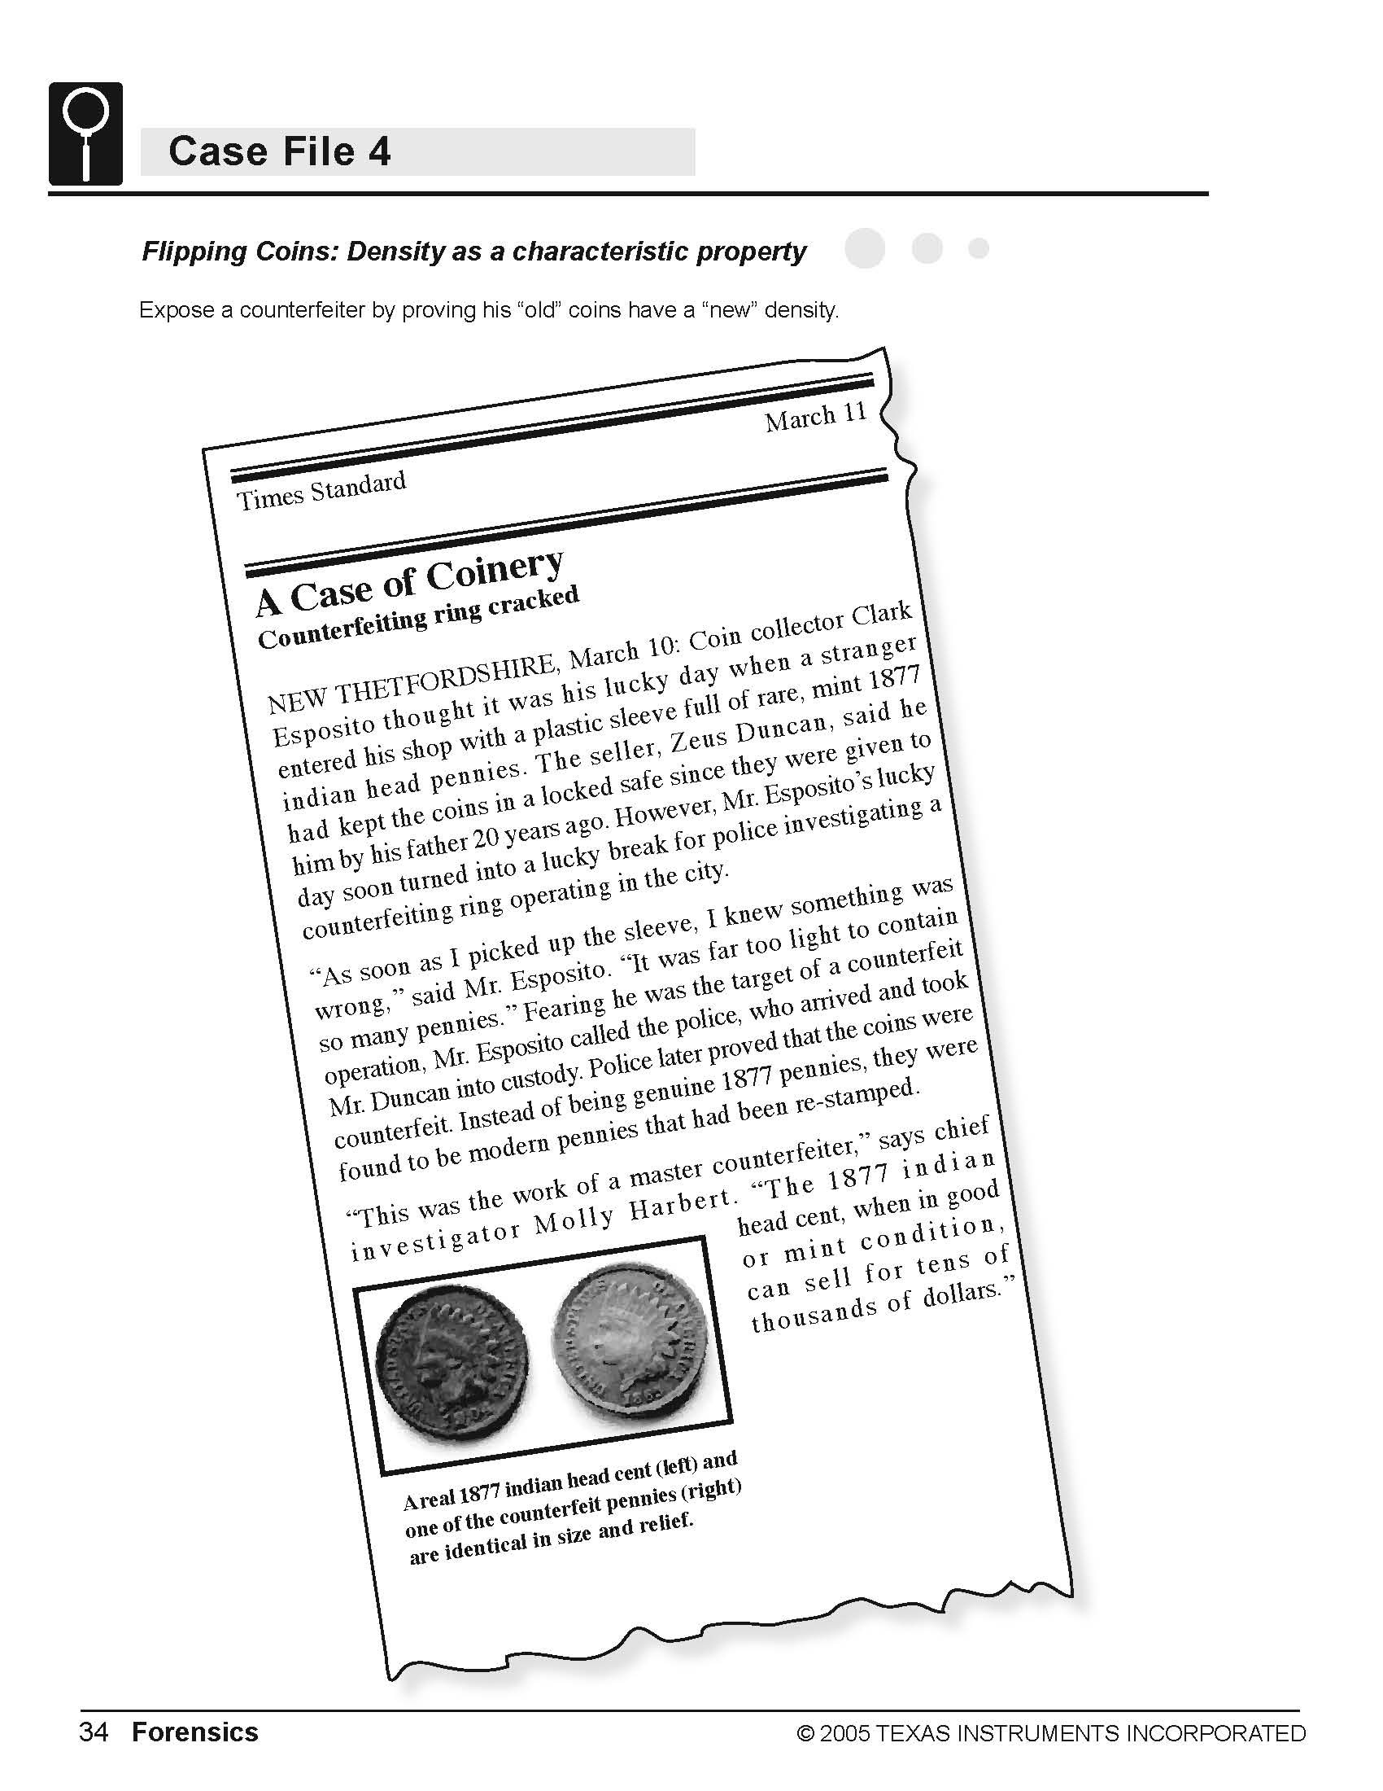
Science Objectives
- Identify counterfeit coins based on the characteristic property of density.
- Model data using a linear equation.
- Interpret the slope and intercept values from a linear model.
- Identify a characteristic property of a substance.

Activity Materials
- TI-NspireTM technology  - Case 4 Flipping Coins.tns file  - Vernier EasyLink™ or TI-Nspire Lab Cradle  - Vernier Dual-Range Force Sensor  - clamp or heavy tape | - small plastic cup  - string  - 20 pennies dated 1963–1981  - 20 pennies dated 1982  - 20 pennies dated after 1982
Procedure
Open the TI-Nspire document Case 4 FlippingCoins.tns.  In this data-gathering activity, you will identify counterfeit coins based on the characteristic property of density. |  | 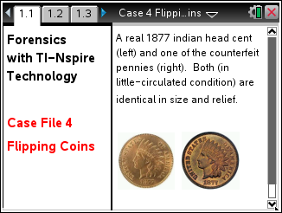
Part 1 – Preparing for Analysis
Move to pages 1.2 – 1.3.
1. Use a pencil to poke small holes on opposite sides of the coffee cup, near the top rim. Thread a piece of string through the holes, and then tie the ends of the string together to form a loop from which to hang the cup.
2. Separate each group of 20 pennies into four stacks of 5 pennies each. As you do this, confirm that you have 20 pre-1982 pennies, 20 pennies dated 1982, and 20 post-1982 pennies.
3. Set the range switch on the Dual-Range Force Sensor to ±10 N.
4. Secure the Force Sensor to the edge of a table. The sensor must be positioned with the hook closest to the ground and should remain level at all times. The figure below shows how the equipment should be set up.
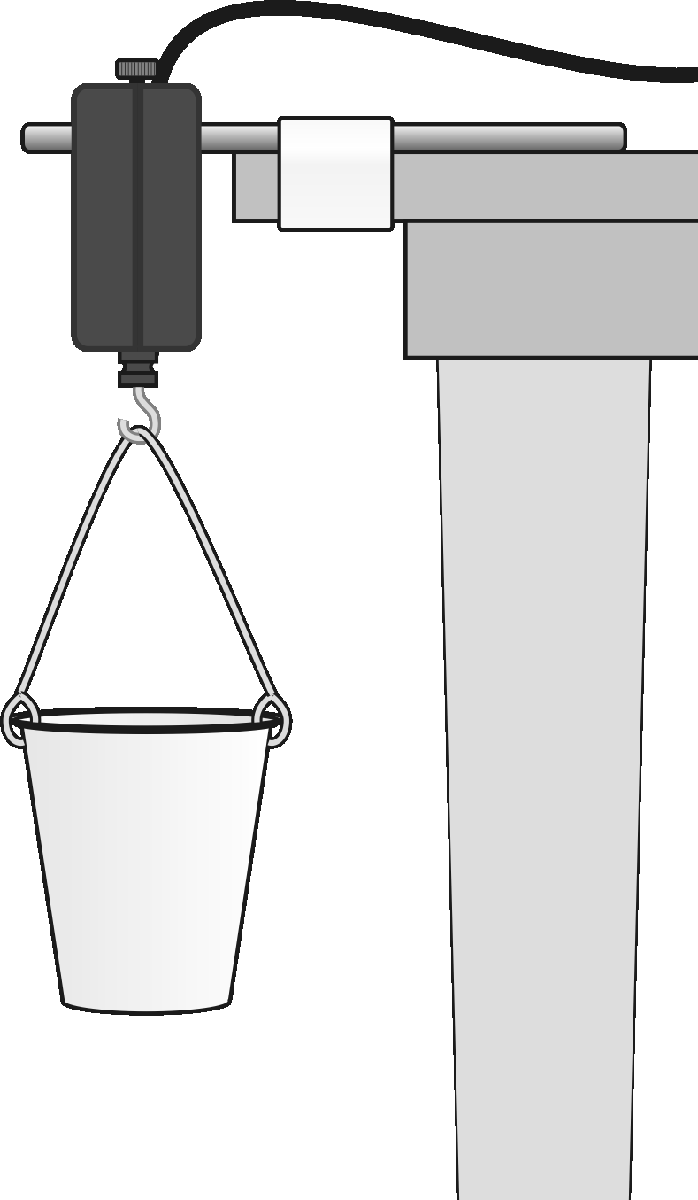

Part 2 – Collecting Data
Move to page 1.4-1.8  5. Connect the Dual-Range Force Sensor to TI-Nspire using EasyLink or the Lab Cradle. | 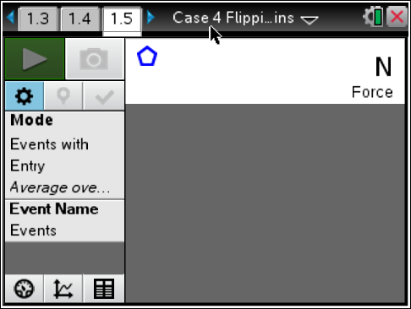
6. In this experiment, you want to measure the weight of the pennies only, not the pennies, cup, and string. To do this, you need to zero the Force Sensor.
a. Hang the empty cup from the hook on the Force Sensor.
b. Wait until the reading is stable. Select MENU > Experiment >Set Up Sensors > Zero. This will set the current weight reading to 0, so the sensor will ignore the weight of the cup and the string.
7. You are now ready to record the weights of different numbers of pennies.
a. The empty cup should be hanging from the hook on the force sensor. Start data collection by clicking the button.
b. When the weight reading of the empty cup is stable, it should be very nearly zero. Select the keep icon to keep current reading.
c. Enter 0 for the number of pennies now in the cup and press OK.
d. Place five of the pre-1982 pennies in the cup, and wait until the reading is stable.
e. Select “Keep” and enter 5, or the number of pennies in the cup. Select OK.
f. Continue with this procedure, using increasing numbers of pre-1982 pennies, in 5 penny increments with 20 pennies as the last point.
g. Stop data collection when you have finished collecting data by pressing the stop button. Your screen shows a graph of force vs. number of pennies. The graph should be linear. If you want to repeat data collection, repeat Steps 6 and 7.
Part 3 – Analyzing the Data
Move to pages 1.9 – 1.10.
18. To determine the equation that describes the relationship between weight and number of pennies, add a linear fit to your data.
- Press MENU > Analyze > Curve Fit.
- Select Linear for the Fit Equation. The linear-regression statistics for these two data columns are displayed for the equation in the form
y = mx + b
where x is the number of pennies, y is the weight, a is the slope, and b is the y-intercept. A best-fit linear regression line will be shown for your five data points. This line should pass near or through the data points and the origin of the graph.
- Record the equation and values for the best-fit line in your Evidence Record and select OK.
- Select the file cabinet icon to store this data. You should notice that the run number says run 2 and the color has changed.

9. Repeat Steps 6–8 for the pennies dated 1982.
10. Repeat Steps 6–8 for the pennies dated after 1982.

Evidence Record
Penny Date | Equation of the Best-Fit Line:  y = ax + b
1963–1981 | a: __________________________  b: __________________________  Correlation: __________________  Equation (y = ax + b):  ____________________________
1982 | a: __________________________  b: __________________________  Correlation: ___________________  Equation (y = ax + b):  ____________________________
After 1982 | a: __________________________  b: __________________________  Correlation: ___________________  Equation (y = ax + b):  ____________________________

Case Analysis
Answer the following questions here, in the .tns file, or both.
Q1. The equation for a straight line is y = ax + b, where x and y are coordinates on the line, a is the slope of the line, and b is the y-intercept (the value of y when x = 0).
In this case, y is the weight of the pennies in Newtons, x is the number of pennies, and a is the “density” of the pennies. What are the units of “density” in this equation?

Q2. Explain why the y-intercept, b, should be 0.

Q3. Was the value of b that you recorded for each group of pennies equal to 0? If not, explain why not.

Q4. How do the “densities” of the three sets of pennies compare? Based on your measurements, what do you think probably happened to the composition of the penny in 1982?

Q5. Use the appropriate equation to determine the weight of 5000 pennies from 1980. Show the equation you used and how you rearranged and/or substituted into the equation. Underline your answer.

Q6. Use the appropriate equation to determine the weight of 5000 pennies from 2005. Show the equation you used and how you rearranged and/or substituted into the equation. Underline your answer.

Q7. In this activity, “density” is in quotation marks because the slope of the line, a, is not actually density; a is just a measure of density. Explain why the value of a is not really density.

Q8. Why can you still use slope, a, as a measure of density?

Q9. What could have made the penny “densities” you calculated inaccurate?

Q10. From 1864 to 1962, pennies were made of 95% copper and 5% zinc-tin alloy. From 1962 to 1981, pennies were made of 95% copper and 5% zinc. Since 1983, pennies have been made of 97.5% zinc and 2.5% copper. Zinc is significantly less dense than copper. Tin is slightly more dense than zinc but still much less dense than copper.
If the suspect’s coins are genuine 1877 pennies, how should their density compare with the densities of the pennies you measured in this activity?

Q11. Police measured the weight of five of the suspect’s coins and found them to be 0.09 N each. Based on the data you collected, explain how the police knew that the suspect's coins were fakes.
Hint: What is the weight of five pennies made after 1982?

Q12. Correlation is a measure of how well the line fits the data points. A Correlation value near 1.0 indicates that the line is a good fit to the data points. Which group of pennies showed the best fit to a straight line? How do you know?

