Open the TI-Nspire™ document Simple_Inequalities.tns.  An inequality like x < -2 is true for some values of x and false for other values of x. In this activity, you will work interactively with number line graphs of inequalities. | 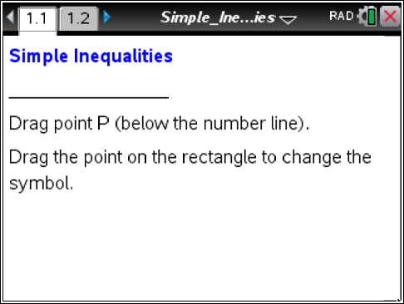

Move to page 1.2.

1. Move point P to the location shown at the right (-2).  a. Describe the changes that occur.  b. What stays the same as you move the point?  c. Make a conjecture about what would happen if you moved point P to the right of 0. | 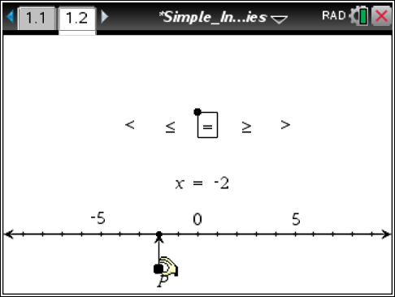
2. Grab the point on the rectangle surrounding the equals sign. Move the rectangle so that an inequality symbol is selected.
a. Describe the changes that occur as you move the rectangle.

b. What stays the same as you move the rectangle?

3. a. Describe the solution set for the inequality x < -3. Indicate how it is shown on the graph.

b. How does the graph show that an equation, such as x = 1, has a finite number of solutions? How does it show that an inequality, such as x > 1, has an infinite number of solutions?

- Describe the characteristics of the graph for each of the following expressions and equation.
 | x < 2 | x ≤ 2 | x = 2 | x ≥ 2 | x > 2
Open or closed circle?
Dark number line to the right or left ?

- a. Which symbol(s) will result in an open circle on the number line?
b. Which symbol(s) will result in a closed circle?
- Mary says, “The graph of x < 5 would have an open circle and appear darker to the right on the number line.” Is she correct? Why or why not?

- Sketch the graph of x ≥ 12 on the following number line. Explain why you chose the characteristics of your graph. Be sure to label your number line.

- Write the inequalities that represent the graphs below.
a.
b.
c.
- The symbols ≤ and ≥ are referred to as inclusive. The symbols < and > are referred to as
non-inclusive. Explain why these words are used.

- Freda says that the graph below is of x > 3. Steve says it is of 3 < x. Who do you think is correct, and why?
- Sketch a graph of each of the following inequalities.
- -3 ≥ x
- x > 2
Move to page 1.3.

- I have decided I need to reduce the number of soft drinks I consume in a month. I have determined that I should drink no more than 10 soft drinks in any particular month. Write an inequality representing this situation using sd as the variable to represent the number of soft drinks.

