Open the TI-Nspire document We’ve_Got_You_Covered.tns.

In this activity, you will be given photos of shapes from outside of the classroom and then asked to determine the areas of these shapes using measurement and computational tools.

Move to page 1.3. | Press / ¢ and / ¡ to navigate through the lesson.
1. In each picture of items from outside of the classroom, you will construct and measure the line segments you need to calculate the area of the 2D shape that you choose. Follow these steps:
- Use only the Segment tool and the Perpendicular tool when drawing on the pictures.
- Double-click on the value of the scale and change it until the measures are more appropriate for the object. Look at a meterstick, ruler, or items in your classroom to help you estimate.
- When the measurements are more realistic for the object, calculate its area by inserting a Calculator Page ( / ¿ · )
- Enter your results into the table below.

Draw your shape with measurements: | Area formula(s) used: | Calculated Area:  (show your work)
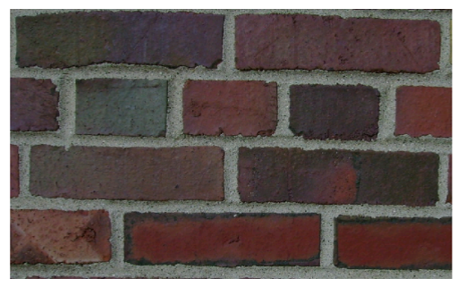
Long Brick
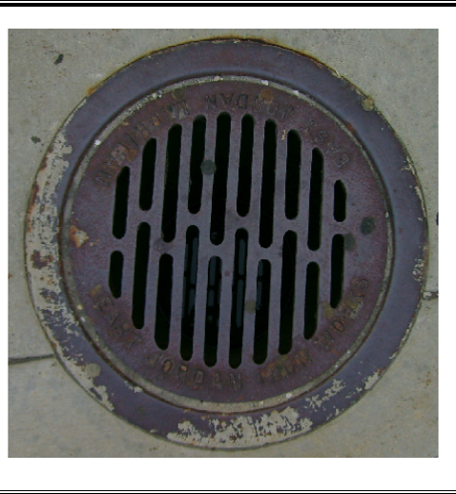
The Grate
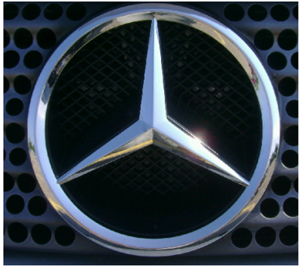
The Emblem

Draw your shape with measurements:
Area formula(s) used: | Calculated Area:  (show your work)
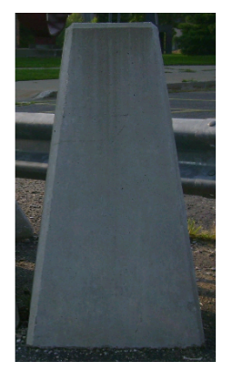
The face of the parking barrier
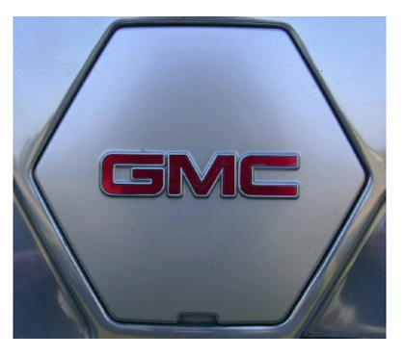
The Emblem
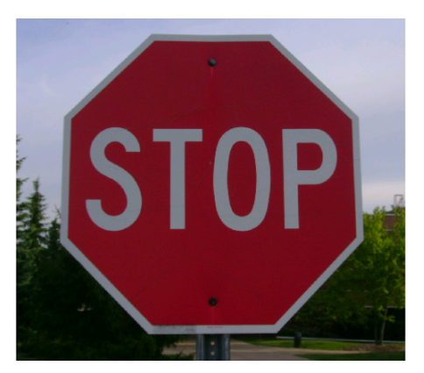
The Sign
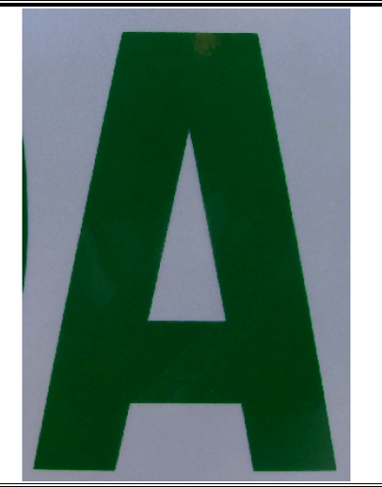
The Letter A

2. For picture 1.3, there are two different faces of the bricks shown, one long and the other short. Visually, it may appear that the area of two of the shorter brick faces is the same as the area of the longer brick face. Is it true? Explain why or why not.

3. In picture 1.4, there is a rim around the outside of the drainage cover. What is the area of just the rim? Show your work to justify your answer.

4. Suppose the identical trapezoidal faces of the parking barriers on picture 1.6 are to be painted with reflective paint. If one can of reflective paint covers approximately 22 square feet, how many cans will be needed to spray all the faces? Show your work.

