Open the TI-Nspire document Meaning_of_Alpha.tns.  What is an alpha level? What does it mean when an outcome is described as significant? In this activity, you will investigate the answers to these questions. | 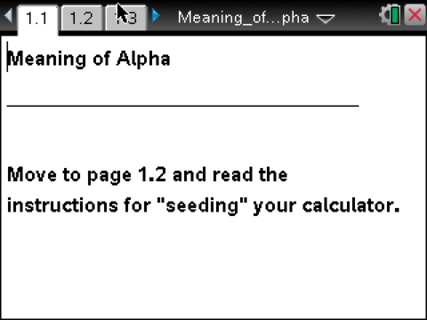

Move to page 1.2. | Press / ¢ and / ¡ to navigate through the lesson.
This activity involves generating a number of random samples from a population. In order to avoid having your results be identical to those for another student in the room, it is necessary to “seed” the random number generator. Read the instructions on page 1.2 for seeding your random number generator.
Consider the following hypothesis test:
H₀: μ = 10
H_{a}: μ > 10
The graph represents a normal population with a standard deviation of 2 that satisfies the null hypothesis.
1. Suppose you were to draw a sample of size 5 from the population described by the null hypothesis. Sketch what you would expect the sample to look like.

Move to page 2.1.

2. Draw a sample of size 5 by clicking the arrow (£).
a. How do the points you generated compare to your prediction in Question 1?

b. Describe the distribution of those points.

c. How does your distribution compare with your classmates’ distributions?

3. a. Based on your prediction in Question 1, do you believe that your sample came from the hypothesized population or from one whose mean is larger than 10? How did you decide?

b. Show your sample to someone else to see if he or she reaches the same conclusion.

c. Under what conditions would you have reached the conclusion that your sample was not taken from the assumed population H₀: μ = 10?

Move to page 2.2.

The top graph is a rescaled copy of the one on Page 2.1. The bottom graph represents the sampling distribution of for all possible samples of size 5 from the given population.

4. a. Explain why the graph of the sampling distribution of is not exactly the same as the graph of the population.

b. What do you think the vertical line labeled xc = 11.1 represents in the graph of the sampling distribution of?

Samples that are judged as unlikely to have come from the hypothesized population will have sample means that are extreme in the direction of the alternative hypothesis. The term alpha (significance level) is used to quantify what statisticians mean by “extreme enough” and establishes an agreed-upon criterion for the meaning of extreme.

5. Look at the mean of your sample in the top graph. Would your sample be judged as unlikely to have come from the hypothesized population for the given alpha level and alternative hypothesis? Why or why not?

6. Even though in practice you can usually obtain only one sample, to determine how often samples are classified as unlikely to have come from the hypothesized population, it is necessary to understand the distribution of all samples from that population. In this activity, you still can’t look at all of the samples, but you can look at a lot more than one.
a. Draw 50 samples, and record the number of times a sample mean falls in the shaded region. What fraction of your 50 samples would be judged unlikely to have come from the hypothesized population?

b. Based on your answers above, what do you think alpha represents? Explain your thinking.

It is important to understand that all the samples you have generated (and will generate) in this activity really are random samples taken from the given population. But samples vary. One consequence of that variation is that some samples will appear not to “belong” to a given population even when they really do. The reason for looking at lots of samples from a known population is to begin to understand just how that random variation affects decisions.

Move to page 3.1, and set alpha to 0.15.

7. a. Explain why the line xc is now 10.9.

b. Predict the proportion of samples that would be judged unlikely to have come from the hypothesized population for an alpha of 0.15.

c. Draw a sample. What does the point in the lower graph represent?

d. Draw 10 samples, and count how many times the sample mean falls in the shaded region.

Move to page 3.2.

8. Use the arrow to draw 100 samples. Page 3.2 shows the distribution of 100 sample means from the samples you generated.
a. What fraction of your 100 samples would be judged unlikely to have come from the hypothesized population based on the given value of alpha?

b. Go back to Page 3.1, and change alpha to 0.1. Return to 3.2, and explain what has changed.

c. Now, what fraction of your 100 samples would be judged unlikely to have come from the hypothesized population, based on this new alpha?

9. Based on your work in Questions 6–8, describe what you believe alpha measures.

When a sample mean indicates the sample is unlikely to have come from the hypothesized population, statisticians would say they “reject the null hypothesis.” Therefore, the region consisting of all sample means that are “extreme” in the direction of the alternative hypothesis is called the “rejection region” for that hypothesis test.

When a sample mean indicates the sample is likely to have come from the hypothesized population, statisticians would say they “fail to reject the null hypothesis.”
10. If a sample mean falls into the rejection region defined by a given alpha value, that sample mean is sometimes called significant at that alpha level.
a. Explain why such a sample mean might be considered significant.

b. For a sample of size 5 and assuming H₀: μ = 10; H_{a}: μ > 10, identify each of the following sample means as significant or not and give an explanation for your conclusion. (You may use any of the pages in the .tns file to support your answer.)
i. α =0.1, sample mean = 12

ii. α = 0.1, sample mean = 10.4

iii. α = 0.05, sample mean = 12

iv. α = 0.03, sample mean = 11

v. α = 0.01, sample mean = 13

c. In which of the cases in part b would you consider the sample mean evidence to reject the null hypothesis? Explain why.

11. In all cases, before gathering the necessary sample, the researcher or statistician sets the alpha level that will determine whether the sample mean will be significant, that is, whether the sample mean will lead to a reject or fail to reject conclusion regarding the null hypothesis.
Suppose you were testing a hypothesis using the given alpha. Describe the possible consequences in terms of the null hypothesis.
a. α = 0.45

b. α = 0.001

This page intentionally left blank.

